September's Tourism Matters: Seasonal event requests, free workshops and celebrations

Dear Tourism Industry colleague

Welcome to September’s Tourism Matters and can you believe that the next bank holiday will be Christmas?! (Oh no it isn’t, we hear you cry). We hope that everyone has had a successful summer.

In this issue we ask for information to help us with our promotional activities, plus we bring you details from VisitEngland on the single use plastic ban, Federation of Small Businesses courses and the latest on the Margate Town Deal projects.

If you know somebody who would like to read our e-news, please forward it on, or let them know they can register to receive it themselves at www.visitthanet.co.uk/tourismmatters.

Keep up to date with the latest event information and seasonal content on our website www.visitthanet.co.uk

Tourism and Visitor Services News
Visitor Information Services Autumn Opening Hours
The Thanet Visitor Information Centre at Droit House, Margate is open Tuesday to Sunday throughout September from 10am to 5pm. Opening hours will change from October to Wednesday to Sunday 10am to 5pm with daily opening during October half term (23 -27).

Broadstairs Information Kiosk: open daily, 10am to 4pm until Sunday 1 October, before closing for the season.

Ramsgate Visitor Information Centre: Open Monday to Saturday, 10am to 4pm and from October, Monday to Saturday 11am to 3pm.

Christmas and New Year Events
The summer holidays may have only just come to an end, but we are gathering together details of Christmas events in the area for our dedicated website page, social media, press and visitor enquiries.

If you are planning an event, please let us know by emailing visitorinformation@thanet.gov.uk. Please include the event name, date, time, location, contact details, description of what the event includes, admission cost (if relevant) and a landscape image.

Visitors’ Map for half term
With just a few weeks until the October half term, we want to ensure that as many of our tourism, leisure and hospitality businesses as possible have got copies of our Visitors’ Map, for your guests and visitors.

If you would like to pick-up a supply of the map, please ring the Visitor Information Centre team on 01843 577577 or email visitorinformation@thanet.gov.uk to make arrangements so that we can ensure we have a supply ready for you.

2024 What’s New and Anniversaries
Do you have a new business offering planned for 2024 with touristic appeal, or is your venue or event celebrating a key anniversary? If so, please let us know. We will share your information with national and regional tourism bodies, and promote it in our PR activities. It will appear on our website and in social media posts where relevant. Please send a full description, an image and link for further information to julie.edwards@thanet.gov.uk

VisitBritain/VisitEngland Update
New fire safety guidance comes into force
The Home Office recently published fully updated guidance for small accommodation businesses to help them comply with fire safety law.

The new guide ‘Making your small paying guest accommodation safe from fire’ replaces the previous ‘Do you have paying guests?’ guide.

The new guidance comes into effect on Sunday 1 October 2023. Read the full regulatory update on the VisitBritain Business Advice Hub and download the new Fire Risk Assessment template which aligns with the new guidance.

VisitEngland is hosting two webinars with industry experts to help support businesses and provide more information about the new guidance and regulations. The webinars will feature expert speakers:
- Matthew Armer, Head of Fire Risk Assessment Policy and Practice Team at the Home Office,
- Alistair Handyside MBE, Professional Association Of Self Caterers UK (PASC) Chair
- Paul Bray, Fire Safety Consultant & Fire Risk Assessor

Webinars take place on
- Monday 18 September 11am - 12:30pm Register
- Thursday 21 September 11am - 12:30pm Register

Single use plastic ban extended in October
From Sunday 1 October 2023, the ban on single use plastics is being extended to include more items.

VisitBritain’s latest regulatory update goes through the changes to existing legislation. In addition to the existing ban on plastic stirrers and straws, the new regulations also include single use plastic plates, bowls and cutlery.

Read the full update for more details and how this will apply to your business on the VisitBritain website

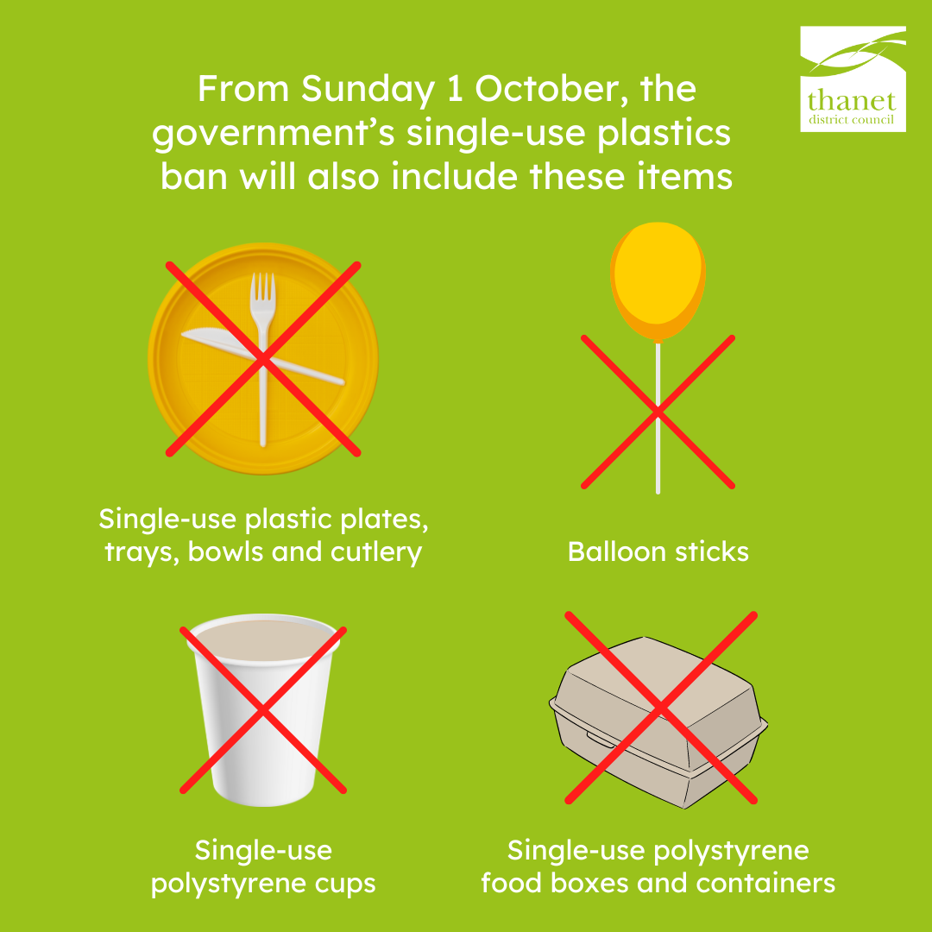

Guides to support travellers with accessibility requirements
VisitEngland has developed an extensive set of guides to enhance their support for travellers with a range of accessibility requirements, both when considering a trip within Britain and when already here. The guides showcase useful links and practical information alongside inspirational experiences and attractions which cater to those with accessibility needs. To find out more head to the VisitEngland website.

Thanet District Council
Margate Town Deal projects update
Read the latest news on the Margate Town Deal projects in the recently published blog

The article includes updates on each of the four Margate Town Deal interventions with details on the Margate Creative Land Trust, Theatre Royal and Coastal Wellbeing initiatives.

Update on Margate Winter Gardens
Looking specifically at Margate Winter Gardens, one of the more high profile Margate Town Deal projects, Thanet District Council has appointed a commercial agent, Colliers. They will help to promote the building to potential new operators and investors. The goal is to attract organisations with the specialist experience and expertise the Winter Gardens needs to thrive in the future. Read more in the council's newsroom

Ramsgate Business Workshops
The Ramsgate High Street HAZ is running a series of free courses to support local non-profit organisations. These courses are delivered by Social Enterprise Kent.
- Tuesday 3 October - Business Strategy and Planning
- Tuesday 7 November - Microsoft Excel: Learn the Basics
- Tuesday 5 December - Social Media Essentials

Sessions take place at Discovery Planet, 47 High Street, Ramsgate CT11 9AG. For more detail and to book, click here

BOSS (Business Owners Supporting and Sharing) Roadshow
Thanet District Council’s Regeneration team is hosting a free one-day business knowledge and networking event at Kent Innovation Centre on Thursday 28 September.

The day gives local business owners the opportunity to improve their skills, hear from industry experts and expand their networks. There will be expert speakers, seminars, one-to-one sessions, a business breakfast and a networking lunch.

All Thanet businesses are welcome. If you would like to find out about the sessions and book, visit the council’s website

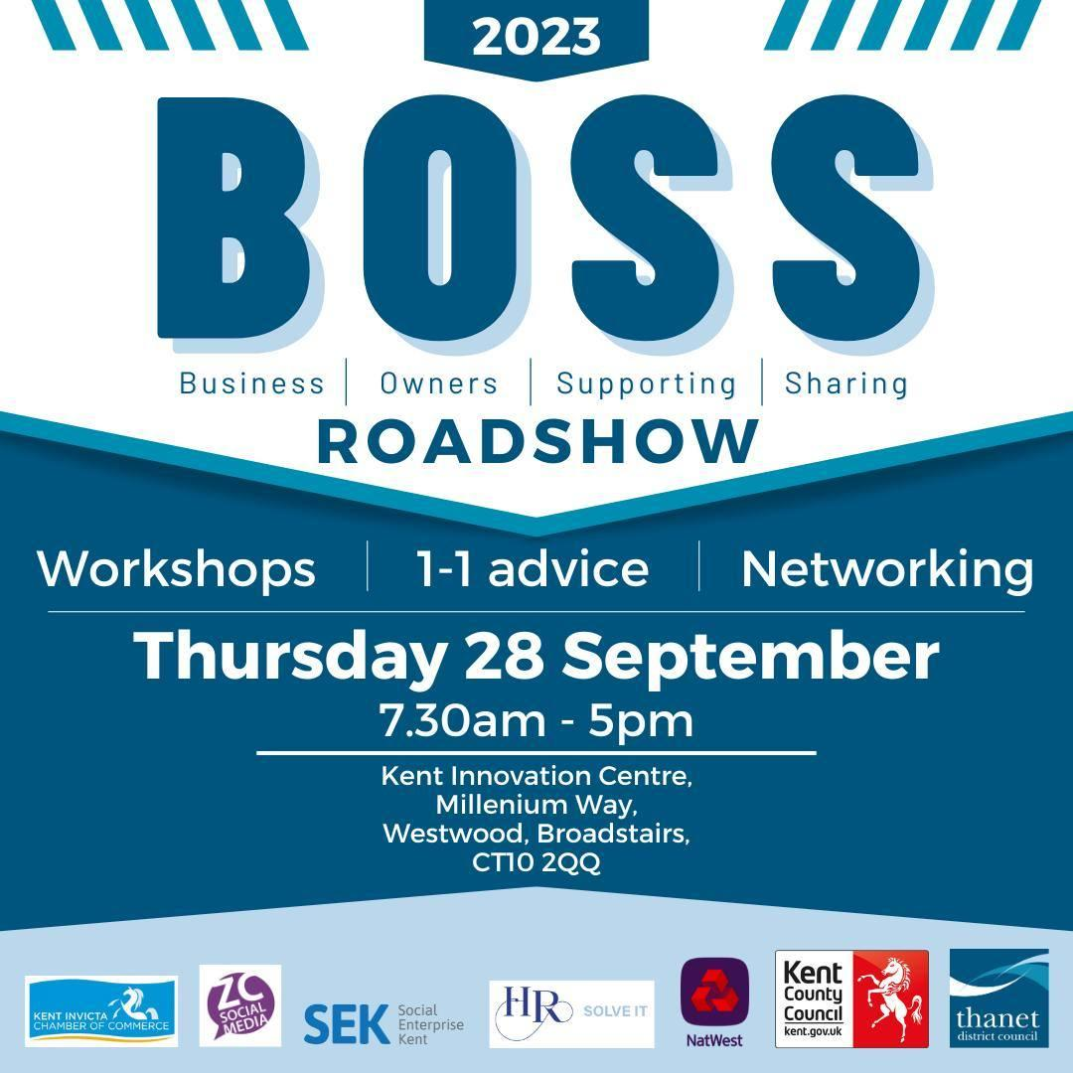

Sustrans Cycling and Walking Infrastructure Plan
Sustrans is a charity working to make it easier for everyone to walk, wheel and cycle. They look after the National Cycle Network, and Thanet District Council is working with them to develop a Cycling and Walking Infrastructure Plan (CWIP) for Thanet.

Sustrans held in-person workshops in June, with an online consultation, to help to understand where people want to walk and cycle in Thanet.

Sustrans is holding a second in-person event for members of the public: Monday 18 September, 2.30pm to 6.30pm at Minster Village Hall, High Street, Minster, Ramsgate CT12 4BU.

The plan will help Thanet combat climate change and improve air quality, health and access for everyone.

Future of Westbrook Loggia secured with transfer to new owner
Thanet District Council has secured the future of the much-loved Westbrook Loggia building at Westbrook Bay.

Following a competitive tendering process, the building has been sold to Tracey Emin. Emin’s extensive plans for the renovation of the building include a community bathers club with café, hot showers, toilet facilities, sauna and winter club room on the ground floor. The first floor will provide a range of facilities including a large art studio, gym, restaurant and a hot desk station. The roof area will be transformed into a sunbathing area with refreshment facilities. Read more in the council’s newsroom.

Beach users to benefit from new information boards at coastal locations
The council has installed new information boards at Thanet’s most popular beaches and bays. The boards provide information specific to each location, with details on the facilities there. The new signs feature website addresses and QR codes so that visitors can access more detailed information via the council’s website.

The boards feature illustrations of some of the birds and sea life most commonly found on our shores, so that visitors can look out for, and identify them. Read more on the council’s website.
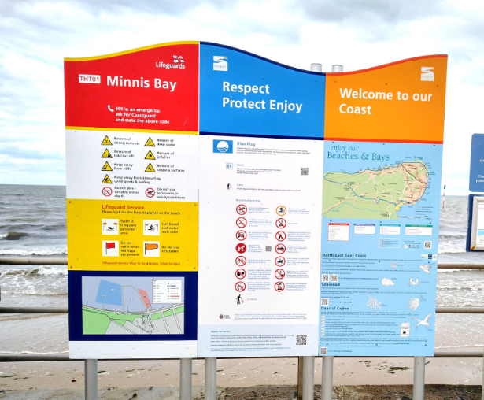

Other News
Federation of Small Businesses (FSB) - upcoming events (online/virtual)

Wednesday 20 September Health, wellbeing and personal development for small businesses 4.30pm to 5.45pm
Click here to find out more and book a place

Friday 29 September Big networking for small businesses 10am to 11.30am
Click here to find out more and to book a place

Tuesday 3 October Growth through exceptional customer experience 2pm to 3pm
Click here to find out more and to book a place

Tuesday 24 October Cost of Living: How employers can support staff and boost retention 11am to 12pm
Click here to find out more and to book a place

Find out more about the FSB and other events visit www.fsb.org.uk

Thanet Parkway station
The new Thanet Parkway station, Thanet’s first new railway station in over 90 years, opened to passengers on Monday 31 July.

Thanet Parkway is situated between Ramsgate and Minster and offers Southeastern highspeed services to London St. Pancras International in just 70 minutes, as well as Southeastern mainline connections to other London terminals and across Kent.

A new road provides access to the station from the A299 Hengist Way. There is parking available for 293 cars, including 16 for Blue Badge holders, and there are 12 charging points for electric vehicles. Secure cycle racks are also available.

Thanet Parkway is rated Category A for accessibility and has step-free lifts to both platforms. Southeastern is currently operating a pilot scheme for Assisted Boarding Points at this station, providing customers needing assistance with the confidence that they are in the right position to get the assistance needed for their journey. Wayfinding tactile paving has also been placed throughout the station to assist those who have a visual impairment.

There are 11 Help Points, with hearing loops, connecting to their control centre and there is extensive CCTV coverage to ensure customer safety. The station is staffed Monday to Friday 8am to 4pm with plans to staff it at weekends in the near future.

The offer
To celebrate the opening, for a limited time when you buy a train ticket on the Southeastern app or website from Thanet Parkway to anywhere on the Southeastern network you can receive a discount.*

Your ticket must be bought between 11 September 9am and 31 October 11.59pm and outward travel must be completed by 1 November 2023, return travel within the validity period of the ticket purchased. The discount is only available for eTickets and tickets purchased via their contactless smartcard. The Key and the discount code can only be used once by each customer for an individual purchase.

If you spend £50 or more on a ticket, receive £10 off. Use code ThanetParkway10

If you spend £20 or more on a ticket, receive £5 off. Use code ThanetParkway5

Railcard discounts will be valid to give further savings.

To claim your discount, visit the Southeastern website or download their app from the App store or Google Play to buy your ticket and select Thanet Parkway as your origin station.

If you’re booking Assisted Travel and need help buying your tickets and using the discount codes, please contact Southeastern on freephone 0800 7834524.
*Terms and conditions apply

Your News
Congratulations to Ramsgate Discovery Planet which is celebrating 10 years of providing science workshops to children in the community this September.

Congratulations to Cliftonville Farmers’ Market which celebrates its 22nd birthday on Sunday 24 September.

Bucket and Spade List Results
In July’s Tourism Matters we included the new competition from Seaside Heritage Network, in collaboration with Coast Magazine, to find the nation’s best-loved seaside heritage.

Dreamland was included in the shortlist, along with arcade machines, Blackpool Tower, Babbacombe Model Village and rockpooling.

The result of the voting for the ‘Top Ten Bucket and Spade List’ was announced in Blackpool on Monday 11 September, with Dreamland Margate as number 8.

