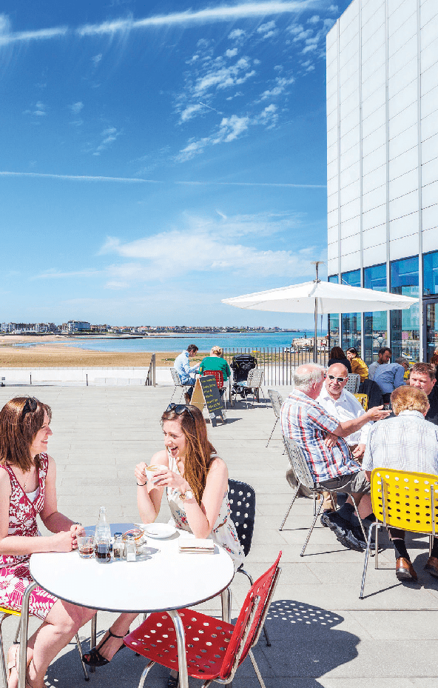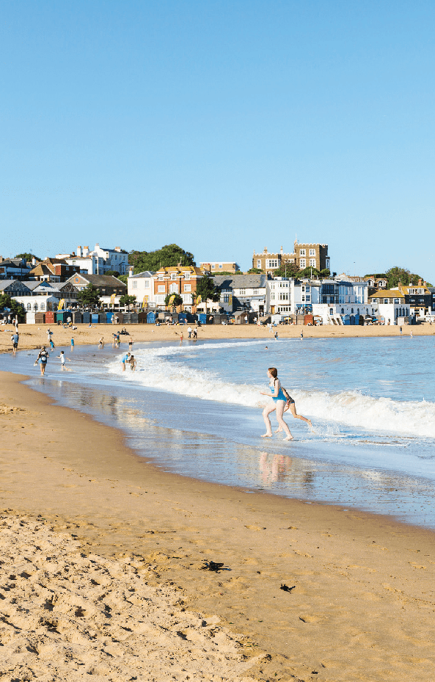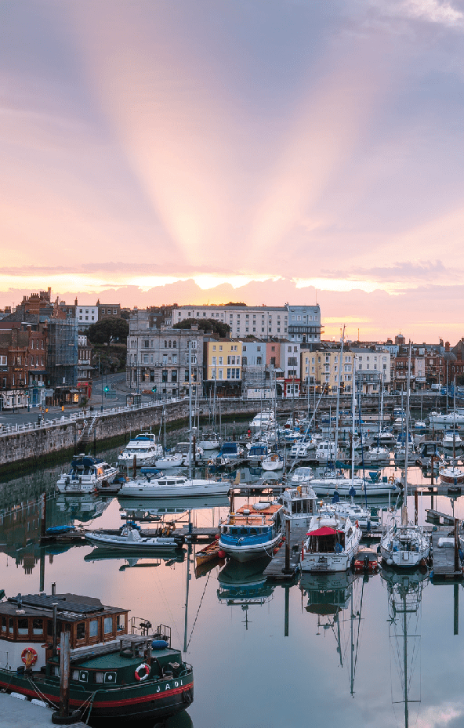
Visit Thanet Press Pack Margate, Broadstairs and Ramsgate

Escape to the Isle of Thanet

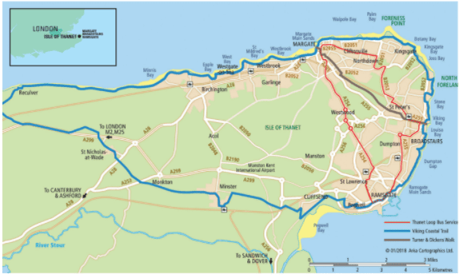
The Isle of Thanet is around 40 square miles (103.30 square km) with coast on three sides at the most north-easterly edge of Kent, the Garden of England. Historically the isle was separated from the mainland by a significant
waterway, the Wantsum Channel. Today the isle is easily accessible with excellent road links to the national motorway network.

It takes just 75 minutes from London’s St Pancras International aboard HS1, the country’s only high-speed rail service. Rail services link Thanet to other London stations and mainland Europe (Eurostar) via Ashford International. Cross- Channel services are available from the Port of Dover and Eurotunnel Folkestone.

The Isle’s three resorts – Margate, Broadstairs and Ramsgate – have golden sandy beaches, chalk cliffs and mainline railway stations. They are geographically so close to each other but their personalities could not be more different.
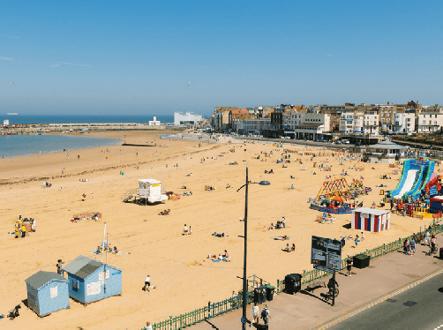
Thanet’s unique selling points

Margate Main Sands

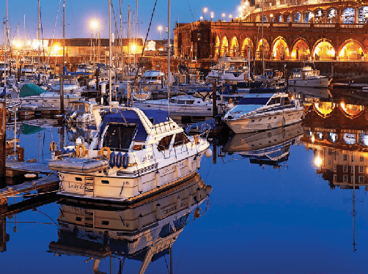
Ramsgate Royal Harbour

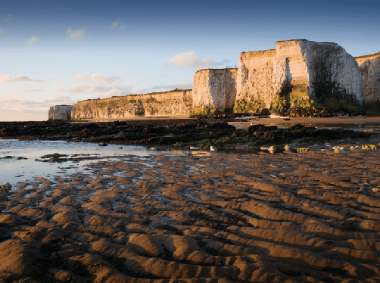
Botany Bay, Broadstairs
- 16 spectacular sandy beaches and bays -
10 with Blue Flags or Seaside Awards (2021 awards applied for and awaiting confirmation)
- North East Kent Marine Protected Area (NEKMPA) – the coastline is covered by international and national designations for its marine and bird life
- Longest continuous stretch of coastal chalk in Britain
- The only Royal Harbour in the country, celebrating 200 years of ‘Royal’ designation in 2021
- Turner Contemporary – the largest purpose- built gallery in the South East, outside London. Celebrating 10 years since opening
- Dreamland, the UKs original pleasure park, reimagined
- Rich historic connections and commemorations such as the evacuation of Dunkirk, helping hold the frontline in WW1 and WW2, the arrival of the Saxons, the invasion of Hengist and Horsa, the start of Roman Britain led by Julius Caesar and the arrival of England’s first Christian
- Famous literary and artistic connections such as Charles Dickens, JMW Turner, Augustus Pugin and Tracey Emin
- High Speed 1 from St. Pancras International
  - Margate (90 mins), Broadstairs (85 mins) and Ramsgate (75 mins)
- Viking Coastal Trail (32 miles), most attractive leisure cycling route in Kent, much of which is along traffic free promenades www.visitthanet.co.uk/cycling
- Coastal Explorer Packs, unique to Thanet, helping visitors to discover our rich heritage stories and natural coastal designations www.visitthanet.co.uk/coastalexplorers
- Digital Discovery Plaques, learn about some of isle’s unique stories, rich heritage and secrets at key locations around the Thanet coast.
- www.visitthanet.co.uk/digitaldiscovery

THANET VISITOR ECONOMY
- 4.6 million visitors each year
- 8,664 jobs
- Contributes £365 million to the local economy each year (Cambridge Model Economic Impact survey 2019). This figure does not include the value of language schools to the local economy, which 2013 research found to be £41 million.

THANET PEOPLE
- Thanet population: 141,900 (ONS mid-2019)
- Mean age: 42.6 years (Source: Based on 2019 Mid Year Population Estimates, Office for National Statistics)

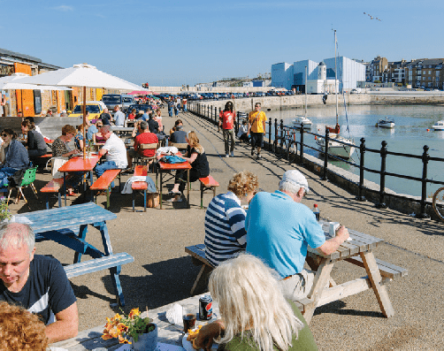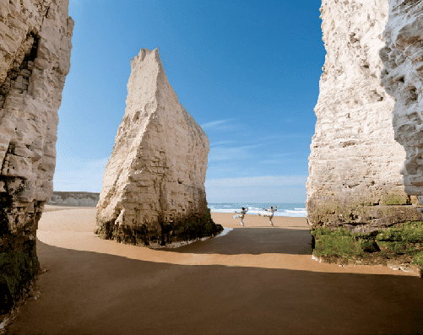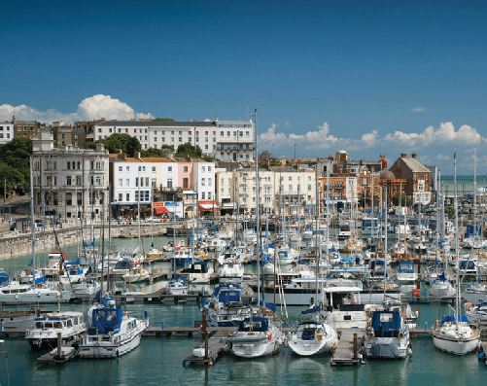
Margate Harbour Arm Botany Bay

Why visit?
Royal Harbour, Ramsgate

Londoners have been escaping to the Isle of Thanet for more than 200 years … for the laidback seaside vibe … breathtaking sandy beaches … fresh sea air… and romantic Turner skies …
Here at the very edge of the Garden of England, three Georgian and Victorian resorts, each with its own distinctive character
– Margate, Broadstairs and Ramsgate – cluster
around the bays at the far end of a peninsula.
There’s a quirky and convivial feel to these harbour towns, with their friendly creative scene, their remarkable 18th and 19th century architecture, their classic seaside heritage, their eclectic attractions and events, their galleries and music venues large and small, and their special one-off places to eat, drink, shop and stay, year round.
Miles of low chalk cliffs edge the peninsula, sheltering a string of secluded, unspoilt
sandy bays. Chalk rockpools, chalk stacks and rare chalk reefs teem with wildlife.
These are the closest surfing beaches to the capital city: a popular choice with south-east boarders.
Artists, writers and musicians – from Van Gogh and TS Eliot to Bob & Roberta Smith and the Libertines – have long been inspired by this almost-island and continue to be drawn here.
Turner said Thanet had “the loveliest skies in all Europe” … for Dickens Broadstairs was
“the freshest, freest place” … and Tracey Emin declares in pink neon on Margate seafront: “I never stopped loving you”.
The Isle’s a historic landing place steeped in symbolism for the story of Britain … the first Saxons Hengist and Horsa arrived and
settled here … and St Augustine first stepped onto these shores on his way to nearby Canterbury.
For this is the furthest south east you can go in Britain … almost touching mainland
Europe … yet these days only 75 minutes from

central London …
And now with Turner Contemporary and Dreamland, and high-speed trains from the capital … a new generation is discovering this original seaside escape.

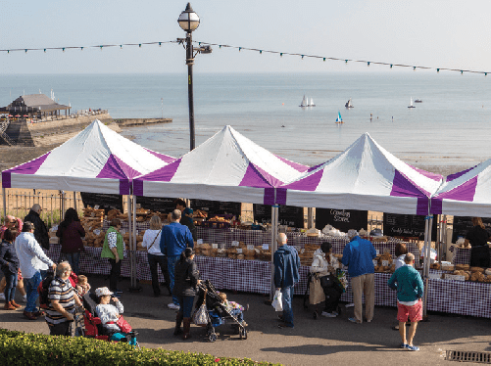
On the menu Where to stay

Thanet has a wide range of eateries and fine dining opportunities.
Stark in Broadstairs became the Isle’s first Michelin starred restaurant in 2020, with 1 Michelin Star. It’s a small, intimate restaurant offering only a six course menu and the option of matching wines.
Arya in Ramsgate, a small plates, tapas restaurant, was awarded a Michelin Bib Gourmand.
Angela’s fish and seafood restaurant in Margate has recently been recognised as a Michelin Green Star Restaurant, highlighting them as a role model for sustainable practices.
Pale Ale Mary by Northdown Brewery won Kent Beer of the Year in the Taste of Kent Awards 2020. Gadds No.3 by Ramsgate Brewery made it into the final three. The isle has 11 pubs and micro-pubs listed in the Good Beer Guide 2021.
Margate’s Buoy and Oyster seafood restaurant is a Good Food Award Winner 2021, whilst the town’s Mad Hatter’s Tea Room is a winner in the cafe section with a 2021 Gold Seal.
www.visitthanet.co.uk/foodawards
Cliftonville Farmers’ Market (last Sunday of each month excluding December) and Quex Barn in Birchington, are popular sources of local goodies, whilst foodies are spoiled for choice at Broadstairs’ Food Festival in October.
Numerous places serve great local fish ‘n chips while the traditional taste of the seaside holiday can be experienced at Mannings, a family-run cockle and whelk stall in Margate and Cannons seafood stall in Ramsgate.
Contemporary and richly restored quality boutique hotels are to be discovered across the isle, many with stunning views of sea, sands and Thanet’s stunning sunsets.
Stylish and chic B&Bs and guest houses are flourishing alongside delightful self-catering townhouses, flint-faced fisherman’s cottages and apartments. Outdoor enthusiasts have an excellent selection of caravan and camping sites. Or for something a little bit different there is Quex Livery Glamping, bell tents with individual kitchens and individual bathrooms made from upcycled horse trailers.
The Albion Rooms, Margate - English rock band The Libertines opened The Albion Rooms boutique residence overlooking the sea in September 2020. In addition to the seven individually designed rooms, the venue boasts The Restaurant, Arcady Coffee House and The Waste Land, which is the artistic hub of The Albion Rooms and named in homage to the T. S. Eliot poem.
www.thealbionrooms.live
Find full details of Thanet’s quality assessed accommodation at
www.visitthanet.co.uk/stay-and-eat/places- to-stay/

Broadstairs Food Festival

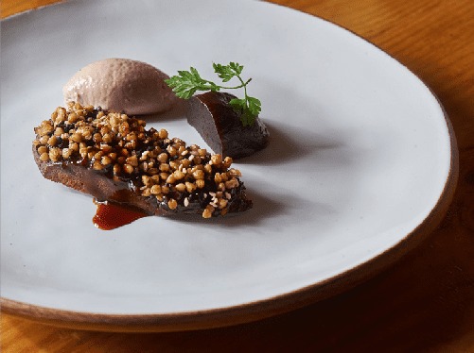
Stark, Broadstairs

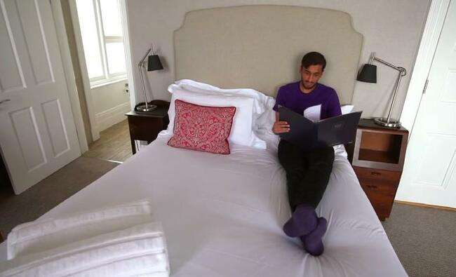

Stylish and chic accommodation
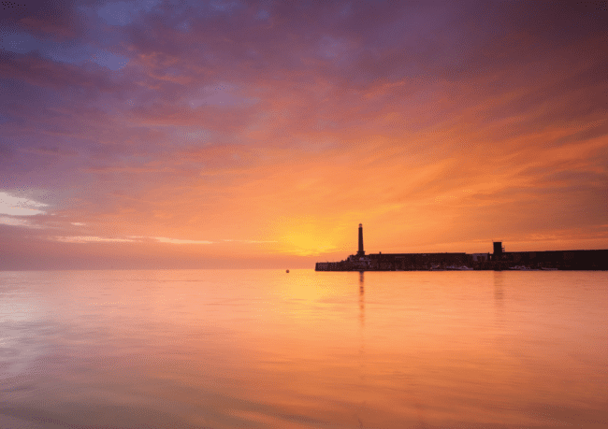

“the freshest, freest place”Charles Dickens
“the loveliest skies in all Europe” JMWTurner
“I never stopped loving you” Tracey Emin (Turner Sunset, Margate Harbour Arm)

Roots, revival and regeneration

ROOTS
The origins of the district’s three distinctive resorts – Margate, Broadstairs and Ramsgate – and their surrounding villages lie in farming and fishing.
The passion for the health benefits of sea air and bathing, which started among the aristocracy in the 18th century, led to a building boom and development of the towns to cater for a rapidly growing number of wealthy visitors.
With an increase in ferry services from London and even more significantly the arrival of the railways, many more people gained access to the coastal resorts, each of which has its own mainline stations.
Investment in buildings and businesses followed providing accommodation and entertainment for holidaymakers, group excursions and day trippers from the capital and beyond.

The resorts shared much in common – golden sands, sweeping beaches and hidden bays framed by impressive chalk cliffs.
However, each developed differently. Ramsgate’s waterfront reflects its maritime heritage including its working Royal Harbour and port.
Broadstairs grew up around its traditional fishing roots with narrow streets frequented by Charles Dickens. Margate’s wide and open seafront was shaped by its capacity to develop the heyday of classic seaside fun and entertainment alongside the narrow, cobbled streets of its Old Town.
As the visitor economy grew so did the number of wealthier people wishing to enjoy much more of the year on the healthy coast or spend their retirement in an area where they had enjoyed happy summer holidays. Grand houses and gated communities were built along the coast on the outskirts of the main resorts as were many estates of classic bungalows.

From the mid-20th century wider access to package holidays abroad gradually took its toll on the Thanet visitor economy. Increasingly cheaper flights and the rapid growth of resorts in destinations such as Spain meant more people chose to go abroad for their one or two-week family sun and sand holidays. Thanet continued to be popular as a daytrip or weekend destination but many of the larger hotels and guest houses had to close followed by larger entertainment venues.

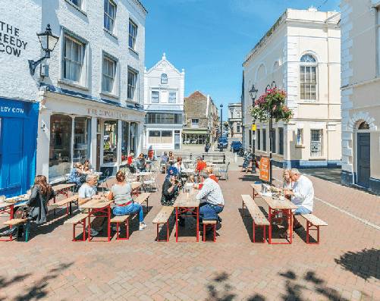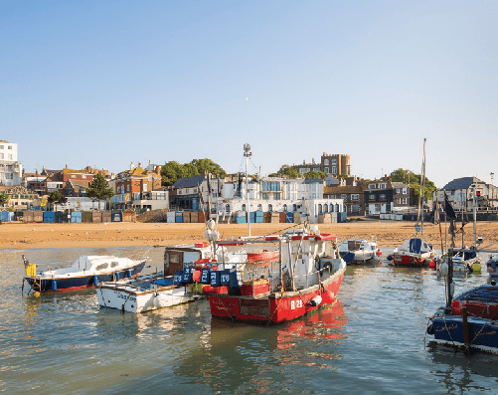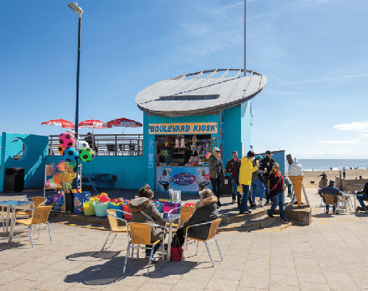
Margate Old Town Broadstairs Harbour Ramsgate Main Sands

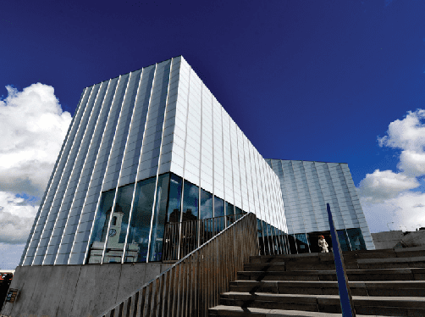
Turner Contemporary, Margate

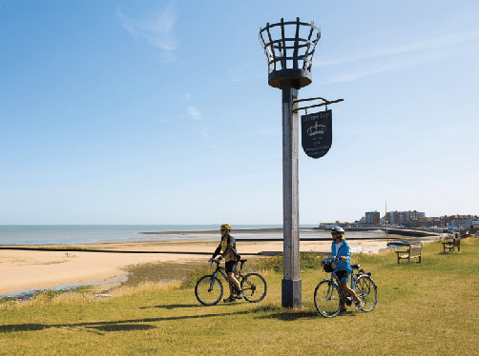
Viking Coastal Trail

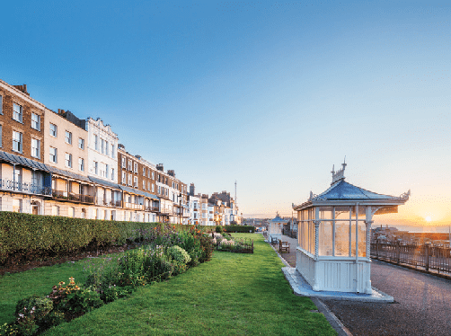
Westcliff, overlooking Royal Harbour, Ramsgate

REVIVAL
In recent years, fashions in holidays have changed once again. Popularity of package holidays has declined in favour of a widening interest in independent travel to more unusual destinations. More people want to be travelers joining the local community rather than tourists.
Concerns about the environmental costs of flying abroad are also heightened and the popularity of the staycation and long-weekend break has increased dramatically. At the same time, people have become more interested in
re- discovering different areas of the UK enabled by the new trend for taking one or two short breaks during the year alongside the main holiday.
There is a growing desire to escape big towns and cities to get outdoors and enjoy the health benefits of walking and cycling, alongside a wealth of water sports. Thanet with its superb coastline and beaches, alongside its history and heritage in three highly distinctive resorts in easy reach of London, is ideally placed to cater for the needs of today’s visitor economy.
Margate captures the fun and entertainment of the Great British Seaside Holiday alongside a cultural and creative revolution inspired by the internationally acclaimed Turner Contemporary gallery and the regeneration of Margate Old Town with a wealth of cafés, galleries and independent shops.
Broadstairs, with its narrow streets, flint-faced cottages and picturesque harbour that would still be recognised by its most famous resident, Charles Dickens, retains its traditional seaside atmosphere including two 1950s-style ice- cream parlours.
Meanwhile, the impressive Georgian and Victorian architecture of Ramsgate, overlooking its historic Royal Harbour and modern marina, reflects its maritime heritage as well as its 18th and 19th century role as a very popular health and leisure destination with the wealthy.

Perhaps reflecting its importance as a port and proximity to Europe, the resort is now famous for its busy waterfront continental café culture.

REGENERATION
Public and private investment in regeneration has seen the arrival of HS1, improvements
to the road infrastructure, development of Ramsgate’s Royal Harbour and marina, and the rebirth of Margate as an internationally acclaimed destination.
Regeneration is totally refreshing the visitor industry in Thanet and bringing benefits to the wider economy across the resorts and their villages.
High Speed 1 links Margate, Broadstairs and Ramsgate to St. Pancras International in 90, 85 and 75 minutes respectively, while other rail services link Thanet to other London stations and mainland Europe (Eurostar) via Ashford International. Cross-Channel services are available from the Port of Dover and Eurotunnel, Folkestone.
There is increased interest in people moving to Thanet, to set up new homes here and as a way of improving their lifestyle.
Thanet is attracting new investment in 21st century boutique hotels, guest houses, restaurants, cafés and outdoor leisure opportunities alongside new and relocating businesses.
The isle now has world class attractions such as Turner Contemporary. Relatively new attractions like Margate Caves, Dreamland and Ramsgate Tunnels, complement traditional favourites such as the Shell Grotto and the Spitfire and Hurricane Memorial Museum.
Turner Contemporary, designed by award- winning architect Sir David Chipperfield, opened to the public 10 years ago in April 2011. Since opening, the gallery has welcomed 3.6 million visits from all over the world.
Thanet District Council was the first local authority in Kent to take up Visit England’s initiative for Destination Management Plans (DMPs). Working with the local tourism industry, the five-year plan was reviewed and a Destination Management Framework (DMF) produced. The (DMF) sets out shared
key priorities for strengthening and growing Thanet’s visitor economy for the next five years, making it more sustainable. Whilst the DMF was prepared prior to the current COVID-19 crisis, the approach and content is still relevant and will help inform the recovery of Thanet’s tourism sector.
Other major initiatives in Thanet will complement the DMF activity and help enhance the quality of life for residents and visitors.
Ramsgate was awarded Heritage Action Zone status by Historic England in April 2017. The five year programme aims to help understand what makes Ramsgate’s heritage really special, to share the findings and stories, and to protect and improve Ramsgate’s heritage for the future. A body of research has been undertaken to raise awareness of the town’s heritage and to inform heritage-led regeneration.
In September 2020, Ramsgate received High Street Heritage Action Zone status. The scheme under development will seek to rescue and transform some of the historic buildings in

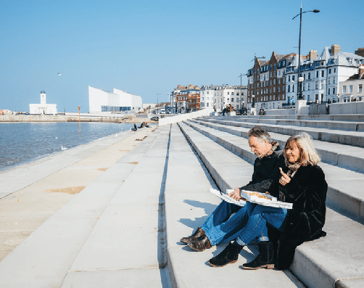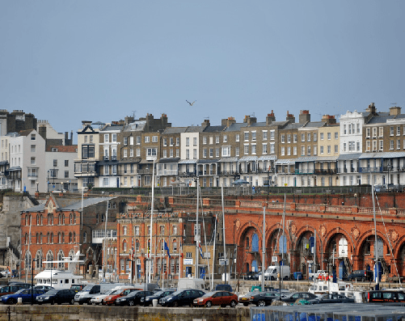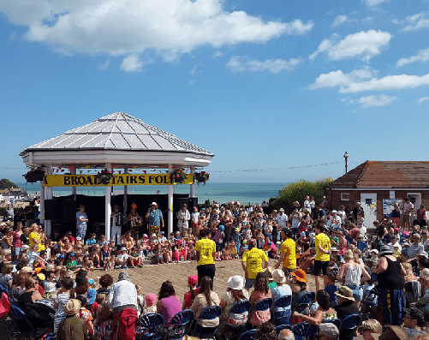
Margate Flood Defences Ramsgate waterfront and Nelson Crescent Broadstairs Folk Week, credit Dylan Woolf

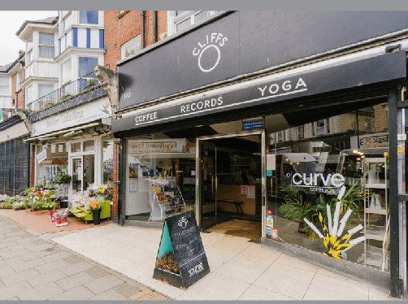
Northdown Road, Cliftonville

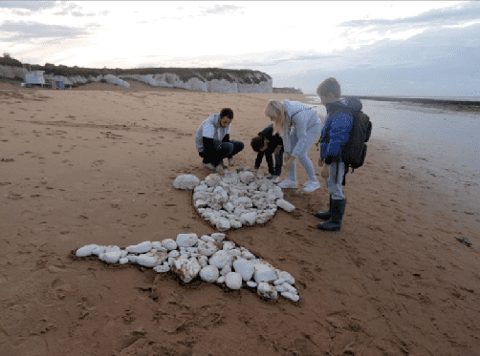
New Experiences

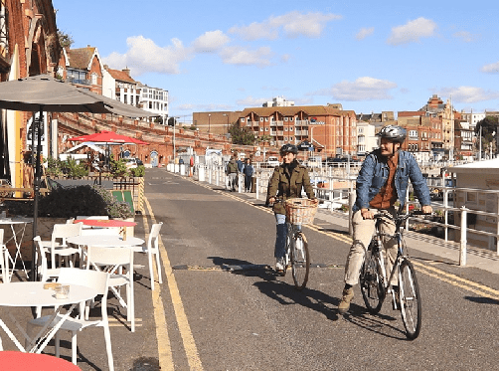
Military Road, Ramsgate
Harbour Street, make improvements to the High Street and repurpose empty buildings for creative and community use.
In December 2020, the Government announced Ramsgate as one of 72 areas across the country to be allocated funds from the £830 million Future High Streets Fund.The aim of the fund
is to renew and reshape town centres and high streets, improving experience, driving growth and ensuring future economic sustainability. The offer for Ramsgate is for just over £2.7m.
Margate was one of 101 towns from across England selected by the Ministry for Housing, Communities and Local Government (MHCLG) to bid for funding as part of the government’s
£3bn.
A ten-year ‘Town Investment Plan’ was submitted to the MHCLG which identified
£29m of investments. It has been confirmed that Margate will receive £22.2m, which will be transformative for the town and act as a
catalyst for future investment and regeneration.
In July 2020, the new Thanet Community Rail Partnership, covering all seven local stations, was one of five in Kent to receive a share of £400,000 from Southeastern. Turner Contemporary leads the project with Thanet District Council and Visit Thanet. The CRP will provide a voice for the community through art and creativity, helping to welcome tourists and encourage sustainable travel. It will also encourage local groups to animate railway
stations and trains and promote the use of cycle networks.
As part of the Interreg funded Experience Product Development Programme, Thanet aims
to have a minimum of 10 new, off-season, bookable experiences to tempt visitors to the isle. The project is a 4-year scheme that runs until the end of August 2023, and is worth £23 million across 10 partners in France and England. Led by Norfolk County Council, both Visit Kent, the destination management organisation for the county, and the Kent Downs AONB, are core partners with distinctive roles underpinned by budgets of £1.6 and £3.1 million respectively.

In the context of the current COVID-19 crisis, this project will be vital activity to help rebuild the tourism sector in Thanet and throughout Kent and the Channel area. The project is also a crucial step in helping to reposition the isle as a ‘coast for all seasons’ and to encourage year- round visits.
Find out more about the regeneration of Thanet at www.visitthanetbusiness.co.uk

There is a full events calendar with long- standing favourites such as Broadstairs Folk Week, Margate Soul Festival and Ramsgate Week. Find out more on www.visitthanet.co.uk
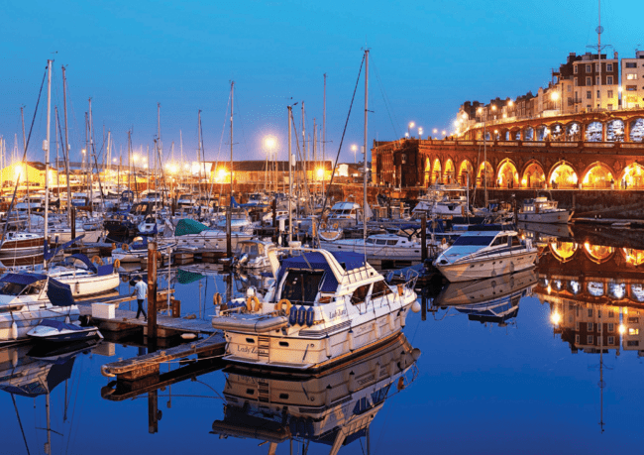

Royal Harbour, Ramsgate
What’s New and Anniversaries 2021

TURNER CONTEMPORARY - 10th ANNIVERSARY YEAR AND NEW EXHIBITIONS
Turner Contemporary opened on 16 April 2011 and since then the gallery has welcomed 3.6 million visits, hosted the Turner Prize 2019 and is featured on the new £20 note. Exhibitions during its10th anniversary year include:
- The Tourists - February – June 2021
- Steve McQueen’s video installation ‘Ashes’ (2002-2015) - February – June 2021
- Barbara Walker’s ‘Place, Space and Who’ - ongoing
- Antony Gormley’s ‘Another Time’ - until 2030
www.turnercontemporary.org

ENGLAND’S CREATIVE COAST 2021 - 1 MAY TO NOVEMBER
As part of England’s Creative Coast and working with Turner Contemporary, Michael Rakowitz will be producing a specially commissioned artwork for Margate.
England’s Creative Coast is a ground-breaking new cultural tourism experience. It aims
to connect outstanding galleries and arts organisations across the Kent, Essex and Sussex coastlines. This will be via seven new site- specific artworks by leading contemporary artists and the world’s first ever art digital geocaching tour.

The project will launch at Turner Contemporary on 1 May. Turner Contemporary leads on the project with Visit Kent (Go to Places) www.turnercontemporary.org/whats-on/ englands-creative-coast/

MURKY MARGATE
A new, guided historical murder town trail in Margate launching in February/March 2021.
Join Johanne Edgington on a guided tour, in and around Margate’s Old Town, to hear tales unfold about the darker side of Margate’s history. Tales include:
- Murder at the Metropole
- Margate’s link to the Chocolate Cream Killer
- A suspicious death off Margate’s jetty
- An unusual discovery in The Parade cinema
- The murder of Mary Ann Bridger www.murky-margate-tours.business.site

BICENTENARY OF THE ‘ROYAL HARBOUR’ RAMSGATE
In 1821 King George IV set off from Ramsgate with the Royal Squadron en route to Hanover. He was so impressed by the hospitality he received at the Kent port that he decreed it be declared a ‘Royal Harbour’ - a status that’s unique in mainland Britain.
Events and activities are being planned to celebrate this anniversary.

Turner Contemporary, Margate

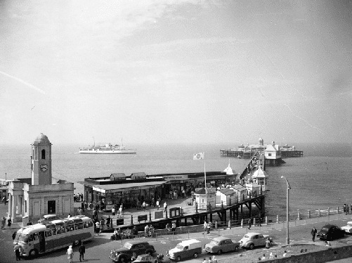
Murky Margate Tours, credit Margate Museum/Thanet District Council

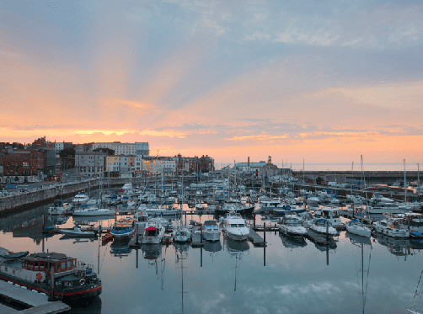
Royal Harbour, Ramsgate

MARGATE CAVES
Whilst it opened towards the end of 2019, Margate Caves is still little-known due to closures as a result of the COVID-19 restrictions.

The Caves were originally dug as a chalk mine in the 18th century. Visitors today can share the rich history of the caves through exhibition and interpretation spaces, which explain how the landscape, ecology and geology of the area has become intwined in the town’s rich social and cultural history.
www.margatecaves.co.uk

CRAB MUSEUM, MARGATE
Crab Museum is a totally new and unique, all- ages visitor attraction opening in the heart of the Old Town in 2021.
Beyond just the science of the seas and the scandalous, forgotten story of the Margate crab, a visit to the Crab Museum will baffle and delight with its combination of philosophy, humour and critical thinking. As well as their
quirky, interactive exhibits, they invite the public to enjoy their cafe and gift shop, and sample their flat whites and lobster repellent!! www.crab.mu

FAGIN’S DEN, BROADSTAIRS
Fagin’s Den is a new, Dickensian themed holiday cottage named after the character Fagin in Oliver Twist. Families and Dickens enthusiasts will step back in time with furniture,
memorabilia, books, games and artwork creating the ambience of the era. Dickensian costumes are supplied to make the experience even more authentic.
To add to the fun, there are two treasure hunts, one for adults and one for children, where the aim is to find Fagin’s hidden stash within the accommodation.
This unique experience will be both fun and educational, with guests discovering more of Dickens’ life, work and his strong connections to Broadstairs.
www.holiday-cottages-broadstairs.co.uk/ fagins-den

THE ALBION ROOMS, MARGATE
English rock band The Libertines opened The Albion Rooms boutique residence overlooking the sea in September 2020. In addition to the seven individually designed rooms, the venue boasts The Restaurant, Arcady Coffee House and The Waste Land, which is the artistic hub of The Albion Rooms and named in homage to the T. S. Eliot poem.
www.thealbionrooms.live

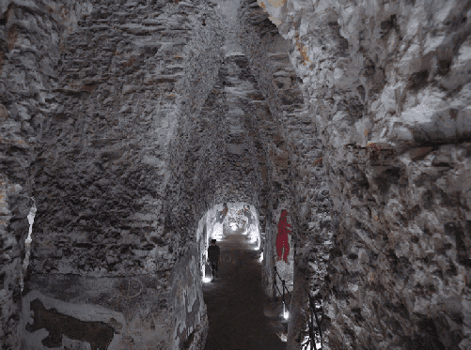
Margate Caves

Crab Museum, Margate

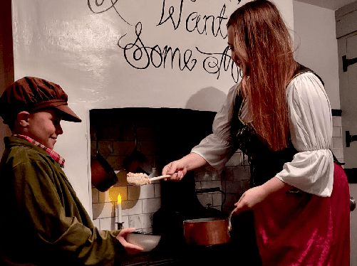
Fagin’s Den, Broadstairs
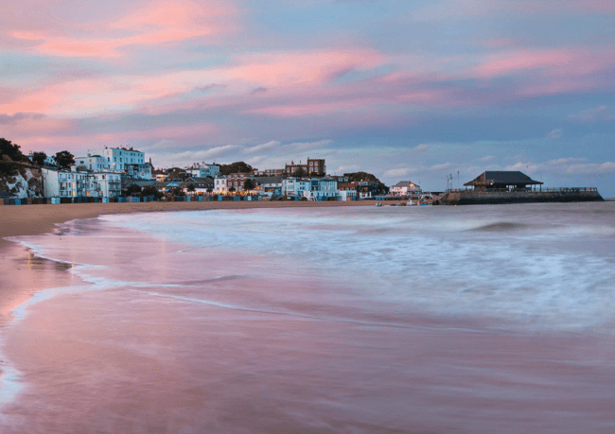

Viking Bay, Broadstairs

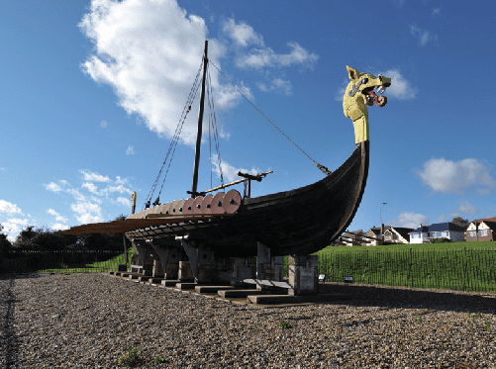
Interesting Facts

Viking Ship Hugin
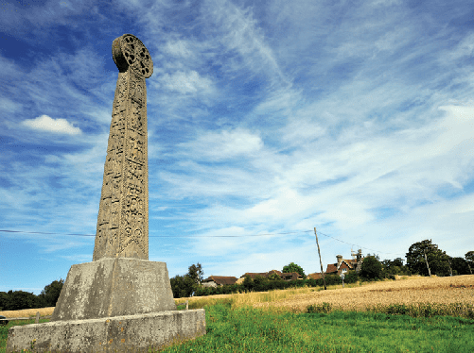

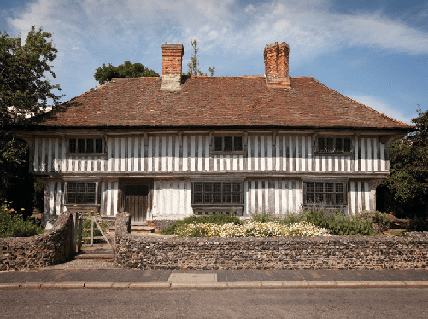
St Augustine’s Cross
Tudor House,Margate
- The Thanet coastline represents 20% of the UKs and 12% of Europe’s coastal chalk and we have the longest continuous stretch of chalk cliffs in Britain.
- The 19 miles of Thanet coastline boasts 10 Blue Flags or Seaside Awards (2021 awards applied for and awaiting confirmation).
- Thanet has 27 conservation areas and over 2,000 listed buildings.
- The whole of the Thanet coastline is designated as part of the ‘North East Kent European Marine Sites’ covering a number of international nature conservations designations. www.nekmpa.org.uk
- Thanet is unique. It is the most easterly of the British Isles and for this reason Stone Age people buried their ancestors here so that they could be nearest to the rising sun.
- Thanet has around 250 hectares of intertidal chalk reef that is home to an array of shorelife from the white bivalve ‘piddock’ shells – which entomb themselves for life there – to seaweeds and vibrant rockpool life.
- The Thanet Coast Marine Conservation Zone designation covers coastal habitats like our blue mussel beds, and rare species like the stalked jellyfish.
- The area has a rich agricultural tradition.
- During the Middle Ages the island was owned by two monasteries of Canterbury, which ran it as a farming estate dominated by massive
churches and administered from monastic granges.
- Even in its early period as a resort, Thanet was considered close to London being conveniently reachable by boat.
Simultaneously it was far enough removed from the capital to allow visitors to feel that they could ‘let their hair down’.
- Thanet has been described as the gateway island since it has been the point of arrival of a succession of continental people and ideas since the earliest human occupation of Britain.
- Thanet was home to both the man who saved Stonehenge for the nation, Lord Lubbock (who was also the inventor of Bank Holidays) and the band most associated with Stonehenge, Hawkwind (who were also the precursors of Punk and New-Age Travellers).
- The Georgian architecture of health and pleasure peppers the district as a monument to the island’s life-enhancing properties and it is no coincidence that Margate pioneered the mixed bathing rebellion among the Edwardian working class; a revolution led by the great Soubrette and Margate-lover Marie Lloyd.
- One of Thanet’s rarest and strangest wildlife can be found at the back of our chalk sea caves – living algal communities cover the sides and back of the caves.

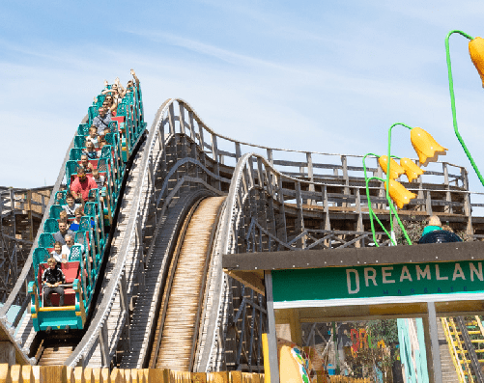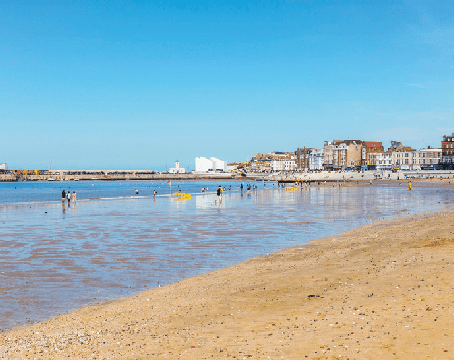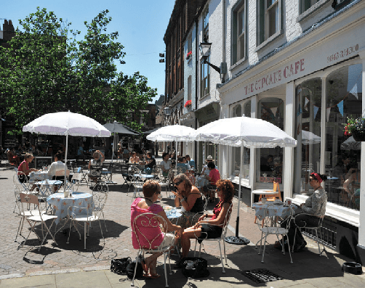
Dreamland, Margate Margate Main Sands Margate Old Town

Our three resorts

MARGATE
Margate is a classic seaside destination with deep roots in the original development of visits to the coast for the health benefits of exhilarating sea air and salt water bathing.
As the passion and fashion for seaside fun and frivolity became more accessible with boat trips from London and the arrival of the railways, Margate and neighbouring Cliftonville became synonymous with family holiday fun, weekend escapes (including romantic liaisons) and daytrips.
Visitors today soak up the sun, sands and sea with all the enthusiasm of previous generations of the bucket ‘n spade brigade as well as a wealth of retro and vintage seaside pleasures presented in 21st century style.
Dreamland is one of the newest additions and celebrates the age of the Great British seaside
amusement experience, including the country’s oldest wooden roller coaster, the Grade II* listed Scenic Railway
Along with the resort’s residents, visitors find themselves at the heart of the cultural and creative arts revolution sweeping along the coast of Kent.
- World class art and cultural exhibitions at Turner Contemporary
- Dreamland, the UK’s original pleasure park
- Margate Old Town, vibrant and expanding creative sector
- Classic seaside heritage
- Grade II listed tidal pool at Walpole Bay
- Hidden gem attractions include Margate Caves, Shell Grotto, Margate Museum, Tudor House, Drapers Windmill and Hornby Visitor Centre
- Two beaches, one with a Blue Flag Award and one with a Seaside Award
- New for 2021, Crab Museum and Murky Margate Tours
- Time and space to relax and enjoy the resort’s famous sunsets, clifftop walks and trails, and contemporary culture
- Independent galleries, vintage and retro hotspots, contemporary and quirky shops along cobbled streets
- Events include POW! Thanet (March),
Mods & 60s Festival, Margate Meltdown (May), Skagate Weekend (July), Soul Festival (August), Rhythm & Rock 2021, Jazz Weekend, Oh So Retro Show (September) and Looping the Loop (October).Music events at Dreamland throughout the year
Further event information can be found on www.visitthanet.co.uk/whats-on
A Margate press pack is available, see back cover.

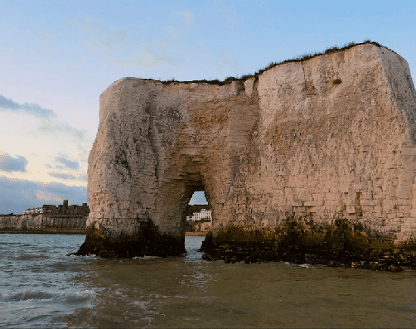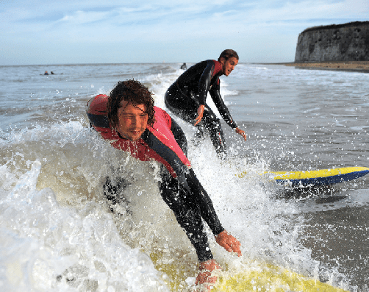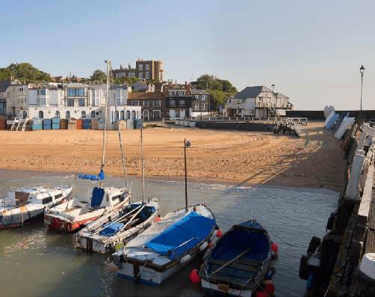
Kingsgate Bay Viking Bay

BROADSTAIRS
Broadstairs succeeds in more than satisfying the needs of today’s generations of short break, weekend visitors and daytrippers who flock to its beaches. This coastal honeypot retains all the charms and features of a traditional seaside destination.
Morelli’s, the quintessential 1950s ice cream parlour, still stands at the top of the chalk cliffs overlooking the flowers planted along the promenade and the gently sloping sands and rock pools of Viking Bay. Charles Dickens, one of the town’s most famous former visitors and resident, would easily recognise the narrow streets and flint walls in the older parts of the
town and the streets winding down to the small fishing harbour.
Throughout the summer demand is high for the town’s many guesthouses and B&Bs, self- catering houses and apartments. As a resort, and a longstanding favourite destination for people

of all ages and interests, Broadstairs has more than held its own and is thriving in the 21st century.
- Seven sand-filled, family-friendly beaches and bays, one with a Blue Flag Award and three with Seaside Awards
- Stunning chalk cliffs including caves and much photographed stacks at Botany Bay
- Closest surfing beaches to London and best in the south east
- Timeless seaside charm
- Traditional fishing harbour, cobbled squares and narrow streets
- Vibrant nightlife economy and exciting eateries
- Classic ice cream parlours and coffee shops
- Clifftop gardens and bandstand
- Clifftop and foreshore strolls, cycling and golf

- Attractions include Dickens House Museum and Crampton Tower Museum
- St. Peter’s Village Tour, guided costumed walk, plus Churchyard and War Graves tours
- Guided Broadstairs Heritage walks
- Events include Blues Bash (February), POW! Thanet (March) ,Dickens Festival (June), Summer entertainment at the Bandstand (July and August), Folk Week (August), Food Festival (September/October) and Looping the Loop (October)
Further event information can be found on www.visitthanet.co.uk/whats-on
A Broadstairs press pack is available, see back cover.

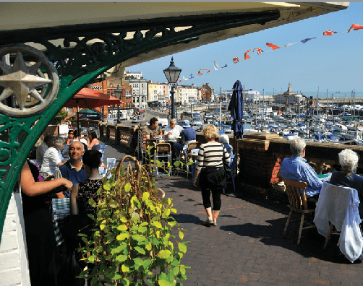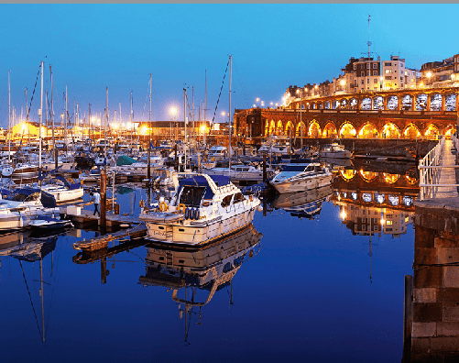
Westcliff Arcade Royal Harbour Ramsgate Tunnels

RAMSGATE
Ramsgate, a favourite seaside destination of Princess Victoria, is an architectural jewel in the coastal crown of the Isle of Thanet.
The town’s long maritime history as a port, with the country’s only Royal Harbour, and its thriving modern marina have contributed to the development of a relaxing Mediterranean-style waterfront filled with a wealth of bustling bistros and restaurants.
The resort’s fine weather, superb sands, sea air and stunning views from the chalk cliffs alongside elegant side streets, independent shops, galleries and seaside entertainments add even more flavour to Ramsgate’s popular café culture.
- UK’s only Royal Harbour, celebrating 200 years of Royal status in September 2021
- One Seaside Award beach, golden sands, famous family-friendly beach, boat trips and clifftop walks

- Modern marina filled with luxury yachts
- Augustus Pugin’s house, The Grange
- St. Augustine & Pugin: Shrine and Visitor Centre
- Mico Museum - the history of personal computing and the inventors of the digital age.
- Elegant Georgian, Regency and Victorian architecture – hundreds of listed buildings
- Ramsgate Tunnels - deep shelter tunnels built to protect civilians duringWWII
- Active Ramsgate - fun and active ways to discover the town by foot, by bike or on the sea
- Thriving continental café culture along the south-facing waterfront
- Fine eateries serving local produce including seafoods

- Retro and contemporary boutique hotels, guesthouses, B&Bs and self-catering
- Italianate Glasshouse
- Petticoat Lane Emporium with over 200 stalls
- Maritime Museum and Steam Tug Cervia
- Rotten Ramsgate and Blitz guided walks, plus Ramsgate guided costumed walks
- Events include POW! Thanet (March), Ramsgate International Film and TV Festival (June), Ramsgate Week (July), Ramsgate Festival of Sound, National Kite Surfing Championships (August/September), Royal Harbour of Ramsgate 200 (September) and Looping the Loop (October)
Further event information can be found on www.visitthanet.co.uk/whats-on
A Ramsgate press pack is available, see back cover.

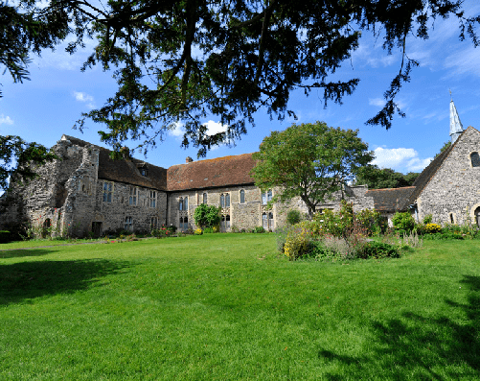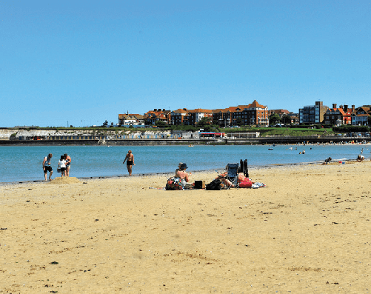
Minster Abbey Spitfire and Hurricane Memorial Museum West Bay

THANET VILLAGES
Just a short distance from the coast visitors discover a treasure chest of delights in Thanet’s traditional villages.

Popular visitor gems include:
- Birchington and Westgate – Coastal villages with Blue Flag beaches at Minnis Bay, West Bay and St.Mildred’s Bay.
- Internationally acclaimed Powell-Cotton Museum, Quex House and Gardens (currently closed and undertaking an exciting ‘Reimagining’ project) www.powell- cottonmuseum.org
- Quex Park Estate with a wide range of attractions including activities for children, farmers market and craft village. Plus full and varied diary of annual events including Big Truck Monster Show in July 2021, www. quexpark.co.uk
- The Spitfire and Hurricane Memorial Museum, Manston, now with a Spitfire cockpit simulator
- RAF Manston History Museum

- MinsterAbbey – possibly the oldest inhabited house in the country near where St.Augustine led the first Christian mass in Britain
- Minster Show – (www.minstershow.org.uk) Since 1886, Minster and neighbouring villages work together to present entertainment, celebrating the success of flower and vegetable growers, cooks, jam and preserve makers and more.
- Monkton Nature Reserve – trails, UK’s first artificial bat cave, fossils and visitor centre
- St.Mary the Virgin Church at Minster – a large Roman Catholic church with 18 fine medieval misericords, which are amongst the best in south east England.

For further media information including packs on Margate, Broadstairs and Ramsgate, press trips and access to up-to-date images, please contact Julie Edwards, Senior Tourism Officer at Visit Thanet, tel: 01843 577671 or email: Julie.edwards@thanet.gov.uk

For further information on the Isle of Thanet, attractions and accommodation go to www.visitthanet.co.uk for visitor stats go to www.visitthanetbusiness.co.uk

@VisitThanet www.visitthanet.co.uk/blog
VISIT THANET

Margate Broadstairs Ramsgate

