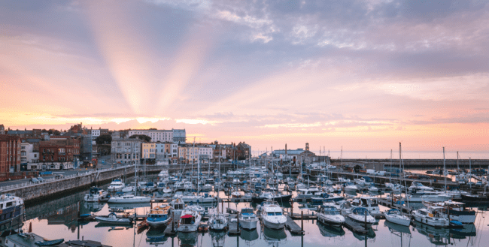
Ramsgate Press Pack www.visitthanet.co.uk

Come to Ramsgate
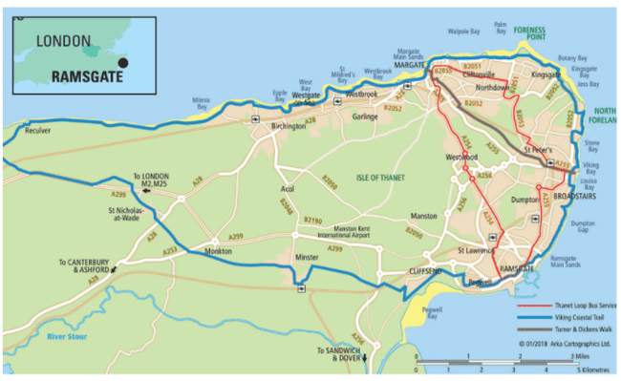
Ramsgate is a seaside resort situated on the Isle of Thanet, the most easterly point in Kent, ‘The Garden of England’.

The resort is easily accessible by train, coach and car. The country’s only high-speed train service, HS1, brings travellers from St Pancras, London, to Ramsgate in just 75 minutes.

There are regular train and bus services, including the Thanet Loop, to the neighbouring resorts of Broadstairs (2 miles/ 3.2km) and Margate (5.3 miles/ 8.5km). The City of Canterbury is 17.3 miles (27.8km) away and the Port of Dover, with its cross-channel services, just 20.5 miles (33km) distant taking the A256. The Eurotunnel terminal at Folkestone is just 34.5 miles (55.5 km) away.

Cyclists are always welcome in Thanet to explore the numerous cycling opportunities including the www.visitthanet.co.uk/cycling
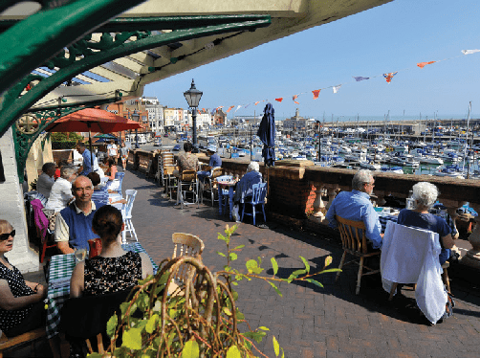
Escape to Ramsgate

Westcliff Arcade

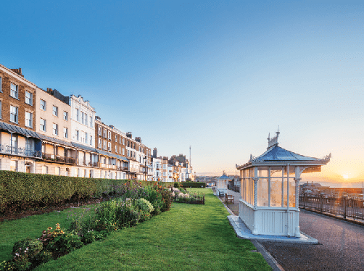
Elegant Architecture

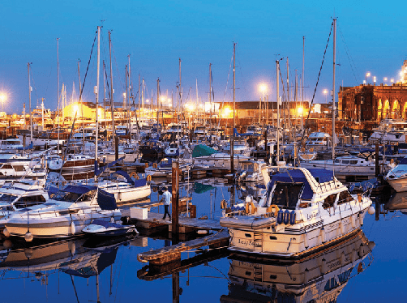
Royal Harbour
- UK’s only Royal Harbour, celebrating 200 years of Royal status in September 2021
- Elegant Georgian, Regency and Victorian architecture – hundreds of listed buildings
- Seaside Award beach, golden sands, famous family-friendly beach and bay, boat trips and clifftop walks
- Modern marina filled with a vibrant mix of luxury yachts, houseboats and working vessels
- Thriving continental café culture along the waterfront, cosmopolitan atmosphere
- Fine eateries serving local produce including seafoods
- Retro and contemporary boutique hotels, guesthouses, B&Bs, self-catering
- Ramsgate, a favourite destination for Princess Victoria, is an architectural jewel in the coastal crown of the Isle of Thanet on the north eastern edge of Kent – the Garden of England
- Major attractions alongside hidden gems
- Growing reputation as a great place to visit for an active break
The importance of the town’s long maritime history as a port, and its fine hospitality, were recognised by King George IV when he awarded the harbour Royal status – a unique accolade in mainland Britain

He was particularly impressed by the harbour, the warm welcome and the hospitality he received when he set off from Ramsgate with the Royal Squadron for Hanover in 1821.

Today the historic harbour and its thriving modern marina are the perfect setting for a relaxing Mediterranean-style waterfront filled with a wealth of bustling bistros and restaurants.

The resort’s fine weather, superb sands, sea air and stunning views from the chalk cliffs alongside elegant side streets, independent shops, galleries and seaside entertainments add even more flavour to the resort’s popular café culture.

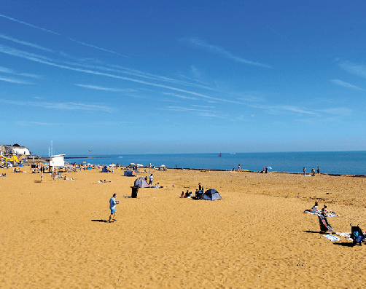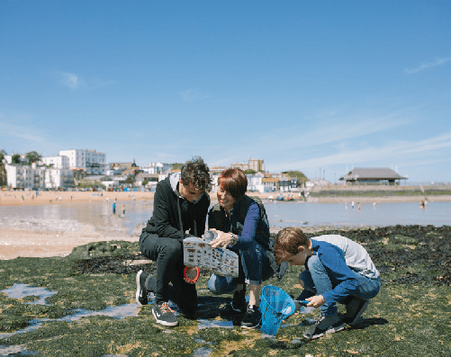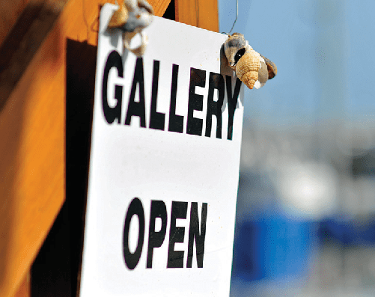
Ramsgate Main Sands Coastal Explorer Packs Galleries

Beaches, Bays and Royal Harbour Galleries
Ramsgate Main Sands – a south-facing, Seaside Award winning, spacious, sandy beach, next to the Royal Harbour, is popular throughout the day and into the long summer evenings. The beach is popular with families and swimmers of all ages. Plenty of beach activities to enjoy
with ice creams and fish ‘n chips readily available just a few steps away.
Western Undercliff – a beach with tidal pools which is backed by high chalk cliffs.
Pegwell Bay – a rewarding destination for landscape lovers, geologists seeking rare cliff faces, birdwatchers, photographers and outdoor enthusiasts. Country park.
Discover more of Thanet’s award-winning beaches and bays at www.visitthanet.co.uk/beaches-bays
(2021 Awards applied for and awaiting confirmation)
Ramsgate Royal Harbour www.portoframsgate.co.uk - historic buildings nestled around a working harbour. The port was at the heart of WW2’s Operation Dynamo
when the ‘little ships’ helped rescue troops from the beaches of Dunkirk. The stunning Marina has a Four Gold Anchor Award with 700 berths serviced by first class facilities.

Coastal Explorer Packs
All you need to explore Margate, Broadstairs and Ramsgate, linking coastal delights and great heritage. Explorer packs include trails, historic maps, binoculars, compass, rock pooling nets and marine life identification sheets. www.visitthanet.co.uk/coastalexplorers
Beach within Reach is a small Thanet-based charity that provides all-terrain wheelchairs to some of the beautiful beaches around the Isle of Thanet. www.beachwithinreach.org.uk
Ramsgate’s numerous galleries offer a wide range of artworks and crafts, many inspired by the Thanet coast and the surrounding countryside, to suit all tastes.
Look out for:
Something Fishy – The Little Arch Gallery with ceramics and crafts by Suzy Curtis www.facebook.com/somethingfishy1

York Street Gallery www.yorkstreetgallery.co.uk;

McGillan & Woodell www.mcgillanandwoodell.co.uk;

The Gallery @ Nice Things www.thegallerynicethings.co.uk and Silverland Studios www.joe-allen.de/joewp

Attractions

The Ramsgate Tunnels www.ramsgatetunnels.org – the UK’s largest network of civilian wartime tunnels. The tunnels were capable of sheltering 60,000 people in WW2. Guided tours bring the history of the tunnels into the 21st century.
The Micro Museum www.themicromuseum.org
– a celebration of vintage computers, video gaming and micro-electronics and their roles in our lives.
The Grange www.landmarktrust.org.uk – the first ‘modern-house’ designed and lived in by architect Augustus Pugin, who designed the interiors of the Houses of Parliament. The Grange, now Grade I listed, is on the clifftop with stunning views.
St. Augustine & Pugin: Shine & Visitor Centre www.augustinepugin.org.uk - the place to discover the life of St.Augustine, who brought Christianity to England and became the first Archbishop of Canterbury, and the distinctive designs of architect Augustus Pugin.
Italianate Glasshouse www.facebook.com/italianatetea – an early 19th century delight constructed for Sir Moses Montefiore and now exquisitely restored.
Montefiore Mausoleum www.ramsgatemontefioreheritage.org.uk – a replica of Rachel’s Tomb on the road from Jerusalem to Bethlehem. The tomb is the resting place of Sir Moses Montefiore, Jewish campaigner and great philanthropist, and his wife Judith, Lady Montefiore.
Petticoat Lane Emporium www.petticoatemporium.com - offers 202 stalls, three shops filled with vintage, retro, craft and antique goods.
St.Augustine’s Cross www.englishheritage. org.uk – the 19th century cross with
Saxon design, marking where it is thought the missionary Augustine landed in AD 597, bringing Christianity to England.
Spitfire and Hurricane Memorial Museum www.spitfiremuseum.org.uk and RAF Manston History Museum www.rafmanston.co.uk - an RAF airfield was established at Manston in 1916. Manston served as a forward airbase in the Battle of Britain. The museums capture the lives of the pilots and the challenges they faced. Genuine aircraft on site to admire. The Spitfire and Hurricane Museum features a full-size Spitfire cockpit simulator.
The Hugin Viking Ship at Pegwell Bay, near the popular nature reserve, is a longstanding family favourite.
Maritime Museum www.ramsgatemaritimemuseum.org – recording the harbour’s seafaring history and including Ramsgate’s own Meridian – five minutes and 41 seconds ahead of GMT.
Steam Tug Cervia Discover the history of this hard-working 320 tonne vessel and the people who served on board. Open to visitors during summer weekends.

Ramsgate Tunnels

Pugin Tomb at St.Augustine’s Church. Photo: Ludmila Griffin

Spitfire and Hurricane Museum

Outdoor Adventures
Active Ramsgate showcases the attractive coastal location of Ramsgate through a range of inspiring walks, cycle routes, canoe and kayak trails, pickleball, tennis, golf and bird watching tours created to capture the unique combination of sandy beaches and bays, heritage, wildlife and vibrant café culture found in the microclimate of south-eastern Kent. www.ramsgatetown.org/activeramsgate
Head out on bike or on foot along the 32-mile (51.4 km) Viking Coastal Trail and discover dramatic scenery and a wealth of local historical gems. The trail can be split into smaller themed sections and is also known as Regional Route 15 of the National Cycle Network www.visitthanet.co.uk/cycling

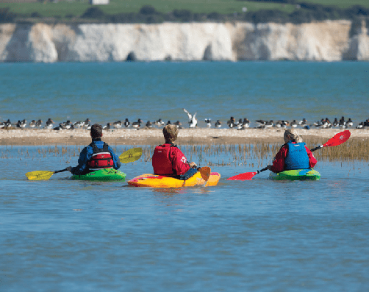
Guided canoe trip

Digital Discoveries Plaques
Three eye-catching new plaques can be seen at key locations across Ramsgate. The plaques tease the reader to discover more than the bite-sized information offered - by entering a code into their mobile device, the location and its stories come alive through video, audio and imagery. www.visitthanet.co.uk/digitaldiscovery
Join a Costumed Walk to uncover Ramsgate’s history and meet famous characters from the past, or visit the places and hear the stories
of the dark days of WWII on a Blitz Walk - Ramsgate was the heaviest bombed seaside town in the country.
Rotten Ramsgate guided walks tell the story of historical murders in the town between 1651 and 1930. www.rottenramsgate.weebly.com
The town’s history and architecture can be discovered further on a variety of self-guided walks including a Pugin Town Trail, tracing Augustus Pugin’s architectural legacy, a

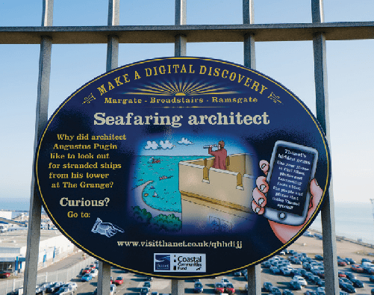

Digital Discoveries Plaques

Montefiore Heritage Walk or the Military and Heritage Trail. www.visitthanet.co.uk/walking
Boat trips www.go2sea.co.uk www.seasearcher.co.uk or www.ramsgatefishingcharters.co.uk – seal trips, harbour tours, fishing or offshore windfarm trips.
Sandwich & Pegwell Bay National Nature Reserve www.kentwildlifetrust.org.uk – In winter, thousands of wading birds gather here. In summer, orchids and other wild flowers flourish in the grasslands.
Golfing opportunities include www.staugustinesgolfclub.co.uk www.manstongolfcentre.co.uk and www.stonelees.com. There is also the fun filled Rascal Bay Mini Golf www.rascalbay.co.uk featuring huge dinosaurs.

Rascal Bay

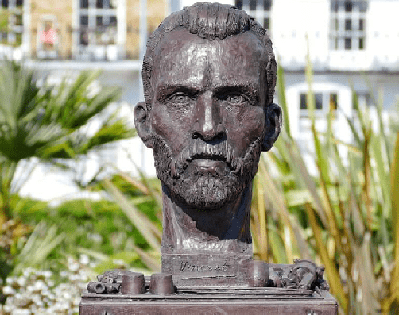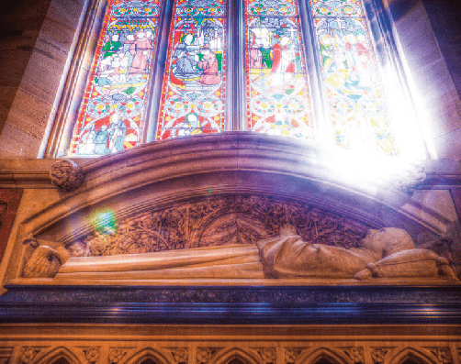
Ramsgate Music Hall - credit Dik Ng Vincent Van Gogh statue - credit Frank Leppard St.Augustine’s Church

Entertainment
Look out for impromptu entertainments on the waterfront overlooking Ramsgate Royal Harbour, after enjoying the many outdoor activities on offer.
Ramsgate Music Hall www.ramsgatemusichall.com – an intimate venue with a capacity of just 130, offering a passionate music experience.

Artistic impressions
Princess Victoria enjoyed visiting and staying in the resort and, as Queen, she was eager to capture those memories and buy William Powell Frith’s popular painting Ramsgate Sands (Life at the Seaside) completed in the 1850s.
Artist Vincent Van Gogh taught at a local school when he was 23 years old and made his home at Spencer Square. In 2019, a ‘Bronze Finish’ bust of the artist, gifted by renowned sculptor Anthony Padgett, was unveiled at Spencer Square.
Karl Marx (1818-1833) stayed in the town on several occasions, as did his mentor and supporter Frederik Engels. His daughter, the writer and activist Eleanor Marx, also lived here.
Jane Austen’s brother, Frances Austen (1774- 1865), who served as Admiral of the Fleet, lived in Ramsgate. Jane Austen visited him here and in her novel Pride and Prejudice Georgiana Darcy spends a summer in the town.

Victorian Gothic architect Augustus Pugin created his family home at The Grange. Pugin’s son Edward completed the work his father had started at St Augustine’s Church.
A Blue Plaque in Wellington Crescent marks the lodgings of Samuel T Coleridge (1772-1834) poet and author famed for The Rime of the Ancient Mariner.
A plaque in Nelson Crescent records time spent in the town by Wilkie Collins (1824-1889) author of detective novels The Moonstone and The Woman in White.
Other celebrated residents include: Anthony Buckeridge (1912-2004) author of the Jennings school stories; actor John Le Mesurier (1912- 1983) much remembered as Sgt.Wilson in the BBC comedy series Dad’s Army; and Golden Globe winner and Academy Award nominee Brenda Blethyn.

Annual events

Great Bucket and Spade Run

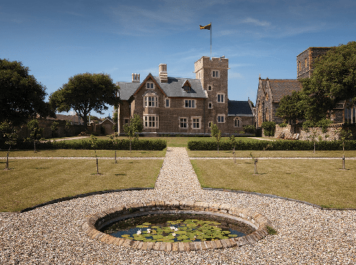
Pugin’s The Grange

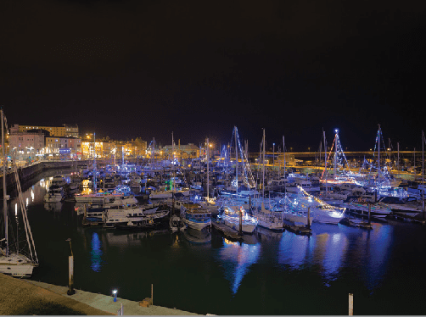
Ramsgate Illuminations

MAY/JUNE
St Augustine Week – a festival of activities celebrating Augustine of Canterbury who landed near Ramsgate in 597AD and became the first Archbishop of Canterbury
www.augustine-pugin.org.uk/

JUNE (first Sunday)
The Great Bucket and Spade Run – presented by the Ramsgate Old Motor and Motorcycle Club. Classic vehicles dating from the 1920s to the 21st century head to
Government Acre. Over 350 cars participated in 2019.
https://www.rommcc.org/

JUNE
Ramsgate International Film and TV Festival – the festival showcases new works, helps promote film-makers and encourages people to view and appreciate independent cinema.
www.ramsgateiftvfest.org

JULY
Ramsgate Week – is the Royal Temple Yacht Club’s annual international regatta, known as the friendly alternative to Cowes, plus special events and entertainments around the harbour and waterfront. www.ramsgateweek.com
Ramsgate Festival – is a feast of creative and performance workshops, exhibitions, film, theatre and dance at venues across the resort. www.ramsgatefestival.org

AUGUST/SEPTEMBER
Ramsgate Festival of Sound – Ramsgate Festival of Sound presents ‘Stories From The Sea’ celebrating the 200th anniversary of the Royal Harbour through it’s Sonic Trail, Busk at Dusk, heritage talks, family entertainment and music! https://ramsgatefestival.org/
Royal Harbour 200th Anniversary – In 1821 King George IV set off from Ramsgate with the Royal Squadron en route to Hanover. He was so impressed by the hospitality he received at the Kent port that he decreed it be declared a ‘Royal Harbour’ - a status that’s unique in mainland Britain.
Events and activities are being planned to celebrate this anniversary. www.ramsgate2021.co.uk

SEPTEMBER
Heritage Open Days – explore behind the scenes in historic and heritage buildings many of which are not usually open to the public. www.heritageopendays.org.uk

DECEMBER
Ramsgate Illuminations – Memorable displays of Christmas lights in Ramsate’s Royal Harbour and across the resort.

Events might be subject to cancellation or change due to Covid-19 and changing restrictions.
Further event information can be found on www.visitthanet.co.uk/whats-on

Food and drink, where to stay
As King George IV noted, Ramsgate has a long tradition of providing great hospitality for all its guests. Today that tradition flourishes.

ON THE MENU?
Restaurants and cafes across the town serve local fish and seafoods, often alongside chips made with Thanet potatoes. Cannon’s fishmongers and seafood stall at Ramsgate
Harbour sells locally caught fish and shellfish, including cockles and whelks.
Meanwhile, as well as a growing range of wines, ciders and fruit juices produced in Kent readily available, there are plenty of opportunities
to sample Gadds No 3 from the Ramsgate Brewery which won Kent Beer of the Year in the Taste of Kent Awards 2020.
Four Ramsgate pubs feature in the Good Beer Guide 2021 and whilst they all serve good beer, they offer different pub experiences. The Montefiore Arms is a true, old fashioned backstreet pub with a friendly atmosphere;

Arya
The Red Lion is a busy pub in the heart of the town centre; The Artillery Arms
boasts artillery prints, memorabilia and listed windows depicting Napoleonic scenes, and Wetherspoons’ The Royal Victoria Pavilion, originally built as a concert hall/assembly rooms, is a Grade II listed building and striking example of seaside architecture, right next to the beach.
Located above The Ravensgate Arms pub in King Street is Arya, a family run, small plates, tapas restaurant awarded a Michelin Bib Gourmand in 2020.
Look out too for Sorbetto Ice Cream Parlour, at Harbour Parade, with its freshly-made traditional recipes and a wealth of different flavours. www.sorbetto.co.uk

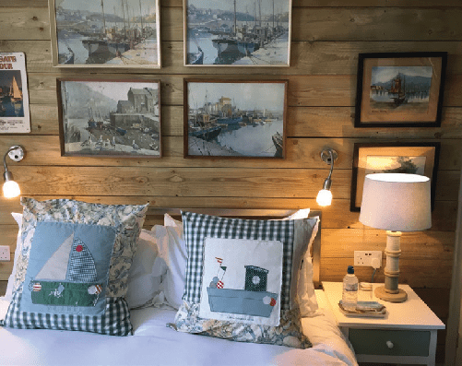
WHERE TO STAY?
Ramsgate has a long tradition of providing a warm welcome.
The visitor accommodation offering ranges from stylish clifftop hotels with stunning sea views, quality guest houses and B&Bs, great value
self-catering town-houses and cosy cottage to a family-run campsite
Find out more about quality places to stay in Ramsgate at www.visitthanet.co.uk

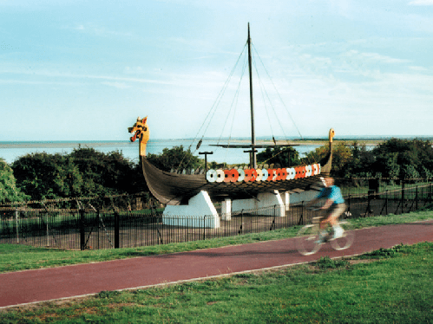
Roots, revival and regeneration

Viking Ship Hugin

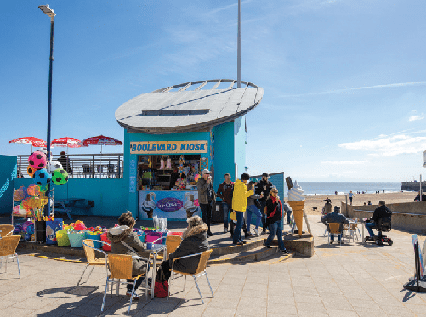
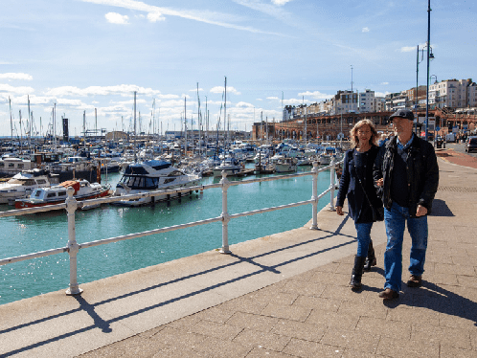
Ramsgate Town
Ramsgate’s roots lie in fishing, boat building and farming – a history still reflected in the town’s passion for local produce and fish dishes.
Construction of the Royal Harbour started in the mid-18th century and finished approximately 100 years later. Much of the fine maritime architecture around the harbour – the main embarkation point for the Napoleonic Wars – still stands today.
The town was perfectly placed to be adopted as a fashionable health and pleasure destination by the wealthier aristocracy during the 18th century with many aspiring to have a second residence at the seaside.
Development of the railways in the mid-19th century made the town and its beaches even more accessible to holiday makers, group excursions and day trippers from the capital and beyond. The growing number of tourists gave a welcome boost to the local economy well into the 20th century.
Today, Ramsgate’s many visitors are a new generation of weekend breakers, day trippers, family holiday-makers, and outdoor enthusiasts for walking, cycling, watersports and sailing, second homers and boat owners taking advantage of the marina and its service trades.
Their enthusiasm for coastal escapes, staycations and short breaks away from major towns and cities in exhilarating landscapes is rapidly regenerating Thanet’s three distinctive resort towns and their neighbouring villages.
Exciting 21st century attractions, entertainments, outdoor activities and events are now on offer alongside state-of-the-art boutique hotels, B&Bs, waterfront cafés, bistros and restaurants.
The revival of Ramsgate’s visitor economy is greatly enhancing the quality of life for the town’s 44,000 plus residents, and leisure and pleasure seekers alike.
Ramsgate was awarded Heritage Action Zone status by Historic England in April 2017. The five-year programme aims to help understand what makes Ramsgate’s heritage really special, to share the findings and stories, and to protect and improve Ramsgate’s heritage for the future.
A body of research has been undertaken to raise awareness of the town’s heritage and to inform heritage-led regeneration. https://historicengland.org.uk/images-books/ publications/ramsgate-town-and-seaside- heritage/
In September 2020, Ramsgate received High Street Heritage Action Zone status. The scheme under development will seek to rescue and transform some of the historic buildings in Harbour Street, make improvements to the High Street and repurpose empty buildings for creative and community use. www.thanet.gov.uk/info-pages/ramsgate- heritage-action-zone/

In December 2020, the Government announced Ramsgate as one of 72 areas across the country to be allocated funds from the £830 million Future High Streets Fund.The aim of the fund is to renew and reshape town centres and high streets, improving experience, driving growth and ensuring future economic sustainability. The offer for Ramsgate is for just over £2.7m.
Ellington Park’s Regeneration Project, funded by the National Lottery Heritage Fund, will renovate the bandstand; restore features of the original 1893 Joseph Cheal landscape scheme; improve play facilities; and provide a cafe and toilets. Further information can be found at www.thanet.gov.uk/info-pages/ellington-park- regeneration-scheme

In association with Turner Contemporary, Conrad Shawcross will display a new commissioned artwork designed by local primary school children. Created for Ramsgate Royal Harbour, the commission is part of the ambitious multi-year project, Pioneering Places which encourages local people to get involved with cultural organisations and shape the area where they live. He was commissioned for the project by over 60 children from two Ramsgate primary schools who asked the artist to respond to the themes of ‘play and playfulness’, ‘caring’ and ‘modern machinery’. The resulting work will be a series of bright, modular, mechanical disks, to be placed near the bandstand area.

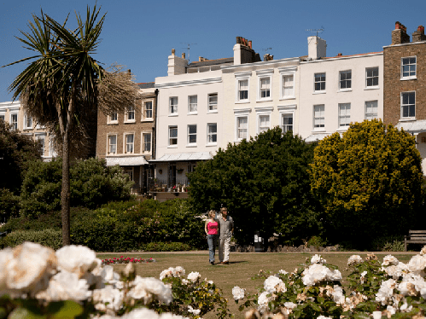
Madeira Gardens

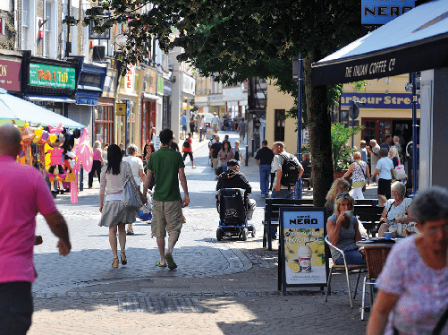
Ramsgate Town

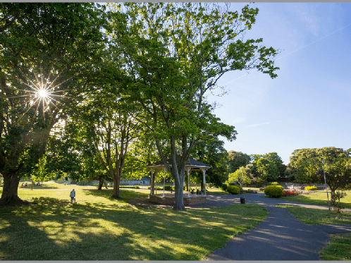
Ellington Park

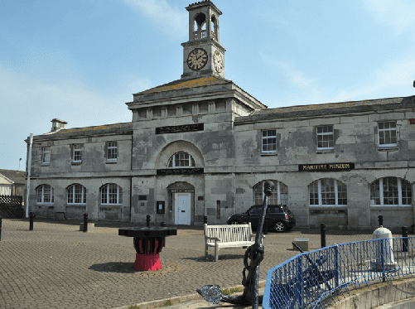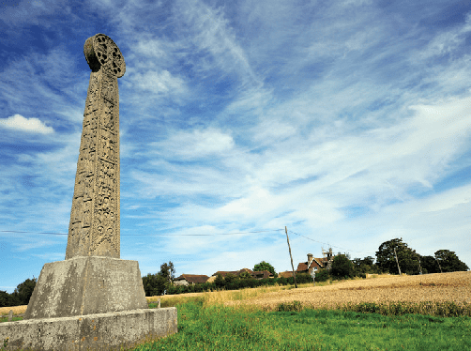
Maritime Museum

Did you know?
  - The earliest naming of the town in the later 13th century refers to Remmesgate. The name is believed to be from the late Anglo Saxon hremmes, meaning raven, and gate for a gap in the cliffs. In the 14th century the town was referred to as Ramesgate.
  - Ramsgate was a member of the Confederation of Cinque Ports.
  - Ramsgate is an amalgamation of two settlements – a fishing community on the coast and an inland farming community at St Lawrence.
  - An international hoverport used to be based at Pegwell Bay offering speedy Channel crossings to France.
  - In WW1 Ramsgate suffered the first air raids from Zeppelins.
  - The Sailor’s Church and Harbour Mission, close to the foot of Jacob’s Ladder, was built in 1878 by Canon Eustace Brenan.
Pugin’s The Grange

- The Rolling Stones performed at Ramsgate’s West Cliff Hall to raise funds for the town’s football club in 1964.
- St George’s Church, a Grade I listed building just off the High Street, has a lantern turret on its west tower, funded by Trinity House, which is used as a navigation aid.
- The popular 19th century Paris society artist James Tissot visited and painted in Ramsgate. A pen and ink drawing in the Tate collection shows a room overlooking the seaside town.
- The English novelist and playwright Wilkie Collins stayed at 14 Nelson Crescent in the 1870s.
- Ramsgate has its own Meridian Line and ‘mean time’, being 5 minutes and 41 seconds faster than Greenwich Mean Time. This can be seen at the Maritime Museum.
- In 597AD St.Augustine’s arrival marked the introduction of Christianity to this country.
St Augustine’s Cross

- St.Augustine was the first Archbishop of Canterbury. St.Augustine’s Cross marks the area where he is thought to have landed.
- Augustus Pugin and Sir Moses Montefiore both chose Ramsgate as the place to build their ideal communities.

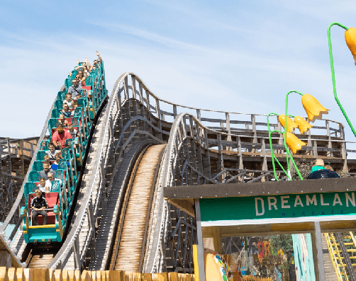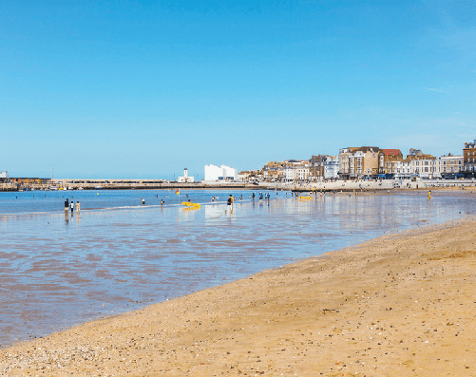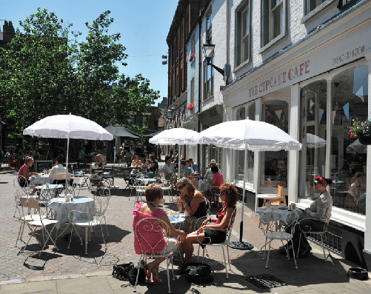
Dreamland, Margate Margate Main Sands Margate Old Town

So close

MARGATE
Margate is a classic seaside destination with deep roots in the original development of visits to the coast for the health benefits of exhilarating sea air and salt water bathing.
As the passion and fashion for seaside fun and frivolity became more accessible with boat trips from London and the arrival of the railways, Margate and neighbouring Cliftonville became synonymous with family holiday fun, weekend escapes (including romantic liaisons) and daytrips.
Visitors today soak up the sun, sands and sea with all the enthusiasm of previous generations of the bucket ‘n spade brigade as well as a wealth of retro and vintage seaside pleasures presented in 21st century style.
Dreamland is one of the newest additions and celebrates the age of the Great British seaside
amusement experience, including the country’s oldest wooden roller coaster, the Grade II* listed Scenic Railway
Along with the resort’s residents, visitors find themselves at the heart of the cultural and creative arts revolution sweeping along the coast of Kent.
- World class art and cultural exhibitions at Turner Contemporary
- Dreamland, the UK’s original pleasure park
- Margate Old Town, vibrant and expanding creative sector
- Classic seaside heritage
- Grade II listed tidal pool at Walpole Bay
- Hidden gem attractions include Margate Caves, Shell Grotto, Margate Museum, Tudor House, Drapers Windmill and Hornby Visitor Centre
- Two beaches, one with a Blue Flag Award and one with a Seaside Award
- New for 2021, Crab Museum and Murky Margate Tours
- Time and space to relax and enjoy the resort’s famous sunsets, clifftop walks and trails, and contemporary culture
- Independent galleries, vintage and retro hotspots, contemporary and quirky shops along cobbled streets
- Events include POW! Thanet (March), Mods & 60s Festival, Margate Meltdown (May), Skagate Weekend (July), Soul Festival, Margate Pride (August), Rhythm & Rock 2021, Jazz Weekend, Oh So Retro Show (September) and Looping the Loop (October).Music events at Dreamland throughout the year
Further event information can be found on www.visitthanet.co.uk/whats-on
A Margate press pack is available, see back cover.

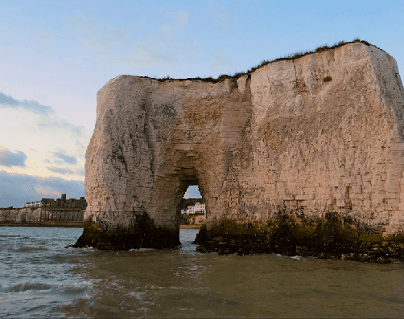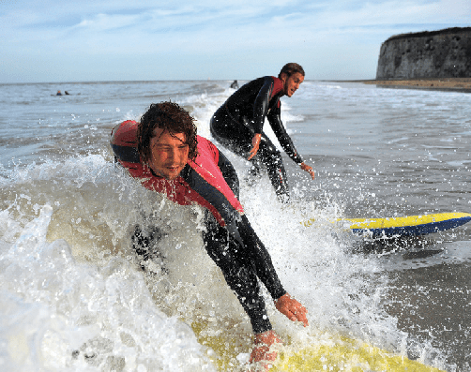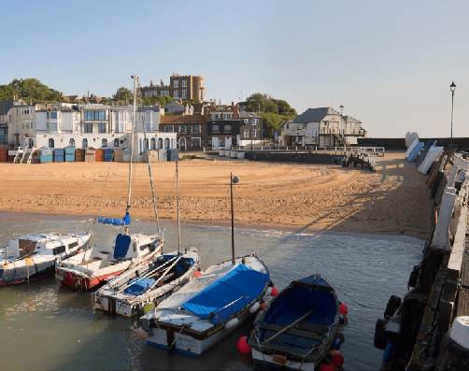
Kingsgate Bay Viking Bay

BROADSTAIRS
Broadstairs succeeds in more than satisfying the needs of today’s generations of short break, weekend visitors and daytrippers who flock to its beaches. This coastal honeypot retains all the charms and features of a traditional seaside destination.
Morelli’s, the quintessential 1950s ice cream parlour, still stands at the top of the chalk cliffs overlooking the flowers planted along the promenade and the gently sloping sands and rock pools of Viking Bay. Charles Dickens, one of the town’s most famous former visitors and residents, would easily recognise the narrow streets and flint walls in the older parts of the town and the streets winding down to the small fishing harbour.
Throughout the summer demand is high for the town’s many guesthouses and B&Bs, self- catering houses and apartments. As a resort, and

a longstanding favourite destination for people of all ages and interests, Broadstairs has more than held its own and is thriving in the 21st century.
- Seven sand-filled, family-friendly beaches and bays, one with a Blue Flag Award and three with Seaside AwardsStunning chalk
cliffs including caves and much photographed stacks at Botany Bay
- Closest surfing beaches to London and best in the south east
- Timeless seaside charm
- Traditional fishing harbour, cobbled squares and narrow streets
- Vibrant nightlife economy and exciting eateries
- Classic ice cream parlours and coffee shops

- Clifftop gardens and bandstand
- Clifftop and foreshore strolls, cycling and golf
- Attractions include Dickens House Museum and Crampton Tower Museum
- St. Peter’s Village Tour, guided costumed walk, plus Churchyard and War Graves tours
- Guided Broadstairs Heritage walks
- Events include Blues Bash (February), POW! Thanet (March), Dickens Festival (June), Summer entertainment at the Bandstand (July and August), Folk Week (August), Food Festival (September/October) and Looping the Loop (October)
Further event information can be found on www.visitthanet.co.uk/whats-on
A Broadstairs press pack is available, see back cover.

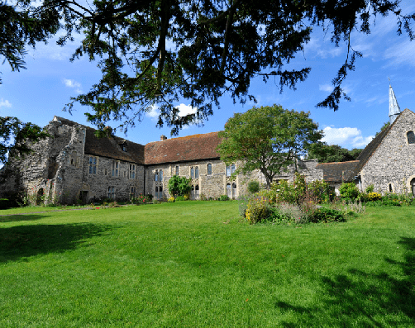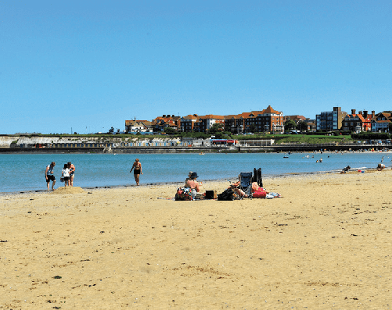
Minster Abbey Spitfire and Hurricane Memorial Museum West Bay

THANET VILLAGES
Just a short distance from the coast visitors discover a treasure chest of delights in Thanet’s traditional villages.

Popular visitor gems include:
• Birchington and Westgate – Coastal villages with Blue Flag beaches at Minnis Bay, West Bay and St.Mildred’s Bay.
• Internationally acclaimed Powell-Cotton Museum, Quex House and Gardens (currently closed and undertaking an exciting ‘Reimagining’ project) www.powell- cottonmuseum.org
• Quex Park Estate with a wide range of attractions including activities for children, farmers market and craft village. Plus full and varied diary of annual events including Big Truck Monster Show in July 2021, www. quexpark.co.uk
• The Spitfire and Hurricane Memorial Museum, Manston, now with a Spitfire cockpit simulator
• RAF Manston History Museum

- MinsterAbbey – possibly the oldest inhabited house in the country near where St.Augustine led the first Christian mass in Britain
- Minster Show – (www.minstershow.org.uk) Since 1886, Minster and neighbouring villages work together to present entertainment, celebrating the success of flower and vegetable growers, cooks, jam and preserve makers and more.
- Monkton Nature Reserve – trails, UK’s first artificial bat cave, fossils and visitor centre
- St.Mary the Virgin Church at Minster – a large Roman Catholic church with 18 fine medieval misericords, which are amongst the best in south east England.

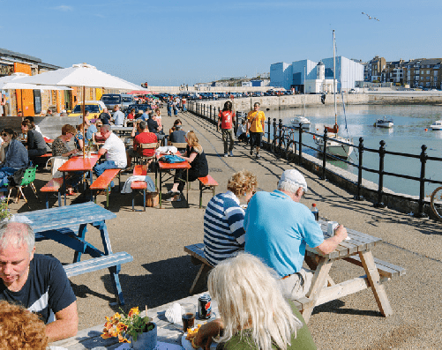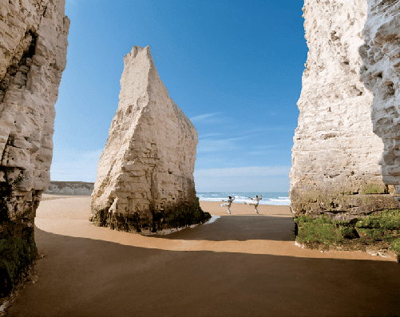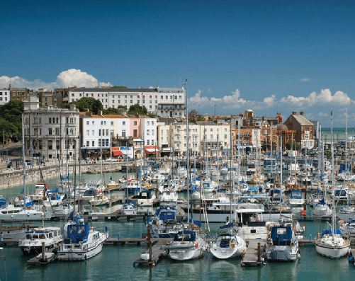
Margate Harbour Arm Botany Bay Royal Harbour, Ramsgate

Why visit?
Londoners have been escaping to the Isle of Thanet for more than 200 years … for the laidback seaside vibe … breathtaking sandy beaches … fresh sea air… and romantic Turner skies …
Here at the very edge of the Garden of England, three Georgian and Victorian resorts, each with its own distinctive character – Margate, Broadstairs and Ramsgate – cluster around the bays at the far end of a peninsula.
There’s a quirky and convivial feel to these harbour towns, with their friendly creative scene, their remarkable 18th and 19th century architecture, their classic seaside heritage, their eclectic attractions and events, their galleries and music venues large and small, and their special one-off places to eat, drink, shop and stay, year round.
Miles of low chalk cliffs edge the peninsula, sheltering a string of secluded, unspoilt
sandy bays. Chalk rockpools, chalk stacks and rare chalk reefs teem with wildlife.
These are the closest surfing beaches to the capital city: a popular choice with south-east boarders.
Artists, writers and musicians – from Van Gogh and TS Eliot to Bob & Roberta Smith and the Libertines – have long been inspired by this almost-island and continue to be drawn here.
Turner said Thanet had “the loveliest skies in all Europe” … for Dickens Broadstairs was
“the freshest, freest place” … and Tracey Emin declares in pink neon on Margate seafront: “I never stopped loving you”.
The Isle’s a historic landing place steeped in symbolism for the story of Britain … the first Saxons Hengist and Horsa arrived and
settled here … and St Augustine first stepped onto these shores on his way to nearby Canterbury.
For this is the furthest south east you can go in Britain … almost touching mainland
Europe … yet these days only 75 minutes from

central London …
And now with Turner Contemporary and Dreamland, and high-speed trains from the capital … a new generation is discovering this original seaside escape.
Key Tourism Stats
The Cambridge Model Economic Impact Study 2019 shows:
The value of tourism to the local economy is £365m.
We welcomed 4.6 million visitors to the area.
Tourism in Thanet supports 8,644 jobs.
To see the full report go to www.visitthanetbusiness.co.uk
Key Tourism Stats
The Cambridge Model Economic Impact Study 2019 shows:
The value of tourism to the local economy is £365m.
We welcomed 4.6 million visitors to the area.
Tourism in Thanet supports 8,644 jobs.
To see the full report go to www.visitthanetbusiness.co.uk

For further media information including packs on Margate, Broadstairs and Ramsgate, press trips and access to up-to-date images, please contact Julie Edwards, Senior Tourism Officer at Visit Thanet, tel: 01843 577671 or email: Julie.edwards@thanet.gov.uk

For further information on the Isle of Thanet, attractions and accommodation go to www.visitthanet.co.uk for visitor stats go to www.visitthanetbusiness.co.uk

@VisitThanet www.visitthanet.co.uk/blog
VISIT THANET
Margate Broadstairs Ramsgate

