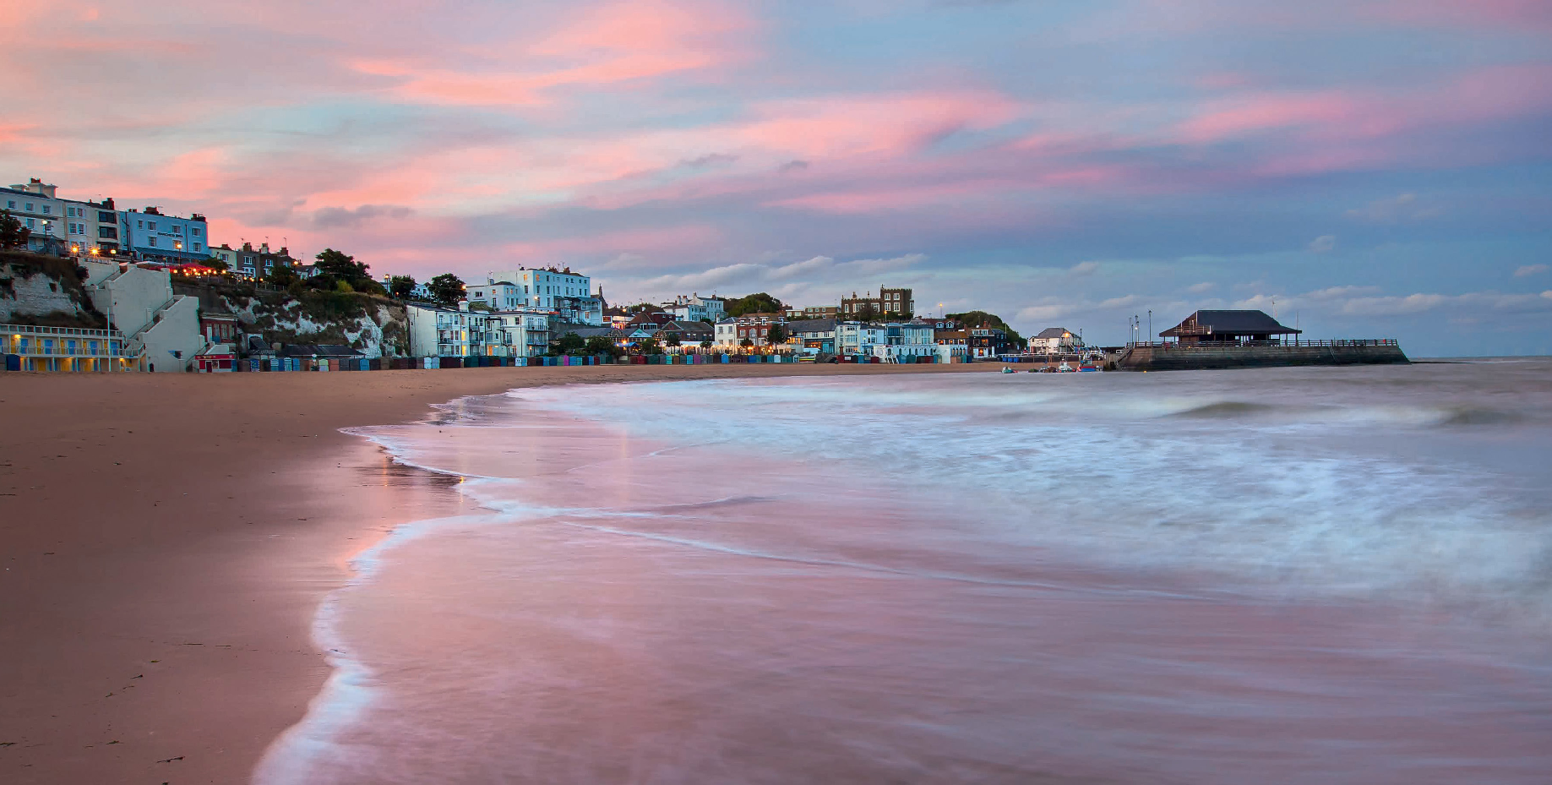
Broadstairs Press Pack www.visitthanet.co.uk

Come to Broadstairs
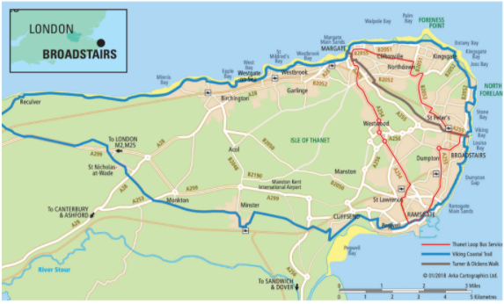
Broadstairs is a seaside town situated on the Isle of Thanet at the most easterly point of the Garden of England.

Broadstairs is easily accessible by car, coach and train.The country’s only high-speed train service, HS1, brings visitors from St Pancras, London, to Broadstairs in just 85 minutes.

There are regular train and bus services, including the Thanet Loop, to the neighbouring resorts of Margate (3.4m / 5.5km) and Ramsgate (2.3m/ 3.7km). The City of Canterbury is 18.8 miles (30.25km) away and the Port of Dover, with its cross-Channel services to mainland Europe, just 22.6 miles (36.4km). The Eurotunnel terminal at Folkestone is just 36 miles (57.9 km) distant.

Cyclists are always welcome in Thanet to explore the numerous cycling opportunities including the Viking Coastal Trail (Regional Cycle Network 15)
– www.visitthanet.co.uk/cycling
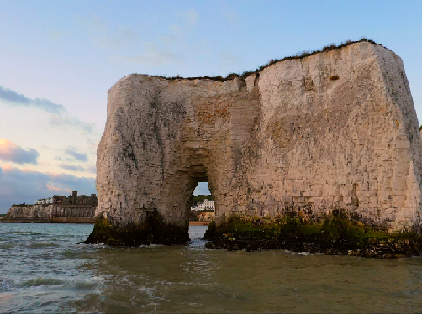
Escape to Broadstairs

Kingsgate Bay

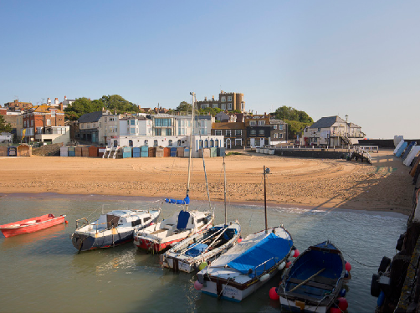
Broadstairs Harbour

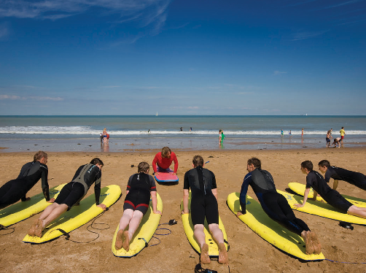
Surf School
- Seven spectacular sandy, family-friendly beaches and bays, with one Blue Flag Award and three Seaside Awards
- Stunning chalk cliffs including caves and the much-photographed stacks at Botany Bay
- Closest surfing beaches to London and best in the south east
- Timeless seaside charm
- Traditional fishing harbour, cobbled narrow streets and squares
- Vibrant nightlife economy and exciting eateries
- Classic ice cream parlours and coffee shops
- Clifftop gardens and bandstand
- Clifftop and foreshore strolls, cycling and golf
- Full diary of festivals and events
Broadstairs succeeds in more than satisfying the needs of today’s generations of short break, weekend visitors and day trippers who flock to its beaches. Yet the coastal honeypot retains all the charms and features of an authentic seaside destination.

Morelli’s, the quintessential 1950s ice cream parlour, stands at the top of the chalk cliffs overlooking floral displays along the promenade and the gently sloping sands and lower tide rock pools of Viking Bay.

Charles Dickens, one of the town’s most famous former visitors and residents, would easily recognise the narrow streets winding down to the small fishing harbour and the distinctive flint walls of the older parts of the town.

Throughout the summer, demand is high for the town’s many guesthouses, B&Bs, self- catering houses and apartments.

As a resort, and a long-standing favourite destination for people of all ages and interests, Broadstairs is thriving in the 21st century. The town is now home to more than 25,800 people enjoying the changing delights of the seaside throughout the seasons.

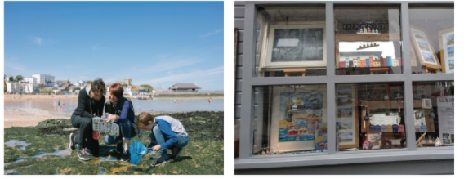
Beaches and bays

Sunseekers, sandcastle builders, swimmers, surfers, fossil hunters, rockpool enthusiasts and more will be delighted with the wide choice of different beaches and bays to be discovered in Broadstairs.
Botany Bay – Thanet’s most photographed beach with towering chalk stacks, golden sands and long sea views. This is a great beach for rockpools and fossil hunting when the tide is out. Seaside Award
Kingsgate Bay – some of the finest examples of sea caves in the country. Secluded sands but cut off at both ends at high tide. Checking tide times is essential before setting out.
Joss Bay – a surfer’s paradise, with a surf school, a 200-metre long sandy beach surrounded by fields, a golf course and space to play. Seaside Award
Stone Bay – as the tide goes out beautiful sands and superb rockpools are revealed. Hours of fun within a short distance of Viking Bay. Blue Flag Award
Viking Bay – A wide horseshoe bay with outstanding sands, tidal pools, beach huts, children’s activities and surf school. Traditional fish ‘n chips, ice creams and lollies are readily available. Seaside Award
Louisa Bay – a small popular bay with refreshments nearby for when the tide is high and the beach is washed clean by the sea.
Golden sand and delightful rockpools.

Dumpton Gap – quiet sands and rockpools with dramatic chalk cliffs and a great coastline walk to Ramsgate at low tide. Checking tide times is essential before setting out.

- Coastal Explorer Packs include binoculars, compass, rockpool nets and marine life identification sheets alongside special trails and historic maps for self-guided discovery of the Thanet coast and heritage www.visitthanet.co.uk/coastalexplorers
- Beach Within Reach is a small Thanet-based charity providing all-terrain wheelchairs to some of the beautiful beaches. www.beachwithinreach.org.uk

Discover more of Thanet’s award-winning beaches and bays at www.visitthanet.co.uk/beaches-bays
(2021 Awards applied for and awaiting confirmation)

Picture perfect
Visitors to Kent Coast Gallery, www.kentcoastgallery.com, are treated to a magnificent overview of the superb coastal sights on offer throughout the seasons across Thanet and beyond.

The Broadstairs Gallery, near Viking Bay, displays the work of local and international artists.
www.broadstairsgallery.com

The Little Art Gallery is a great visitor destination featuring the work of local artists. The gallery is tucked away just off Harbour Street. Paintings to see and buy www.thelittleartgallerybroadstairs.com.

New KentArt Gallery and Studio is an intimate gallery space showcasing local artists www.newkentart.com

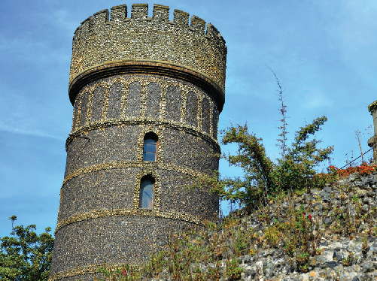
Attractions

Dickens House Museum (www.dickensmuseumbroadstairs.co.uk): a celebration of the life and times of the great British campaigner, journalist and writer set in the cottage that was the inspiration for the home of Miss Betsey Trotwood in David Copperfield.

Bleak House
Charles Dickens spent holidays in the house in the 1850s and 1860s. External viewing only.

Crampton TowerMuseum (www.cramptontower.co.uk): visitors discover the inventions of the Victorian engineer Thomas Crampton, his work for the town and his role in the development of the railways and communication. He was born in Broadstairs on 6 August 1816 and trained on Brunel’s Great Western Railway. He laid the first successful cable for a submarine telegraph between Dover and Calais. His tower housed the first waterworks for the resort.

St Peter’sVillage Tours (www.villagetour.org.uk): a delightful destination, the village offers visitors four award- winning tours – including two War Graves tours, a Churchyard tour and a chance to explore the village’s history with a selection of colourful costumed characters.
Revolution Skatepark and Climbing Centre (www.revolutionskatepark.co.uk): Kent’s premier indoor skatepark since 1998, this is the popular destination for skateboarders and climbers to test their skills and enjoy learning new techniques and approaches to their sport.
Lillyput Mini Golf (www.minigolfbroadstairs.com): a championship mini-golf course, complete with tea garden.

The Escapement
Six new escape rooms in Retreat House - see New for 2021 on page 10.

The Bank Job
Broadstairs’ first escape room. Rob original bank vaults and grab the diamond! thebankjobbroadstairs.co.uk

Broadstairs Town Walks (guided) take visitors on a gentle stroll through 600 years of history in just under an hour – Charles Dickens, Hans Christian Anderson and Ronnie Barker are all included!Walks take place from Easter to the end of August, weekends only at 2pm from the Information Kiosk by the Albion Hotel.

Crampton Tower Museum

Revolution Skatepark

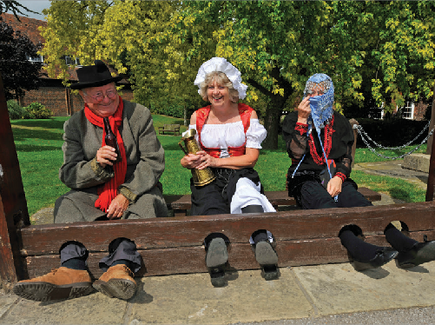
St. Peter’s Village Tour

Entertainment
The Sarah Thorne Theatre Company presents summer rep, plays, pantomimes and musical evenings in the intimate Memorial Theatre. www.sarahthornetheatre.co.uk
Overlooking Viking Bay and the harbour, The Pavilion is a great destination for a relaxing evening with a lively programme of special musical events and entertainment. www.pavilion-broadstairs.co.uk
Cinema lovers are bound to want to experience the cosy Palace Cinema – a 111-seat, family- run cinema in the resort’s historic Harbour Street.
www.thepalacecinema.co.uk
Broadstairs Bandstand was opened in 1892 by Princess Louise, daughter of Queen Victoria. The Bandstand is a focal point for entertainment throughout the year.

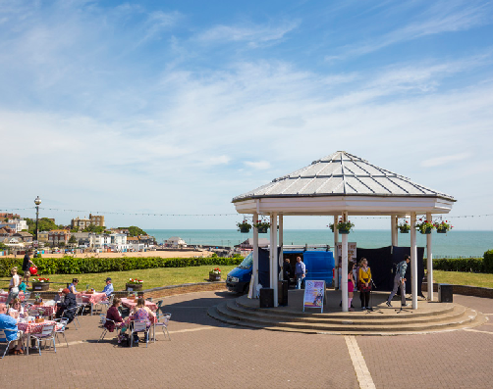
Broadstairs Bandstand

Outdoor Adventures
Enjoy invigorating and gentle walks exploring inlets and quiet bays cut into the chalk cliffs.
Follow the Viking Coastal Trail (32 miles/51.4 km) or mini routes including Historic Broadstairs and Smugglers’ Haunts on foot or on two wheels. Download from www.visitthanet.co.uk/cycling
Broadstairs Town Trail (leaflet) is a self- guided walk around the town with illustrated boards along the route giving an insight
into some of the town’s people, history and buildings.
Turner and Dickens Walk along the restored four-mile route between Dickens’ Broadstairs and Turner’s Margate,much of which follows an ancient footpath between St. Peter’s and St.
John’s churches. www.visitthanet.co.uk/turnerand-dickens- walk/

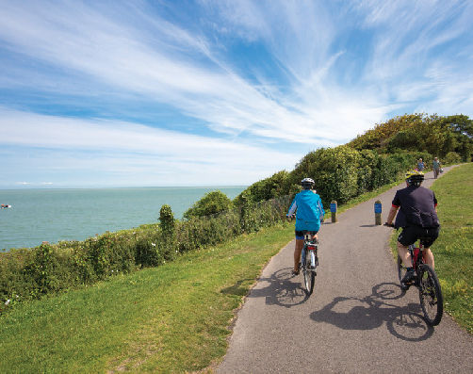

Viking Coastal Trail

Digital Discoveries Plaques
Two eye-catching new plaques can be seen at key locations across Broadstairs. The plaques tease the reader with a hint of information that can be discovered, then upon entering a code into their mobile device, the location and its stories come alive through video, audio and imagery. www.visitthanet.co.uk/digitaldiscovery
North Foreland Golf Club offers seaside golf at its very best with panoramic views from every tee and every green. It is an 18-hole par 3 course.
www.northforeland.co.uk
Discover the fun of surfing and stand up paddle boarding, SUP, with Joss Bay Surf School www.jossbay.co.uk and Kent Surf School at Viking Bay www.kentsurfschool.co.uk.

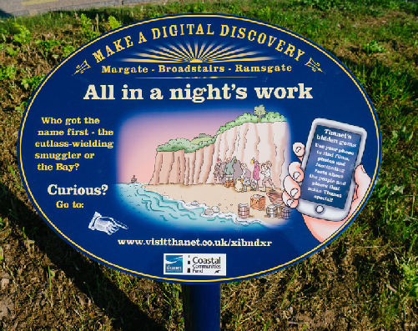

Digital Discovery Packs

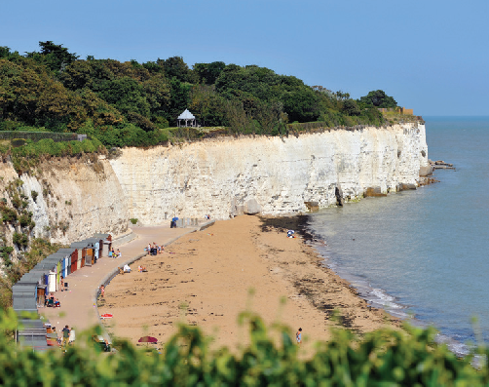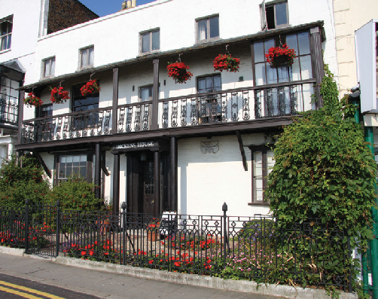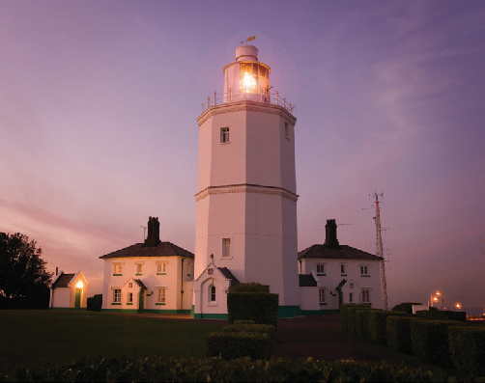
Stone Bay Dickens House Museum North Foreland Lighthouse

Artistic impressions

The Victorian writer Charles Dickens (1812- 1870) is probably Broadstairs’most famous regular visitor and it is not difficult to follow in his footsteps around the town and find the inspiration behind many of his colourful characters and settings. Many of his novels were completed during his visits.
Author of The Thirty-Nine Steps and other novels, John Buchan spent time writing during his 1914 visit to the town’s North Foreland area near Stone Bay.
Frank Richards (Charles Hamilton), the creator of Billy Bunter, made his home at Kingsgate, Broadstairs. Oliver Postgate, of Bagpuss, Noggin the Nog and Clangers fame, also lived in the town while Annette Mills, creator of Muffin the Mule, settled in St Peter’s.
English Impressionist Walter Richard Sickert (1860-1942) regularly painted at his home in St Peter’s village.
The artist and illustrator Sir Samuel Luke Fildes lived for many years at Holland House, Kingsgate. He illustrated The Mystery of Edwin Drood before moving into portraiture and gaining a large and fashionable clientele, including Royals such as Edward VII, Queen Alexandra and George V. These state portraits hang in Buckingham Palace.

Key Annual Events

Broadstairs Food Festival

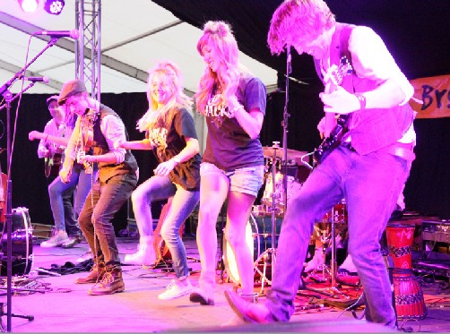
Noble Jacks, credit Dylan Woolf

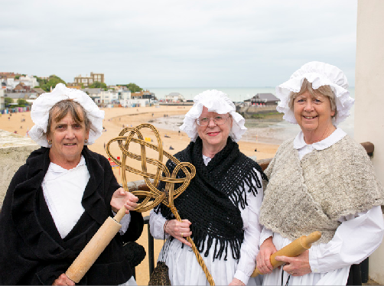
Broadstairs Dickens Festival

FEBRUARY
Blues Bash
www.broadstairsbluesbash.com – a festival of blues music at venues across the town.

MARCH
POW! Thanet
POW! stands for Power of Women and this is one of the UK’s only festivals celebrating
International Women’s Day. This year’s theme is POWer in Protest as 2021 marks 40 years since the Greenham Common peace camps began. www.powthanet.com

JUNE
Dickens Festival www.broadstairsdickensfestival.co.uk – a major celebration of author Charles Dickens’ enthusiasm for Broadstairs which he regularly visited between 1837 and 1859. He described the town as ‘Our English watering place’.
Costumed characters of all ages,Victorian entertainments and special events.

JULY
Water Gala www.broadstairswatergala.co.uk – beach competitions, nautical characters, bandstand events, funfairs and fireworks.

AUGUST
FolkWeek
www.broadstairsfolkweek.org.uk – a major event attracting musicians and folk enthusiasts from across the world. Performances and colourful events are held at venues throughout the resort. Beware of Hooden Horses… but the dragon is friendly.

OCTOBER
Broadstairs Food Festival www.broadstairsfoodfestival.org.uk – a must visit for local and visiting foodies alike
(see page 9).

Looping the Loop
Looping the Loop creates adventures in performance, producing affordable (and often free) live performances in unexpected places around the Isle. www.loopingtheloopfestival.org.uk

Throughout the summer months there is also a variety of entertainment and events at Broadstairs Bandstand.

Events may be subject to change or cancellation due to Covid-19 and changing restrictions. Further event information can be found on www.visitthanet.co.uk/whats-on

Food and drink, where to stay

WHAT’S ON THE MENU?
With a town boasting a major three-day food festival each Autumn, it is not surprising to learn that Broadstairs is a popular destination for foodies. The Broadstairs Food Festival attracts thousands of visitors to the seaside town to taste rare and special foods, many featuring produce from the Garden of England such as superb wines, cask ales and Kent’s famous fruit juices. Look out for the Chefs’ Theatres and Ask the Experts sessions alongside hundreds of opportunities to sample culinary creations. www.broadstairsfoodfestival.org.uk
Broadstairs has numerous independent cafés, bistros and restaurants welcoming visitors throughout the year and serving a wide range of cuisines.
Stark in Broadstairs became the Isle’s first Michelin starred restaurant in 2020 when it was awarded 1 Michelin Star. Stark is a small,
intimate restaurant with a relaxed atmosphere, offering only a six course menu and the option of matching wines.
Wyatt and Jones is listed in the Michelin Guide with, “Appealing modern blackboard menus keep things regional, with a firm focus on seafood.” Also listed is their new takeaway service, Flotsam and Jetsam.
Two micro pubs are featured in the Good Beer Guide 2021. The Four Candles has a real ale brewery crammed into a tiny 3m x 3m cellar, and serves the results in the cosy drinking area upstairs. The Pub features real ales and craft beers and offers interesting bar snack options such as flavoured crickets.
Few visitors to Broadstairs fail to take advantage of the resort’s classic ice-cream parlours Morelli’s and Chiappini’s overlooking the seafront and Viking Bay.

WHERE TO STAY?
There are boutique hotels, guest houses and contemporary B&Bs in historic buildings alongside self-catering apartments, fishermen’s cottages and houses full of character in the heart of the town and overlooking the sea.
The Yarrow Hotel, www.yarrowhotel.co.uk is the only hotel in the country run by a further education college as a training ground for the hospitality industry’s future leaders.
The popular, boutique Bay Tree Hotel, www. baytreebroadstairs.co.uk, offers Victorian elegance with modern luxury.
New is Fagin’s Den, Dickensian themed accommodation (see What’s New page 10).
Discover a range of accommodation at www.
visitthanet.co.uk/stay-and-eat/places-to-stay/
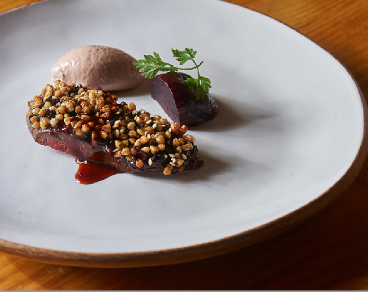
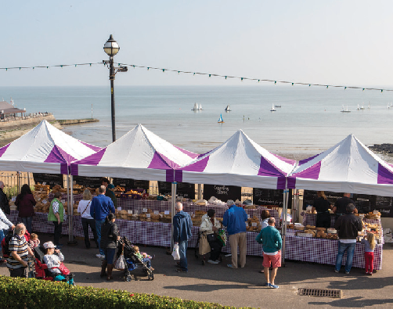
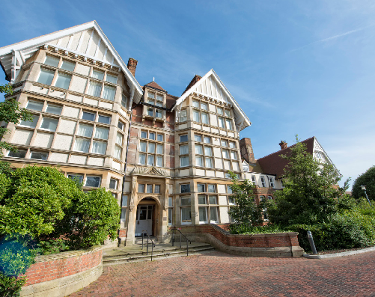

Broadstairs Food Festival Stark

The Yarrow Hotel

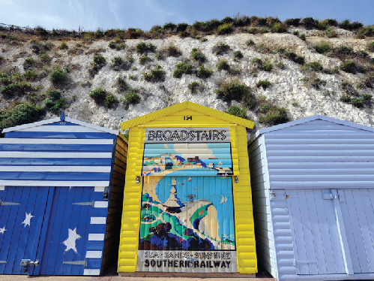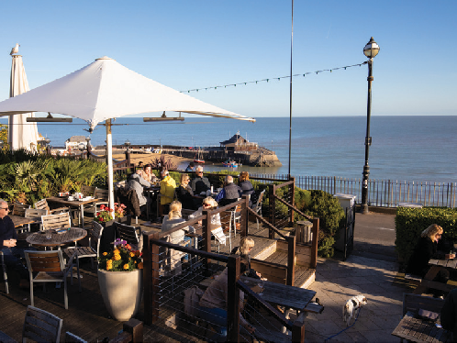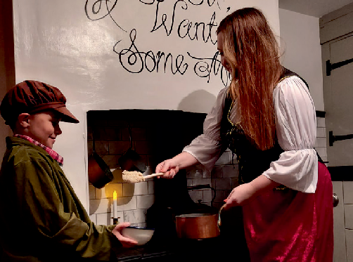
Beach Huts Overlooking Viking Bay Fagins Den

Roots, revival and regeneration New for 2021

Originally Broadstairs was a fishing settlement much smaller than the inland village of St.
Peter’s, which was established around the parish church. The coastline, with its many bays, was popular with smugglers and the residents of Broadstairs and St. Peter’s had a reputation for being very good at outwitting customs agents.
In the early 19th century, steampackets, closely followed by the railways, made trade and travelling links with London much easier and faster. New residents and visitors began to arrive and by the beginning of the 20th century the population in the now rapidly growing resort topped 10,000. Today Broadstairs is home to almost 26,000 people.
Grand houses, impressive estates for wealthy Londoners and their families, and hotels were built along the clifftops and in the town.
Broadstairs was quickly established as a highly desirable place to live and visit throughout the year.
Investment and the development of new retail parks and a major modern shopping leisure centre at Westwood Cross, on the outskirts
of the historic town, has enabled businesses to restore and revive many of Broadstairs’ traditional buildings as independent shops, contemporary visitor accommodation and weekend escapes for second homers.
A multi-million pounds investment has transformed East Kent College’s historic Yarrow Building in into a four-star training hotel with luxury restaurant for lunch and dinner, and a hair and beauty salon.

The Escapement at Retort House
Immersive escape rooms with the focus on story telling and theatrics, including a Harry Potter inspired adventure and an Orient Express train themed room.
www.escapementmargate.co.uk

Fagin’s Den
Dickensian themed holiday cottage named after the character Fagin in Oliver Twist. Families
and Dickens enthusiasts will step back in time with furniture, memorabilia, books, games and artwork creating the ambience of the era. Supplied Dickensian costumes make the experience more authentic.
There are two treasure hunts, one for adults and one for children, where the aim is to find Fagin’s hidden stash within the accommodation.
www.holiday-cottages-broadstairs.co.uk/ fagins-den

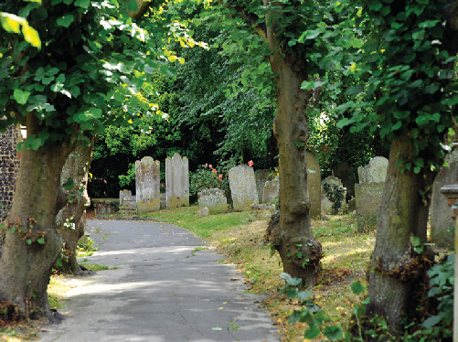
Did you know?

  - North Foreland Lighthouse was the last manned lighthouse in the country. It was automated in 1998. The lighthouse inspired the author Wilkie Collins’ famous novel The Woman in White (1859).
  - The large dome ‘beehive’ at Crampton Tower Museum has an amazing echo and was used, along with the Tower, as an Air Raid Precautions (ARP) centre during WWII.
  - St. Peter’s church tower was used as a signalling station by the Royal Navy during the Napoleonic wars. The church still claims the right to fly the White Ensign.
  - Viking Bay served as a training ground for British troops, stationed in Chandos Square, during the Napoleonic Wars.
  - St. Peter’s churchyard is one of the longest in the country and the largest “Closed Churchyard” in England.
  - Broadstairs gained the first lifeboat to be stationed on the south coast in 1850. One year later it carried out a rescue from the Goodwin Sands.
  - Joss Snelling (1741-1837), known as The Famous Broadstairs Smuggler, was born in Lanthorn Road. The lifestyle must have
suited him as it is recorded he was fined for smuggling when he was 89 years old.
- Thomas Russell Crampton (1816-1888), the Victorian inventor and engineer, was born in Broadstairs and brought gas and water works to the town.
- Broadstairs Dickens Festival started in 1937.
- Broadstairs has seven beautiful beaches and bays, one with a Blue Flag Award and two with Seaside Awards.
- Morelli’s, at Victoria Parade, Broadstairs, is a coffee bar and ice cream cafe preserved almost unaltered since its refurbishment in 1957. It’s one of very few original 1950s
coffee bars left in the country and described by one enthusiast as ‘a symphony of Formica, vinyl and lino’. Morelli’s opened at this location in 1932.
- In 1827 the widowed Duchess of Kent and her young daughter Victoria lived at Pierremont Hall, Broadstairs, for three months. The house belonged to Edward
Fletcher. He rented it to the Duchess for 25 guineas per week. This was just one of many visits to different parts of the Isle of Thanet before 18-year-old Victoria became Queen in 1837.

St. Peter’s Churchyard

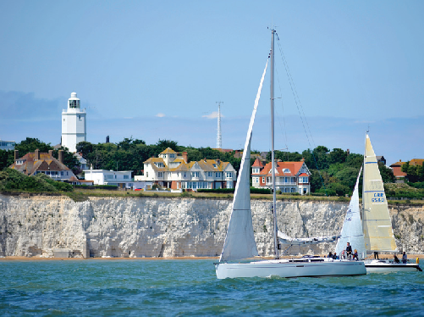
North Foreland Lighthouse

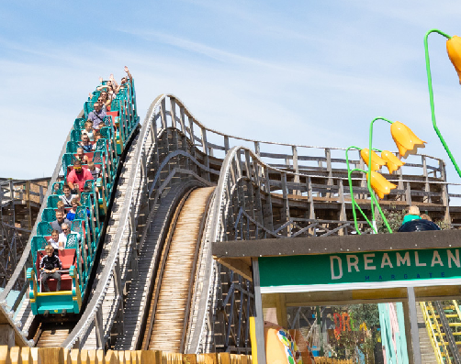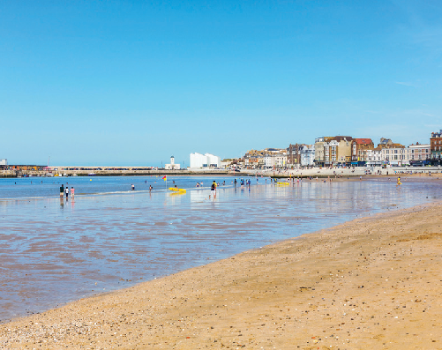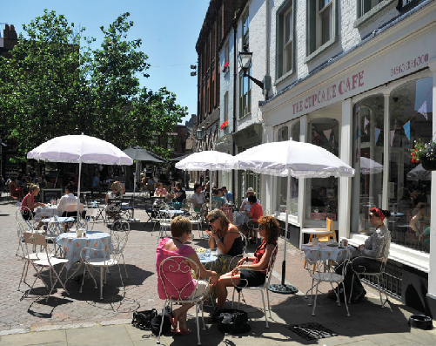
Dreamland, Margate Margate Main Sands Margate Old Town

So close

MARGATE
Margate is a classic seaside destination with deep roots in the original development of visits to the coast for the health benefits of exhilarating sea air and salt water bathing.
As the passion and fashion for seaside fun and frivolity became more accessible with boat trips from London and the arrival of the railways, Margate and neighbouring Cliftonville became synonymous with family holiday fun, weekend escapes (including romantic liaisons) and daytrips.
Visitors today soak up the sun, sands and sea with all the enthusiasm of previous generations of the bucket ‘n spade brigade as well as a wealth of retro and vintage seaside pleasures presented in 21st century style.
Dreamland is one of the newest additions and celebrates the age of the Great British seaside
amusement experience, including the country’s oldest wooden roller coaster, the Grade II* listed Scenic Railway
Along with the resort’s residents, visitors find themselves at the heart of the cultural and creative arts revolution sweeping along the coast of Kent.
- World class art and cultural exhibitions at Turner Contemporary
- Dreamland, the UK’s original pleasure park
- Margate Old Town, vibrant and expanding creative sector
- Classic seaside heritage
- Grade II listed tidal pool at Walpole Bay
- Hidden gem attractions include Margate Caves, Shell Grotto, Margate Museum, Tudor House, Drapers Windmill and Hornby Visitor Centre
- Two beaches, one with a Blue Flag Award and one with a Seaside Award
- New for 2021, Crab Museum and Murky Margate Tours
- Time and space to relax and enjoy the resort’s famous sunsets, clifftop walks and trails, and contemporary culture
- Independent galleries, vintage and retro hotspots, contemporary and quirky shops along cobbled streets
- Events include POW! Thanet (March), Mods & 60s Festival, Margate Meltdown (May), Skagate Weekend (July), Soul Festival, Margate Pride (August), Rhythm & Rock 2021, Jazz Weekend, Oh So Retro Show (September) and Looping the Loop (October).Music events at Dreamland throughout the year
Further event information can be found on www.visitthanet.co.uk/whats-on
A Margate press pack is available, see back cover.

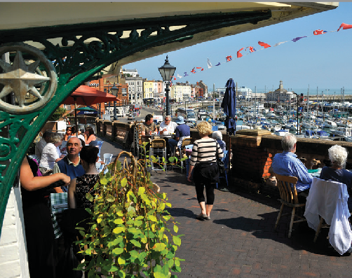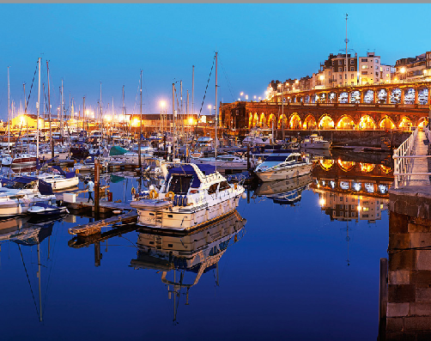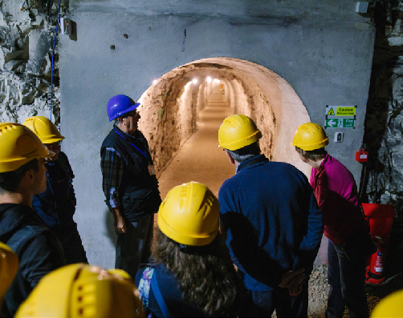
Westcliff Arcade Royal Harbour Ramsgate Tunnels

RAMSGATE
Ramsgate, a favourite seaside destination of Princess Victoria, is an architectural jewel in the coastal crown of the Isle of Thanet.
The town’s long maritime history as a port, with the country’s only Royal Harbour, and its thriving modern marina have contributed to the development of a relaxing Mediterranean-style waterfront filled with a wealth of bustling bistros and restaurants.
The resort’s fine weather, superb sands, sea air and stunning views from the chalk cliffs alongside elegant side streets, independent shops, galleries and seaside entertainments add even more flavour to Ramsgate’s popular café culture.
  - UK’s only Royal Harbour, celebrating 200 years of Royal status in September 2021
  - One Seaside Award beach, golden sands, famous family-friendly beach, boat trips and clifftop walks

- Modern marina filled with luxury yachts
- Augustus Pugin’s house, The Grange
- St. Augustine & Pugin: Shrine and Visitor Centre
- Mico Museum - the history of personal computing and the inventors of the digital age.
- Elegant Georgian, Regency and Victorian architecture – hundreds of listed buildings
- Ramsgate Tunnels - deep shelter tunnels built to protect civilians duringWWII
- Active Ramsgate - fun and active ways to discover the town by foot, by bike or on the sea
- Thriving continental café culture along the south-facing waterfront
- Fine eateries serving local produce including seafoods

• Retro and contemporary boutique hotels, guesthouses, B&Bs and self-catering
• Italianate Glasshouse
• Petticoat Lane Emporium with over 200 stalls
• Maritime Museum and Steam Tug Cervia
• Rotten Ramsgate and Blitz guided walks, plus Ramsgate guided costumed walks
• Events include POW! Thanet (March), Ramsgate International Film and TV Festival (June), Ramsgate Week (July), Ramsgate Festival of Sound, National Kite Surfing Championships (August/September), Royal Harbour of Ramsgate 200 (September) and Looping the Loop (October)

Further event information can be found on www.visitthanet.co.uk/whats-on
A Ramsgate press pack is available, see back cover.

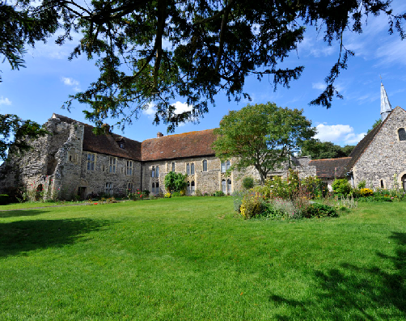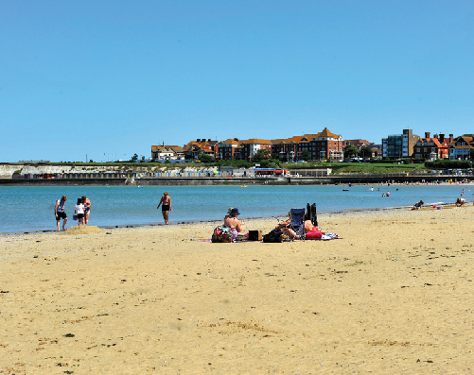
Minster Abbey Spitfire and Hurricane Memorial Museum West Bay

THANET VILLAGES
Just a short distance from the coast visitors discover a treasure chest of delights in Thanet’s traditional villages.

Popular visitor gems include:
- Birchington and Westgate – Coastal villages with Blue Flag beaches at Minnis Bay, West Bay and St.Mildred’s Bay.

- Internationally acclaimed Powell-Cotton Museum, Quex House and Gardens (currently closed and undertaking an exciting ‘Reimagining’ project) www.powell- cottonmuseum.org

- Quex Park Estate with a wide range of attractions including activities for children, farmers market and craft village. Plus full and varied diary of annual events including Big Truck Monster Show in July 2021, www. quexpark.co.uk

- The Spitfire and Hurricane Memorial Museum, Manston, now with a Spitfire cockpit simulator

- RAF Manston History Museum

- MinsterAbbey – possibly the oldest inhabited house in the country near where St.Augustine led the first Christian mass in Britain

- Minster Show – (www.minstershow.org.uk) Since 1886, Minster and neighbouring villages work together to present entertainment, celebrating the success of flower and vegetable growers, cooks, jam and preserve makers and more.

- Monkton Nature Reserve – trails, UK’s first artificial bat cave, fossils and visitor centre

- St.Mary the Virgin Church at Minster – a large Roman Catholic church with 18 fine medieval misericords, which are amongst the best in south east England.

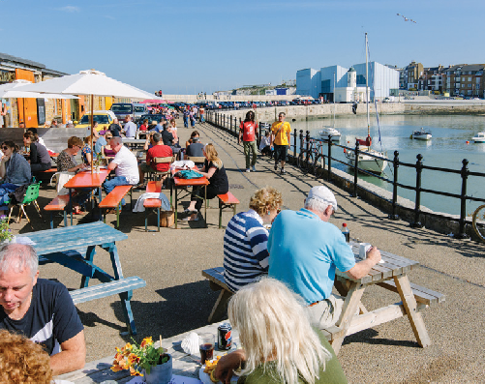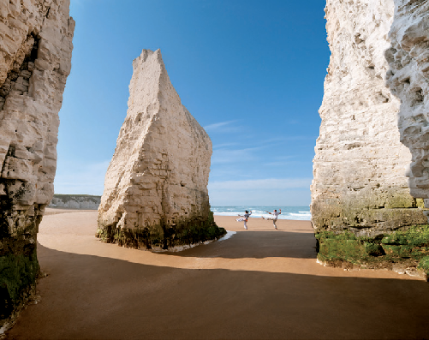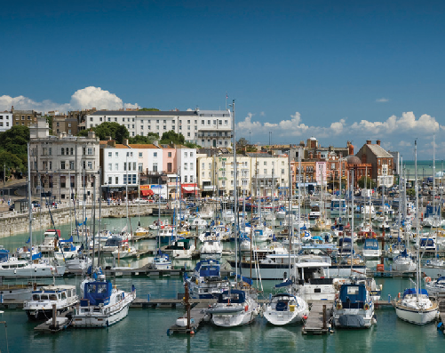
Margate Harbour Arm Botany Bay Royal Harbour, Ramsgate

Why visit?
Londoners have been escaping to the Isle of Thanet for more than 200 years … for the laidback seaside vibe … breathtaking sandy beaches … fresh sea air… and romantic Turner skies …
Here at the very edge of the Garden of England, three Georgian and Victorian resorts, each with its own distinctive character
– Margate, Broadstairs and Ramsgate – cluster
around the bays at the far end of a peninsula.
There’s a quirky and convivial feel to these harbour towns, with their friendly creative scene, their remarkable 18th and 19th century architecture, their classic seaside heritage, their eclectic attractions and events, their galleries and music venues large and small, and their special one-off places to eat, drink, shop and stay, year round.
Miles of low chalk cliffs edge the peninsula, sheltering a string of secluded, unspoilt sandy bays. Chalk rockpools, chalk stacks and rare chalk reefs teem with wildlife.

These are the closest surfing beaches to the capital city: a popular choice with south-east boarders.
Artists, writers and musicians – from Van Gogh and TS Eliot to Bob & Roberta Smith and the Libertines – have long been inspired by this almost-island and continue to be drawn here.
Turner said Thanet had “the loveliest skies in all Europe” … for Dickens Broadstairs was
“the freshest, freest place” … and Tracey Emin declares in pink neon on Margate seafront: “I never stopped loving you”.
The Isle’s a historic landing place steeped in symbolism for the story of Britain … the first Saxons Hengist and Horsa arrived and settled here … and St Augustine first stepped onto these shores on his way to nearby Canterbury.
For this is the furthest south east you can go in Britain … almost touching mainland Europe … yet these days only 75 minutes from

central London …
And now with Turner Contemporary and Dreamland, and high-speed trains from the capital … a new generation is discovering this original seaside escape.
Key Tourism Stats
The Cambridge Model Economic Impact Study 2019 shows:
The value of tourism to the local economy is £365m.
We welcomed 4.6 million visitors to the area.
Tourism in Thanet supports 8,644 jobs.
To see the full report go to www.visitthanetbusiness.co.uk

For further media information including packs on Margate, Broadstairs and Ramsgate, press trips and access to up-to-date images, please contact Julie Edwards, Senior Tourism Officer at Visit Thanet, tel: 01843 577671 or email: Julie.edwards@thanet.gov.uk

For further information on the Isle of Thanet, attractions and accommodation go to www.visitthanet.co.uk for visitor stats go to www.visitthanetbusiness.co.uk

@VisitThanet www.visitthanet.co.uk/blog
VISIT THANET
Margate Broadstairs Ramsgate

