Economic Impact of Tourism
Thanet - 2019 Results
November 2020

Produced by:
Destination Research
www.destinationresearch.co.uk

Contents Page
Introduction and Contextual Analysis 3
Headline Figures 6
Volume of Tourism 8
Staying Visitors in the county context 9
Staying Visitors - Accommodation Type 10
Trips by Accommodation
Nights by Accommodation
Spend by Accommodation
Staying Visitors - Purpose of Trip 11
Trips by Purpose
Nights by Purpose
Spend by Purpose

Day Visitors 12
Day Visitors in the county context 12
Value of Tourism 13
Expenditure Associated With Trips 14 Direct Expenditure Associated with Trips
Other expenditure associated with tourism activity
Direct Turnover Derived From Trip Expenditure
Supplier and Income Induced Turnover
Total Local Business Turnover Supported by Tourism Activity
Employment 16
Direct 17
Full time equivalent
Estimated actual jobs

Indirect & Induced Employment 17
Full time equivalent
Estimated actual jobs
Total Jobs 18
Full time equivalent
Estimated actual jobs
Tourism Jobs as a Percentage of Total Employment 18
Appendix I - Cambridge Model - Methodology 20
Introduction
This report examines the volume and value of tourism and the impact of visitor expenditure on the local economy in 2019 and provides comparative data against the previously published data for Kent (2017).
Part of the Interreg Channel EXPERIENCE project, Destination Research was commissioned by Visit Kent to produce 2019 results based on the latest data from national tourism surveys and regionally/locally based data. The results are derived using the Cambridge Economic Impact Model.
In its basic form, the model distributes regional activity as measured in national surveys to local areas using ‘drivers’ such as the accommodation stock and occupancy which influence the distribution of tourism activity at local level. Whenever possible, results have been enhanced by building in additional local-level data gathered by the district (e.g. local attractions data, boat moorings, language schools in the area, accommodation stock, etc.). See Appendix I for further details.
Contextual analysis
Domestic tourism
In 2019, British residents took 99.7 million overnight trips in England (down from 100.6 million overnight trips in 2017), totalling 290 million nights away from home (down from 299 million nights in 2017). Expenditure reached £19.40 billion (up from £19.05 billion in 2017). The spend per trip was £194.58 and with an average trip length of stay of 2.9 nights, the average spend per night was £66.89.
The South East region experienced a -3% decrease in overnight trips between 2017 and 2019. Bednights were down -2% on 2017 and expenditure was unchanged since 2017. The region received slightly less visitors in 2019 than in 2017 but visitors spent slightly more per night than in 2017. The average spend per trip was £161.37 and with an average length of stay of 2.66 nights, the average spend per night was £60.56.
The GB Tourism Survey data is a key driver for the Cambridge model. However, it is not specifically designed to produce highly accurate results at sub-regional level. In order to improve the accuracy of results we have applied a 3-year rolling average to this data to help smooth out short term market fluctuations and highlight longer-term trends. As such, county and district level results relating to 2019 are an average of 2017, 2018 and 2019.
The domestic tourism results for Kent used in this model combine a mixture of supply and demand data. We do this because extracting county level data from national surveys can lead to inaccurate results due to low sample sizes. Our results show a 1% decrease in the volume of trips between 2017 and 2019. Nights were down by 2% and expenditure was also down by 1%.

Visits from overseas
The International Passenger Survey (IPS) data is a key driver for the Cambridge model. However, as with the GBTS, it is not specifically designed to produce highly accurate results at sub-regional level. In order to improve the accuracy of results we have applied a 3-year rolling average to this data to highlight longer-term trends, whilst helping smooth out short-term market fluctuations and reducing the impact of any methodological changes affecting the survey. As such, county and district level results relating to 2019 are an average of 2017, 2018 and 2019 results.
At national level, the number of visits in 2019 was 36.1 million (33.0 in 2017). The number of visitor nights spent in England was 252.4 million (245.7 million in 2017), with the average number of nights per visit standing at 7.99 in 2019 (from 7.45 in 2017). Expenditure in 2019 was £24.78 billion, slightly below the £24.94 billion achieved in 2017.
Overseas trips to the South England region were down by 1% compared to 2017 at 5.4 million overnight trips. The total number of nights was 36.8 million, down slightly from the 37.4 million nights in 2017. Expenditure in 2019 was £2.58 billion, up 11% from 2.32 billion in 2017.
Kent experienced a 3% increase in the volume of trips between 2017 and 2019. Nights were down by 7% and expenditure was also down by 6%.
The International Passenger Survey is conducted by the Office for National Statistics and is based on face to face interviews with a sample of passengers travelling via the principal airports, sea routes and the Channel Tunnel, together with visitors crossing the land border into Northern Ireland. The number of interviews conducted in England in 2019 was 25,147.

Day visitors
During 2019, UK residents took a total of 1,390 million Tourism Day Visits in England (down from 1,505 in 2017). Around £56.5 billion were spent during these trips, up from £50.9 billion in 2017.
The volume and value of tourism day visits in the South East of England decreased by 5% between 2017 and 2019, from 230 million down to 218 million. Expenditure levels were up by 7% to £7.9 billion in 2019.
The results for Kent are based on a combination of results from the GB Day Visitor Survey, visits to visitor attractions from the Visit Kent Business Barometer and other relevant local level data including visits to local information centres (VICs) and growth in off-peak rail journeys to Kent between 2017 and 2019. Based on these results the model assumes that the volume of day trips was up by 3% between 2017 and 2019 and expenditure for the same period was up by 10%.

Economic Impact of Tourism – Headline Figures Thanet - 2019 Results
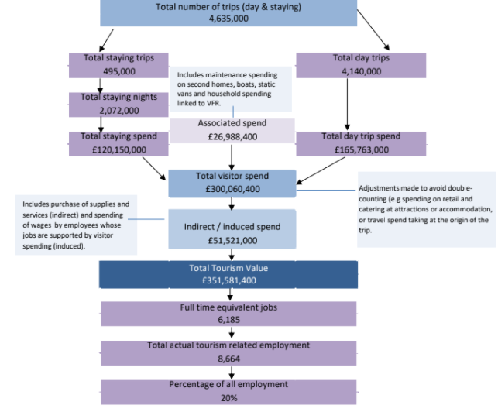
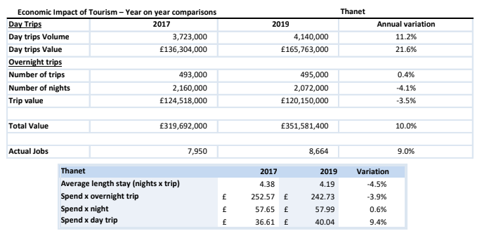

Economic Impact of Tourism – Headline Figures Thanet - 2019 Results

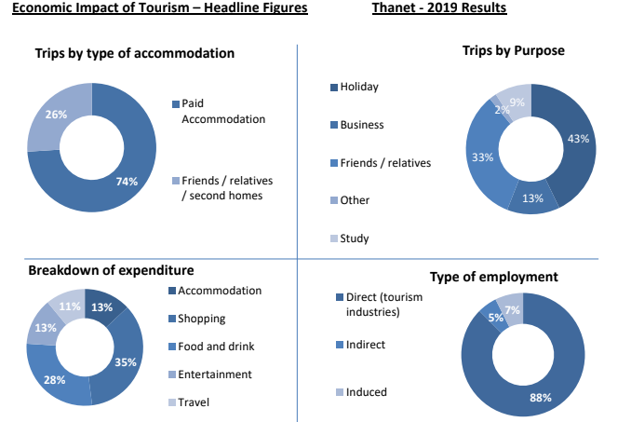

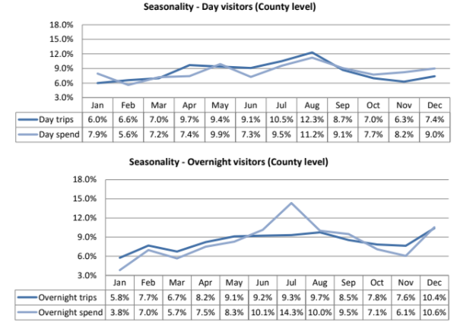

Volume of Tourism

Staying visits in the county context Thanet - 2019 Results

Staying trips in the county context | Domestic trips ('000) | Overseas trips ('000)
Ashford | 279 | 116
Canterbury | 456 | 194
Dartford | 132 | 45
Dover | 334 | 90
Folkestone and Hythe | 392 | 79
Gravesham | 147 | 39
Maidstone | 275 | 86
Medway | 419 | 105
Sevenoaks | 167 | 66
Swale | 351 | 44
Thanet | 342 | 153
Tonbridge and Malling | 191 | 48
Tunbridge Wells | 244 | 68
Kent | 3,729 | 1,133

Staying nights in the county context | Domestic nights ('000) | Overseas nights ('000)
Ashford | 739 | 472
Canterbury | 1,387 | 1,234
Dartford | 377 | 205
Dover | 936 | 457
Folkestone and Hythe | 974 | 407
Gravesham | 379 | 210
Maidstone | 708 | 492
Medway | 1,230 | 643
Sevenoaks | 427 | 330
Swale | 1,224 | 302
Thanet | 1,022 | 1,050
Tonbridge and Malling | 541 | 258
Tunbridge Wells | 735 | 417
Kent | 10,679 | 6,477

Expenditure in the county context | Domestic spend (millions) | Overseas spend (millions)
Ashford | £43 | £27
Canterbury | £75 | £69
Dartford | £19 | £10
Dover | £62 | £25
Folkestone and Hythe | £61 | £19
Gravesham | £15 | £9
Maidstone | £37 | £26
Medway | £60 | £28
Sevenoaks | £23 | £17
Swale | £45 | £11
Thanet | £53 | £67
Tonbridge and Malling | £26 | £11
Tunbridge Wells | £40 | £20
Kent | £560 | £340

Staying Visitors - Accommodation Type Thanet - 2019 Results
Trips by Accommodation
 | UK |  | Overseas |  | Total
Serviced | 150,000 | 44% | 79,000 | 52% | 229,000 | 46%
Self catering | 23,000 | 7% | 20,000 | 13% | 43,000 | 9%
Camping | 24,000 | 7% | 4,000 | 3% | 28,000 | 6%
Static caravans | 24,000 | 7% | 0 | 0% | 24,000 | 5%
Group/campus | 1,000 | 0% | 10,000 | 6% | 11,000 | 2%
Paying guest | 0 | 0% | 0 | 0% | 0 | 0%
Second homes | 6,000 | 2% | 0 | 0% | 6,000 | 1%
Boat moorings | 5,000 | 1% | 0 | 0% | 5,000 | 1%
Other | 1,000 | 0% | 24,000 | 16% | 25,000 | 5%
Friends & relatives | 108,000 | 32% | 16,000 | 10% | 124,000 | 25%
Total 2019 | 342,000 |  | 153,000 |  | 495,000
Comparison 2017 | 345,000 |  | 148,000 |  | 493,000
Difference | -1% |  | 3% |  | 0%

Nights by Accommodation
 | UK |  | Overseas |  | Total
Serviced | 292,000 | 29% | 456,000 | 43% | 748,000 | 36%
Self catering | 103,000 | 10% | 77,000 | 7% | 180,000 | 9%
Camping | 189,000 | 19% | 44,000 | 4% | 233,000 | 12%
Static caravans | 129,000 | 13% | 0 | 0% | 129,000 | 6%
Group/campus | 3,000 | 0% | 62,000 | 6% | 65,000 | 3%
Paying guest | 0 | 0% | 0 | 0% | 0 | 0%
Second homes | 17,000 | 2% | 1,000 | 0% | 18,000 | 1%
Boat moorings | 26,000 | 2% | 0 | 0% | 26,000 | 1%
Other | 2,000 | 0% | 109,000 | 11% | 111,000 | 5%
Friends & relatives | 261,000 | 26% | 301,000 | 29% | 562,000 | 27%
Total 2019 | 1,022,000 |  | 1,050,000 |  | 2,072,000
Comparison 2017 | 1,040,000 |  | 1,120,000 |  | 2,160,000
Difference | -2% |  | -6% |  | -4%

Spend by Accommodation Type
 | UK |  | Overseas |  | Total
Serviced | £28,901,000 | 54% | £48,008,000 | 72% | £76,909,000 | 64%
Self catering | £6,089,000 | 11% | £2,825,000 | 4% | £8,914,000 | 7%
Camping | £5,372,000 | 10% | £1,722,000 | 2% | £7,094,000 | 6%
Static caravans | £3,751,000 | 7% | £0 | 0% | £3,751,000 | 3%
Group/campus | £46,000 | 0% | £3,256,000 | 5% | £3,302,000 | 3%
Paying guest | £0 | 0% | £0 | 0% | £0 | 0%
Second homes | £299,000 | 1% | £10,000 | 0% | £309,000 | 0%
Boat moorings | £579,000 | 1% | £0 | 0% | £579,000 | 1%
Other | £267,000 | 1% | £1,145,000 | 2% | £1,412,000 | 1%
Friends & relatives | £8,168,000 | 15% | £9,712,000 | 15% | £17,880,000 | 15%
Total 2019 | £53,472,000 |  | £66,678,000 |  | £120,150,000
Comparison 2017 | £54,122,000 |  | £70,396,000 |  | £124,518,000
Difference | -1% |  | -5% |  | -4%

Serviced accommodation includes hotels, guesthouses, inns, B&B and serviced farmhouse accommodation. Paying guest refers to overseas visitors staying in private houses, primarily language school students. Other trips includes nights spent in transit, in lorry cabs and other temporary accommodation.

Staying Visitors - Purpose of Trip Thanet - 2019 Results
Trips by Purpose
 | UK |  | Overseas |  | Total
Holiday | 158,000 | 46% | 54,000 | 35% | 212,000 | 43%
Business | 39,000 | 11% | 26,000 | 17% | 65,000 | 13%
Friends & relatives | 138,000 | 41% | 26,000 | 17% | 164,000 | 33%
Other | 7,000 | 2% | 2,000 | 1% | 9,000 | 2%
Study | 0 | 0% | 45,000 | 29% | 45,000 | 9%
Total 2019 | 342,000 |  | 153,000 |  | 495,000
Comparison 2017 | 345,000 |  | 148,000 |  | 493,000
Difference | -1% |  | 3% |  | 0%

Nights by Purpose
 | UK |  | Overseas |  | Total
Holiday | 563,000 | 55% | 215,000 | 20% | 778,000 | 38%
Business | 106,000 | 10% | 81,000 | 8% | 187,000 | 9%
Friends & relatives | 334,000 | 33% | 193,000 | 18% | 527,000 | 25%
Other | 19,000 | 2% | 15,000 | 1% | 34,000 | 2%
Study | 0 | 0% | 546,000 | 52% | 546,000 | 26%
Total 2019 | 1,022,000 |  | 1,050,000 |  | 2,072,000
Comparison 2017 | 1,040,000 |  | 1,120,000 |  | 2,160,000
Difference | -2% |  | -6% |  | -4%

Spend by Purpose
 | UK |  | Overseas |  | Total
Holiday | £30,512,000 | 57% | £14,002,000 | 21% | £45,809,000 | 38%
Business | £12,288,000 | 23% | £4,667,000 | 7% | £17,572,000 | 15%
Friends & relatives | £7,702,000 | 14% | £9,335,000 | 14% | £17,489,000 | 15%
Other | £2,970,000 | 6% | £1,334,000 | 2% | £5,346,000 | 4%
Study | £0 | 0% | £37,340,000 | 56% | £33,934,000 | 28%
Total 2019 | £53,472,000 |  | £66,678,000 |  | £120,150,000
Comparison 2017 | £54,122,000 |  | £70,396,000 |  | £124,518,000
Difference | -1% |  | -5% |  | -4%

Proportion of staying visits in the county context

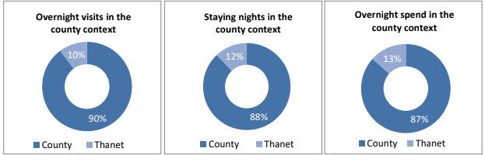

Day Visitors
Total Volume and Value of Day Trips
Thanet - 2019 Results

 | Trips | Spend
Total 2019 | 4,140,000 | £165,763,000
Comparison 2017 | 3,723,000 | £136,304,000
Difference | 11% | 22%

Day Visitors in the county context
District | Day Visits (millions) | Day visits Spend (millions)
Ashford | 4.3 | £155.30
Canterbury | 7.2 | £261.05
Dartford | 10.6 | £434.85
Dover | 4.3 | £141.09
Folkestone and Hythe | 4.4 | £141.78
Gravesham | 1.9 | £58.82
Maidstone | 4.1 | £148.86
Medway | 4.4 | £158.94
Sevenoaks | 4.1 | £153.12
Swale | 5.0 | £156.79
Thanet | 4.1 | £165.76
Tonbridge and Malling | 2.8 | £98.75
Tunbridge Wells | 4.5 | £174.02
Kent | 61.7 | £2,249.15

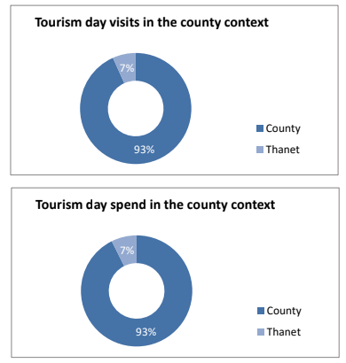

93%

Value of Tourism

Expenditure Associated with Trips Thanet - 2019 Results
Direct Expenditure Associated with Trips
 |  | Accomm. | Shopping | Food and Drink | Attractions | Travel | Total
UK Tourists |  | £18,809,000 | £6,931,000 | £11,745,000 | £5,620,000 | £10,367,000 | £53,472,000
Overseas tourists |  | £18,826,000 | £20,232,000 | £11,966,000 | £10,493,000 | £5,161,000 | £66,678,000
Total Staying |  | £37,635,000 | £27,163,000 | £23,711,000 | £16,113,000 | £15,528,000 | £120,150,000
Total Staying (%) |  | 31% | 23% | 20% | 13% | 13% | 100%
Total Day Visitors |  | £0 | £71,278,000 | £56,360,000 | £21,549,000 | £16,576,000 | £165,763,000
Total Day Visitors (%) |  | 0% | 43% | 34% | 13% | 10% | 100%
Total 2019 |  | £37,635,000 | £98,441,000 | £80,071,000 | £37,662,000 | £32,104,000 | £285,913,000
% |  | 13% | 35% | 28% | 13% | 11% | 100%
Comparison | 2017 | £40,021,000 | £89,495,000 | £71,988,000 | £29,942,000 | £29,384,000 | £260,831,000
Difference |  | -6% | 10% | 11% | 26% | 9% | 10%
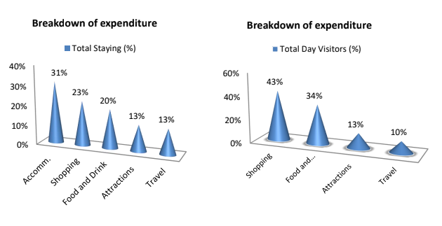

Other expenditure associated with tourism activity
Other expenditure associated with tourism activity - Estimated spend
Second homes | Boats | Static vans | Friends & relatives | Total
£935,000 | £1,280,000 | £218,400 | £24,555,000 | £26,988,400

Spend on second homes is assumed to be an average of £2,050 on rates, maintenance, and replacement of furniture and fittings. Spend on boats assumed to be an average of £2,050 on berthing charges, servicing and maintenance and upgrading of equipment. Static van spend arises in the case of vans purchased by the owner and used as a second home. Expenditure is incurred in site fees, utility charges and other spending and is estimated at £2,050. Additional spending is incurred by friends and relatives as a result of people coming to stay with them. A cost of £180 per visit has been assumed based on national research for social and personal visits.
Direct Turnover Derived From Trip Thanet - 2019 Results

Business turnover arises as a result of tourist spending, from the purchase of supplies and services locally by businesses in receipt of visitor spending and as a result of the spending of wages in businesses by employees whose jobs are directly or indirectly supported by tourism spending.
 | Staying Visitor | Day Visitors | Total
Accommodation | £38,110,000 | £1,127,000 | £39,237,000
Retail | £26,891,000 | £70,566,000 | £97,457,000
Catering | £23,000,000 | £54,669,000 | £77,669,000
Attractions | £16,621,000 | £22,826,000 | £39,447,000
Transport | £9,316,000 | £9,946,000 | £19,262,000
Non-trip spend | £26,988,400 | £0 | £26,988,400
Total Direct 2019 | £140,926,400 | £159,134,000 | £300,060,400
Comparison 2017 | £141,849,000 | £130,852,000 | £272,701,000
Difference | -1% | 22% | 10%

Adjustments have been made to recognise that some spending on retail and food and drink will fall within attractions or accommodation establishments. It is assumed that 40% of travel spend will take place at the origin of the trip rather than at the destination.

Supplier and Income Induced Turnover
 | Staying Visitor | Day Visitors | Total
Indirect spend | £8,201,000 | £8,906,000 | £17,107,000
Non trip spending | £4,048,000 | £0 | £4,048,000
Income induced | £15,313,000 | £15,053,000 | £30,366,000
Total 2019 | £27,562,000 | £23,959,000 | £51,521,000
Comparison 2017 | £27,493,000 | £19,498,000 | £46,991,000
Difference | 0% | 23% | 10%

Income induced spending arises from expenditure by employees whose jobs are supported by tourism spend.

Total Local Business Turnover Supported by Tourism Activity – Value of Tourism
 | Staying Visitor | Day Visitors | Total
Direct | £140,926,400 | £159,134,000 | £300,060,400
Indirect | £27,562,000 | £23,959,000 | £51,521,000
Total Value 2019 | £168,488,400 | £183,093,000 | £351,581,400
Comparison 2017 | £169,342,000 | £150,350,000 | £319,692,000
Difference | -1% | 22% | 10%

Employment

Employment
Thanet - 2019 Results
The model generates estimates of full time equivalent jobs based on visitor spending. The total number of ‘actual’ jobs will be higher when part time and seasonal working is taken into account. Conversion of full time equivalent jobs into actual jobs relies on information from business surveys in the sectors receiving visitor spending. A new Full Time Equivalent tourism job is created with every £54,000 increase in tourism revenue.
Direct employment
Full time equivalent (FTE)
 | Staying Visitor |  | Day Visitor |  | Total
Accommodation | 890 | 34% | 26 | 1% | 916 | 17%
Retailing | 355 | 14% | 932 | 36% | 1,287 | 25%
Catering | 509 | 20% | 1,211 | 46% | 1,720 | 33%
Entertainment | 246 | 9% | 338 | 13% | 584 | 11%
Transport | 108 | 4% | 115 | 4% | 223 | 4%
Non-trip spend | 500 | 19% | 0 | 0% | 500 | 10%
Total FTE 2019 | 2,608 |  | 2,622 |  | 5,230
Comparison 2017 | 2,631 |  | 2,164 |  | 4,795
Difference | -1% |  | 21% |  | 9%
Estimated actual jobs
 | Staying Visitor |  | Day Visitor |  | Total
Accommodation | 1,318 | 36% | 39 | 1% | 1,357 | 18%
Retailing | 533 | 15% | 1,398 | 36% | 1,931 | 25%
Catering | 764 | 21% | 1,816 | 47% | 2,580 | 34%
Entertainment | 347 | 9% | 476 | 12% | 823 | 11%
Transport | 152 | 4% | 163 | 4% | 315 | 4%
Non-trip spend | 570 | 15% | 0 | 0% | 570 | 8%
Total Actual 2019 | 3,684 |  | 3,892 |  | 7,576 | 0.548697464
Comparison 2017 | 3,740 |  | 3,218 |  | 6,957
Difference | -1% |  | 21% |  | 9%

Indirect & Induced Employment
Full time equivalent (FTE)
 | Staying Visitor | Day Visitors | Total
Indirect jobs | 227 | 165 | 392
Induced jobs | 284 | 279 | 562
Total FTE 2019 | 510 | 444 | 954
Comparison 2017 | 509 | 361 | 870
Difference | 0% | 23% | 10%

Estimated actual jobs
 | Staying Visitor | Day Visitors | Total
Indirect jobs | 259 | 188 | 447
Induced jobs | 323 | 318 | 641
Total Actual 2019 | 582 | 506 | 1,088
Comparison 2017 | 580 | 412 | 992
Difference | 0% | 23% | 10%

Total Tourism Jobs Thanet - 2019 Results
Actual jobs are estimated from surveys of relevant businesses at locations in England and take account of part time and seasonal working.
Full time equivalent (FTE)
 | Staying Visitor |  | Day Visitor |  | Total
Direct | 2,608 | 84% | 2,622 | 86% | 5,230 | 85%
Indirect | 227 | 7% | 165 | 5% | 392 | 6%
Induced | 284 | 9% | 279 | 9% | 563 | 9%
Total FTE 2019 | 3,119 |  | 3,066 |  | 6,185
Comparison 2017 | 3,140 |  | 2,525 |  | 5,665
Difference | -1% |  | 21% |  | 9%
Estimated actual jobs
 | Staying Visitor |  | Day Visitor |  | Total
Direct | 3,684 | 86% | 3,892 | 89% | 7,576 | 88%
Indirect | 259 | 6% | 188 | 4% | 447 | 5%
Induced | 323 | 8% | 318 | 7% | 641 | 7%
Total Actual 2019 | 4,266 |  | 4,398 |  | 8,664
Comparison 2017 | 4,320 |  | 3,630 |  | 7,950
Difference | -1% |  | 21% |  | 9%

.492386544 Tourism Jobs as a Percentage of Total Employment
 | Staying Visitor | Day visitors | Total
Total employed | 44,000 | 44,000 | 44,000
Tourism jobs | 4,266 | 4,398 | 8,664
Proportion all jobs | 10% | 10% | 20%
Comparison 2017 | 4,320 | 3,630 | 7,950
Difference | -1% | 21% | 9%
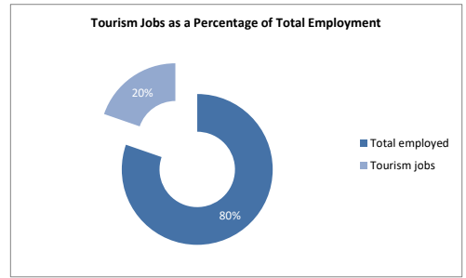

Economic Impact of Tourism – Headline Figures Thanet - 2019 Results
The key 2019 results of the Economic Impact Assessment are:
4.6 million trips were undertaken in the area
4.1 million day trips
0.5 million overnight visits
2.1 million nights in the area as a result of overnight trips
£300 million spent by tourists during their visit to the area
£25 million spent on average in the local economy each month.
£120 million generated by overnight visits
£166 million generated from day trips.
£352 million spent in the local area as result of tourism, taking into account multiplier effects.
8,664 jobs supported, both for local residents from those living nearby.
7,576 tourism jobs directly supported
1,088 non-tourism related jobs supported linked to multiplier spend from tourism

Appendix - Introduction about Cambridge Model
This report examines the volume and value of tourism and the impact of that expenditure on the local economy. The figures were derived using the Cambridge Economic Impact Model and the research was undertaken by Destination Research.
The model utilises information from national tourism surveys and regionally based data held by Destination Research. It distributes regional activity as measured in those surveys to local areas using ‘drivers’ such as the accommodation stock and occupancy which influence the distribution of tourism activity at local level.
Limitations of the Model
The methodology and accuracy of the above sources vary. The results of the model should therefore be regarded as estimates which are indicative of the scale and importance of visitor activity in the local area. It is important to note that in the national tourism surveys the sample sizes for each area changes year on year. This is as a result of the random probability nature of the methodology. As such, the results of the Cambridge Model are best viewed as a snapshot in time and we would caution against year-on-year comparisons.
It should be noted that the model cannot take into account any leakage of expenditure from tourists taking day trips out of the area in which they are staying. While it is assumed that these may broadly balance each other in many areas, in locations receiving significant numbers of day visitors from London, there is likely to be an underestimate in relation to the number of overseas day visitors staying in holiday accommodation in London.
Whilst it is important to be aware of these issues, we are confident that the estimates we have produced are as reliable as is practically possible within the constraints of the information available.
Rounding
All figures used in this report have been rounded. Therefore, in some tables there may be a slight discrepancy between totals and sub totals.
Data sources
The main national surveys used as data sources in stage one include:
• Great Britain Tourism Survey (GBTS) - information on tourism activity by GB residents; • International Passenger Survey (IPS) information on overseas visitors to the United Kingdom; • Day Visits in the annual Great Britain Day Visitor Survey using information on visits lasting more than 3 hours and taken on an irregular basis
These surveys provide information down to a regional level. In order to disaggregate data to a local level the following information sources are used:
• Records of known local accommodation stock held by Destination Research; • VisitEngland's surveys of Visits to Attractions, which provide data on the number of visitors to individual tourist attractions;
• Mid- 2019 estimates of resident population as based on the 2011 Census of Population; • Selected data from the 2011 Census of Employment;
• Selected data on the countryside and coast including national designations and length of the coastline.

Staying Visitors
The GBTS provides information on the total number of trips to the region and the relative proportions using different types of accommodation. By matching these figures to the supply of such accommodation, the regional average number of trips per bedspace or unit of accommodation can be derived. The IPS provides information on the total number of trips by overseas visitors to the region. The model uses three year rolling averages to reduce extreme highs and lows which are due to small sample sizes, rather than being a reflection on drastic changes in demand year-on year.
Day Visitors
Information on day trips at the regional level is available from the Day Visits in Great Britain survey (GBDVS). A day visitor is defined as someone making a day trip to and from home for leisure purposes. The report excludes trips undertaken for business or study purposes. This report presents data on those who took trips of at least 3 hours duration on an irregular basis as defined by the GBDVS. These are identified as tourism day trips by the Department of Culture, Media and the Sport.
Impact of tourism expenditure
This section examines the impact of the tourism expenditure in terms of the direct, indirect and induced expenditure as well as an estimate of the actual jobs (both direct and indirect) supported by tourism expenditure in the district.
The GBTS, IPS and Day Visits to Great Britain survey data on the breakdown of visitor spending. The impact of this initial round of expenditure will be subsequently increased by multiplier effects. These arise from the purchase of supplies and services by the businesses in receipt of visitor expenditure (indirect impacts), and by the income induced-effects arising from the spending of wages by employees in the first round of business and in subsequent expenditure in supplier business (induced impacts).
The New Earnings Survey which provides information on wage levels by industry sector and region; An internal business database which includes data on the structure of business expenditure, local linkages and multiplier ratios drawn from a wide range of business and economic studies carried out by Geoff Broom Associates, PA Cambridge Economic Consultants and others. By applying the breakdown to the estimates of visitor spending, the model generates estimates of total direct spending.
Evidence from national studies suggests that some minor adjustments are required to match visitor spend to business turnover – for example, some expenditure on food and drink actually takes place in inns and hotels that fall in the accommodation sector and within attractions. More significantly, expenditure on travel costs associated with individual trips is equally likely to take place at the origin of the trip as the destination. Therefore, the model assumes that only 40% of travel expenditure accrues to the destination area.
Number of full time job equivalents
Having identified the value of turnover generated by visitor spending, it is possible to estimate the employment associated with that spending. Wages for staff and drawings for the proprietors will absorb a proportion of that turnover. By applying these proportions to the overall additional turnover in each sector, the amount of money absorbed by employment costs can be calculated. The New Earnings Survey provides data from which the average costs by business sector, adjusted to take account of regional differences, can be calculated.
After allowing for additional costs such as National Insurance and pension costs, an average employment cost per full time equivalent job can be estimated. The number of such jobs in the local area can then be estimated by dividing the amount of business expenditure on wages and drawings by the average employment cost per job.
Number of Actual Jobs
The model generates estimates of full time equivalent jobs based on visitor spending. However, the total number of actual jobs will be higher when part time and seasonal working is taken into account. The full time equivalent jobs arising directly from visitor spending are converted into actual jobs using information from business surveys in the sectors receiving visitor spending (principally accommodation, food and drink, retail, attractions, transport). In general, the conversion factor between full time equivalent jobs and actual jobs varies around 1.5 in those sectors.
The indirect and induced jobs arise across a much wider range of employment sectors. Therefore, the average 1.16 for all sectors based on Census of Employment data has been used to convert full time equivalent jobs in this sector to actual jobs.
The employment estimates generated by the model include both self-employed and employed people supported by visitor expenditure. The model also includes an estimate of the additional jobs arising in the attractions sector, which are not related to visitor expenditure. However, the numbers do not include other tourism-related employment such as jobs in local authorities arising from their tourism functions, e.g. tourist information staff, additional public health, parks and gardens, public conveniences, maintenance sections and jobs arising from capital investment in tourism facilities.
Local level data for Kent EIA Reports 2019
The Cambridge Model allows for the use of local visitor related data. Local data from visitor surveys and other sources is not always sufficiently detailed or available regularly enough to make the results consistent. We rely on partners to collect additional locally sourced data to feed into the model. We have also used data from Southeastern, data on Airbnb from the online booking platform AirDNA, and from Visit Kent's Business Barometer such as Accommodation occupancy, visits to visitor attractions and VIC footfall.
Ashford
New product in 2019: Opening of Curious Brewery offering tours, shop, restaurant, in Ashford town centre part of the Chapel Down brand. (May 2019); Opening of new Travelodge in Ashford town centre, Elwick Place with 58 rooms (January 2019); Ashford Coachworks launched creating a new bar, dining and events space alongside co-working space next to Ashford International Rail Station (Autumn 2019)
Events
Annual Create free music festival in Victoria Park, Ashford, 14,000 footfall throughout the day (July 2019). Illuminites, digital mapping illuminated projection celebrating the history of Ashford. 5% increase in footfall to town centre in the evening economy.
Tenterden Folk Festival, weekend event. Estimated footfall approx. 5,000. (October 2019). Tenterden Christmas Market, estimated footfall over weekend 12,000-14,000 (Dec. 2019).
Dartford
Bluewater Shopping Centre - Bluewater attracts up to 28 million visitors per year. Only about a quarter of these visits is accounted for in the Cambridge Model, equating to about 7.8 million visits.
Dover
Port of Dover saw a total of 10,863,262 passengers in 2019, down from 11,723,411 in 2017. The number of cars was 2,000,966 (2,180,611 in 2017) and 73,856 coaches (down from 79,638 in 2017).
Maidstone
New product in 2019: A new river boat tour to the privately owned Allington Castle. Every Tuesday afternoon for 6 months, always fully booked up to 80 people; New small art gallery (Process Gallery) in Lenham; New boats for hire half and full day, run by the owners of the Kentish Lady River boat; New Outdoor Adventure In Mote Park. High ropes, climbing wall, mini golf and segways. (Open April to October); Hush Heath Winery Estate opened new Visitor Centre – now offering tours, tasting and food.
New Glamping site – Rankins Farm with 6 pods for up to 4 people; New accommodation at the Potting Shed, Langley (6 x double rooms); Additional accommodation built at the Black Horse Inn
Leeds Castle added new Adventure Golf and Playground. They also expanded the offer around the Festival of Flowers to offer pre-bookable afternoon tea.
Attraction Visitor Numbers: The latest footfall data from Leeds Castle, Kent Life and Kent Event Centre have been cross checked with the Business Barometer and included in the model.
Thanet
Car Parks - 2019 parking paid for via Ringo 183,205 (105,027 in 2017)
Boat Moorings – 4,142 visiting vessels and 7,500 visitor nights in 2019, up from 4,074 and 6,985 respectively in 2017.
The latest footfall data from Dreamland and Turner Contemporary (including the Turner Prize 2019 exhibition) have been cross checked with the Business Barometer and included in the model.
Tunbridge Wells
Summer schools: 150 summer school students in June to August 2019, up from 100 summer school students over June – August 2017. Students generally staying with families in Tunbridge Wells for 2 to 3 weeks. There were 60 overseas students over the rest of the year (including au pairs and general workers in Tunbridge Wells), up from 50 students in 2017.
2019 closures in Royal Tunbridge Wells (RTW):
Smart & Simple Hotel, Woods Restaurant, Gastronomia G restaurant, Burrswood Accommodation and Gardens, Rosemary Shrager Cookery School, Honnington Gardens B&B, Tunbridge Wells Golf Club, The TW Museum, Art Gallery and Library moved out of the building in RTW for major redevelopment works. The library and museum relocated to a little unit in Royal Victoria Place shopping centre, Apicius restaurant – fine dining, based in Cranbrook.

2019 Openings:
Richard Burnett Heritage Collection / Finchcocks Charity Collection of Harpsichords opened up in a smaller unit in RTW, Cellarhead Brewing company opened to visitors, based in Flimwell, Council stopped running the Farmers Market and it became independent so moved site within Town Centre of RTW, The Small Holding Kitchen opened up May Farm Accommodation in Kilndown, Lower Ladysden Farm opened up to visitors for ‘pick your own’ fruit near Cranbrook and, Central Market, foodie café /bar outdoor place in Royal Victoria Place shopping centre, RTW.
Car Parks – there were 1,752,360 transactions in 2019/20, up 14% from 1,536,526 in 2017/

Commissioned by Visit Kent as part of the Interreg Channel Experience
Project and co-financed by the European Regional Development Fund.
Produced by:
info@destinationresearch.co.uk
www.destinationresearch.co.uk

