Tourism Matters: COVID Restriction changes from Monday

It seems like we have had all the seasons over the last week. As some businesses prepare for reopening and start operating from Monday, we have included a recap of the Prime Minister’s speech on Monday and details of business opportunities for you.

If you know somebody who would like to read our e-news, please forward it on, or let them know they can register to receive it themselves on www.visitthanet.co.uk/tourismmatters

Thanet District Council
Following the update in the last edition on the new Respect, Protect, Enjoy campaign being rolled out in Thanet, we wanted to signpost you to the dedicated pages on the council’s website for more information on the council’s preparations - thanet.gov.uk/welcome-back.

Here, local businesses are able to download new assets to assist with their reopening on 12 April onwards. There are various themes of posters available, including encouraging social distancing or wearing a mask. There is also a poster which allows businesses to indicate the number of people allowed in their premises at any one time or to detail their opening times. Finally, there are posters that focus on welcoming people back safely and encouraging people to shop & eat local. Download them here

Also, keep an eye out for new pavement vinyl stickers which will be in place across the district’s town centres under the same shop & eat local theme.

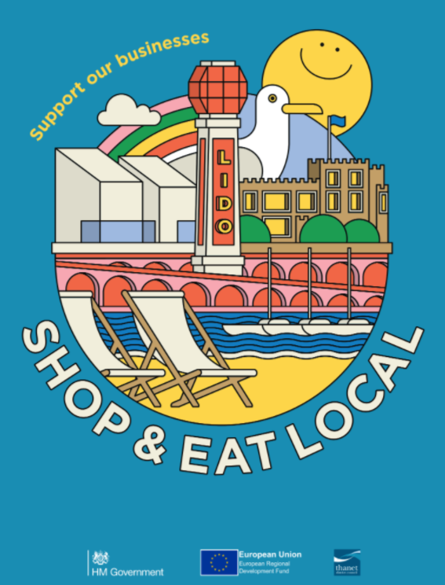

Government Updates
In his statement on Monday 5th April, the Prime Minister, Boris Johnson confirmed that, from Monday 12th April, England will move to step 2 of its roadmap. As part of the roadmap early thinking on four reviews has been published, on the safe return of major events, on social distancing, the potential role of Covid status certification, and on the resumption of international travel.

Updates to guidance on (COVID-19) Coronavirus restrictions: what you can and cannot do (England)

Some COVID-19 restrictions will be eased from 12 April
- Self-contained accommodation will be able to open for overnight stays in England for people with their household or support bubble
- Outdoor hospitality venues will be able to reopen, with table service only
- Most outdoor attractions including zoos, theme parks, and drive-in performances (such as cinemas and concerts) will be able to reopen
- Some smaller outdoor events such as fetes, literary fairs, and fairgrounds will be able to take place
- Non-essential retail will be able to reopen
- Personal care premises such as hairdressers and nail salons will be able to reopen
- Public buildings such as libraries and community centres will be able to reopen
- Weddings, civil partnership ceremonies, wakes and other commemorative events will be able to take place for up to 15 people (anyone working is not included in this limit), including in indoor venues that are permitted to open or where an exemption applies. Wedding receptions can also take place for up to 15 people, but must take place outdoors, not including private gardens
Guest accommodation providers such as hotels, B&Bs and caravan parks may only remain open for the specific reasons set out in law. A full list of reasons can be found in the guidance on closing certain businesses and venues in England

Key points from Update on Roadmap Reviews

A policy paper was published on Monday 5th April updating on the roadmap reviews

Updates to NHS COVID-19 app and twice weekly rapid testing to be available to everyone in England
Everyone in England will be able to access free, regular, rapid coronavirus (COVID-19) testing from Friday 9th April. To coincide with the offer of free rapid testing for everyone, there will be updates to the NHS COVID-19 app in England from Thursday 8th April. All venues in England in scope of the regulations are legally required to display an official NHS QR code poster. There will be new posters displaying QR codes for hospitality venues in England. Find out how to create an NHS QR code for your venue

Testing Kits are available from https://maps.test-and-trace.nhs.uk/
- Paydens Pharmacy Ltd - Minnis Road, Birchington
- Paydens Ltd - 67-69 Station Road, Birchington
- Paydens Ltd - 76 St Mildreds Road, Westgate-on-Sea
- Paydens Pharmacy Ltd - 164 Canterbury Road, Garlinge
- Paydens Ltd - 5-9 Hawley Street, Margate
- Pharma Plus Medical Ltd - 142 Northdown Road, Cliftonville Margate
- Paydens Pharmacy Ltd - Palm Bay Avenue, Cliftonville Margate
- Manor Pharmacy (Broadstairs) Limited - 73-75 High Street, Broadstairs
- Paydens Ltd - 15 The Broadway, Broadstairs
- Gs Phillips - 47 Newington Road, Ramsgate
- Tesco Stores Limited - Manston Road, Ramsgate
- Paydens Ltd - Montefiore Medical Centre, Ramsgate
- Asda Stores Ltd - 56 Chatham Street, Ramsgate
- Paydens Ltd - Dashwood Medical Centre, Ramsgate
- Paydens Ltd - 3-5 King Street, Ramsgate
- X-Pharm Limited - 72 High Street, Minster

Everyone in a group must check in
In line with new regulations, when a group enters a hospitality venue, every individual must check either by scanning the official NHS QR code poster with the NHS COVID-19 app, or by providing their contact details. Previously, only the lead member of the group needed to provide contact details to check in.

Venue history sharing
If an app user tests positive, they will be asked to share their venue history in a privacy-protecting way via the app. This will allow venue alerts to be generated more quickly, and improve the ability to identify where outbreaks are occurring and take steps to prevent the virus spreading.

Additional venue alerts
If a person has been at a venue on the same day as several other people who have since tested positive for COVID-19, they may receive an alert advising them to book a test immediately, whether they are showing symptoms or not. This is to support finding asymptomatic cases who may have caught the virus but are not displaying symptoms.

A new ‘Pharmacy Collect’ service is also launching which will provide an additional route to regular testing.

The universal offer is currently for England only. The Devolved Administrations make their own policy decisions around testing.

Read the press release to find out more, including how the expanded regular testing offer will be delivered

New Events Guidance
DCMS has published new events guidance which includes roadmap Step 2 and Step 3. Further information can be found here

Visit Kent - Winter Residents Tourism Survey
Visit Kent and Kent Downs AONB would like to hear from local residents about how they think of winter tourism in the county through a short survey. All respondents will have the opportunity to enter a draw for a chance to win a £40 food voucher at a Shepherd Neame pub or hotel of your choice.

The survey explores residents' perceptions of the impact that tourism has on the economy in your area, on your local community and on your wellbeing and is part of the INTERREG EXPERIENCE project.

The survey will take around 12 minutes to complete. It is conducted for Visit Kent and the Kent Downs AONB by the University of Surrey, and is co-financed by the European Regional Development Fund. You must be 18 years or over to complete the survey.

To take part in the survey by Friday 9th April, please click here

Update your Google Listing
As lockdown easing continues, and your business starts to reopen, visitors are more likely to want real time opening and COVID-19 safety information. If you have a Google My Business listing, keeping it up to date will enable visitors to know your current opening details which can increase visitors to your venue.

What is Google My Business?
Google My Business is a free tool that allows you to promote your Business Profile and business website on Google Search and Maps. With your Google My Business account, you can see and connect with your customers, post updates to your Business Profile and see how customers are interacting with your business on Google.

If you don’t have a Google My Business listing, they are very easy to set up. If you’d like to find out more about this, please contact Francesca from our team directly on francesca.sayer-doyle@thanet.gov.uk and she can provide advice and assistance.

You may also be interested to know that Google offers completely free 1:1 business help to improve your presence on Google Maps and Search with a Digital Expert. Go to goo.gle/ukmentoring to book a call.

Other News
Federation of Small Businesses - Managing Long Covid (free webinar)
Wednesday 14th April, 11am to 12pm
The webinar will cover the impact of long COVID on small employers and their employees, small business owners and the self-employed and will answer questions about dealing with long COVID in the workplace and the implications for employment law.

For further information and to register, click here

Your News
Congratulations to the Thanet Businesses who have received grants in the latest Culture Recovery Fund. To read more about this, click here

Congratulations to The Palace Cinema in Broadstairs, that has received an grant award from the British Film Institute.

