Tourism Matters - Summer Beach Management Plans

The clocks have gone forward, restrictions are starting to ease and it is already Easter Weekend. We are sending our very best wishes to all our tourism colleagues running outdoor activities, who are now able to open again, we hope all goes well for you.Our thoughts are also with those still waiting to reopen, fingers crossed the roadmap to recovery goes to plan and you will soon be reopening too.

In this issue of Tourism Matters we focus on the Beach Management plans for the summer

Thanet District Council - Beach Focus

Council prepares for summer season to start three months early

Thanet District Council has updated its Beach Management Plan, with preparations in place three months earlier than normal, ready for the Easter weekend.

Every year in Thanet, plans are made for ‘high season’ which tends to coincide with school summer holidays. However, this year the council has built on the experience gained last season and listened to residents’ concerns in its proactive planning for a potential influx of visitors to the district with Government restrictions easing. It has made some changes to its preparations which crucially includes activating its Beach Management Plan much earlier.

The Council’s Beach Management Plan (first published June 2020) aims to help everyone respect, protect and enjoy Thanet’s coastline by working with multiple key agencies.

Based on learnings and feedback from last year, the Council has:

Litter:
- Installed 80 new 1,100 litre colourful bins which are normally reserved for the summer months. These bins will be emptied twice a day, seven days a week.
- Ordered 42 new blue recycling bins for its Blue Flag and Seaside Award beaches. These will be put out at the end of April and have ‘aperture’ type tops to accept bottles and cans etc whilst making it more difficult to dispose of non-recyclable waste.
- Extended working hours of its cleansing teams on beaches/promenades for the duration of the school Easter holidays.
- Assigned two mobile litter teams on the coastline. These are in addition to the static cleaners at Margate, Broadstairs, Ramsgate and Joss Bay.
- Completed sand levelling and large scale litter-raking. The beach tractor will then follow the normal summer rota from 5 April 2021.

Anti-social behaviour, including COVID restrictions:
- Provided four Covid-wardens for beaches and promenades.
- Recruited dedicated enforcement officers to educate people on the Council’s new Beaches and Coast Public Spaces Protection Order (PSPO) and Coastal Code of Conduct. This PSPO makes the rules of our coast clear and enforcement officers will challenge nuisance behaviour and can issue FPNs of £100 for serious and persistent breaches. They will be working alongside Kent Police Officers.

Toilets:
- Opened all of the toilets around the district from Monday 29 March, which will be cleaned throughout the day.
- Installed portaloos at Margate Main Sands and Botany Bay.
- Increased security around our toilets.

Parking
- Increased presence of Civil Enforcement Officers patrolling on foot in the Kingsgate/Broadstairs area.
- Prepared static signage to direct visitors to some of the beaches which have more space and available parking when needed.

To read the full news release, please visit the Thanet District Council website

Viking Bay and Ramsgate Lifts
Unfortunately the lifts will remain closed. Even if temporary repairs can be made to get the lifts open, contractors have advised there is no guarantee they will stay working during the season. A long-term strategy for both lifts will be formulated to consider their future, in the meantime, the council has measures in place to allow for alternative accessible routes to the beach, which include:

- putting matting at one side of the beach (Harbour Street, Broadstairs) to lengthen the boardwalk and allow for alternative accessible routes to the beach.
- installing four additional disabled parking bays at Harbour Street Car Park in mid April. Blue Badge holders will be reminded that they can park for free in any available parking bay providing they display their badge.

A new creative to accompany messaging on ‘Respect, Protect and Enjoy’ as below, will be seen at prominent locations across the district including bus stops, along roads, popular beaches, train stations, car parks and on litter bins.
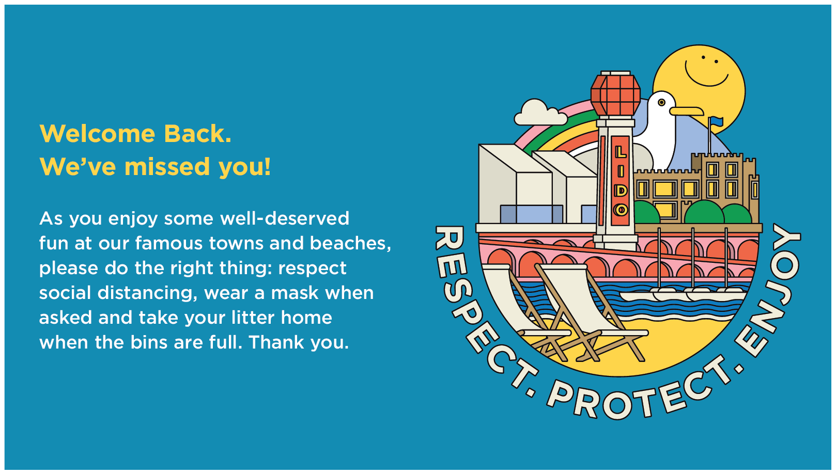

Visit Kent
Updates and Clarifications
Visit Kent has received updated guidance as well as clarification on a number of queries

Outdoor guided tours
From the 29th March, outdoor, socially-distanced, organised activities including workshops such as photography, gardening, and crafts at heritage sites and other outside spaces will be permitted.

Other outdoor activities such as themed walking trails will also be permitted including guided walks consisting of either a single permitted group or multiple permitted groups that are kept separate throughout the tour. These types of activities are subject to the gathering limits set out in the Roadmap - i.e. outside in groups up to a maximum of 6 people (the Rule of 6) or with one other household, though people from different households will still need to socially distance from each other. Support bubbles will continue to be counted as part of the same household.

The tour guide does not count towards the Rule of 6 or 2 households limits.

Other updates include:
- Show rounds for business events, meetings, training and education are permitted from 29 March if this cannot reasonably be done from home (even if the venue is otherwise closed).
- Weddings show rounds can only take place when the venue is permitted to open for leisure purposes - people must not visit a closed venue for the purposes of a wedding viewing.

Visit Kent has a FAQs section of their website with further information

Winter Tourism Survey
Visit Kent and Kent Downs AONB would like to hear from local residents about how they think of winter tourism in the county through a short survey. All respondents will have the opportunity to enter a draw for a chance to win a £40 food voucher at a Shepherd Neame pub or hotel of your choice.

The survey explores residents' perceptions of the impact that tourism has on the economy in your area, on your local community and on your wellbeing and is part of the INTERREG EXPERIENCE project.

The survey will take around 12 minutes to complete. It is conducted for Visit Kent and the Kent Downs AONB by the University of Surrey, and is co-financed by the European Regional Development Fund. You must be 18 years or over to complete the survey.

To take part in the survey by Friday 9th April, please click here

National Coastal Tourism Academy Survey
We would appreciate as many businesses as possible spending a little bit of time completing the National Coastal Tourism survey to see how we compare nationally to help understand the impact of the last year on businesses, the plan for recovery and the support that is needed.

Click here to complete the survey before the deadline of the end of Monday 5th April. Thank you for your support with this.

Thank you to everyone who has already completed the survey as it is extremely valuable.

Tourism and Visitor Information News
Plans are being finalised for the reopening of the Thanet Visitor Information Centre and we hope to have a date for you soon. The team remains available for enquiries between Wednesday -Sunday 10am-5pm via email, telephone and on social media. The team will be available on Easter Monday (5th April).

