February’s Tourism Matters: Have your say and Business Grant Updates

Dear Tourism Industry Colleague,

It has definitely felt a bit colder around Thanet in the last few days, with some lovely snowy images shared with us on social media.

This month we bring you an update on the Government’s loan schemes and the chance for you to have your say in the Foreshores and Coastline Consultation.

If you know somebody who would like to read our e-news, please forward it on, or let them know they can register to receive it themselves on www.visitthanet.co.uk/tourismmatters

Thanet District Council
Have your say on Foreshores and Coastline PSPO Consultation
Thanet District Council has launched a live public consultation for all to have their say on the Foreshore and Coastline Public Spaces Protection Order 2021 running from Monday 25th January to Sunday 21st February.

The consultation is on two proposals which will affect how residents and visitors use and enjoy our Beaches and Coastline.

The first proposal is the introduction of a new Beaches and Coast Public Space Protection Order (PSPO), which is based on the current bylaws. The second proposal focuses on the way that Powered Water Crafts (PWC) access and use the coastline, alongside changes to the water user group.

Full details of the proposal can be found online. We would appreciate you completing the live questionnaire providing your thoughts and feedback.

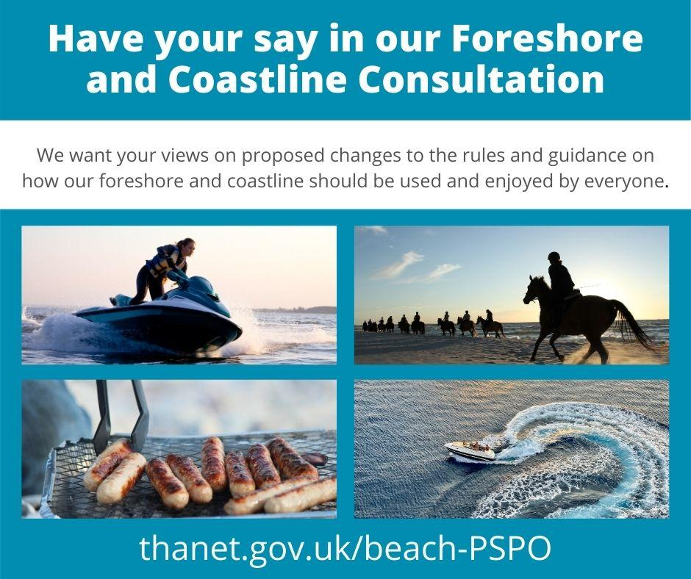

Business Grants Update
We are still awaiting information from the Department for Business, Energy & Industrial Strategy about the next stage of business grants for the period 16 February onwards.

For the majority of businesses, we have now paid up to and including Monday 15 February 2021 but are waiting for guidance about when further payments can be made and how much they will be.

For more information and details of other business support available:
- visit Thanet District Council COVID-19 business support pages
- email highstreets@thanet.gov.uk to sign-up for updates direct to your inbox
- request to join Thanet Business Support Facebook Group
- call the business support line (03333 602300), delivered by the Kent & Medway Growth Hub, between 8:30am and 5pm Monday – Friday

Virtual Cuppa Club
A new fortnightly online coffee and support group for local businesses has launched as part of the Safe Reopening of High Streets funding. The virtual cuppa club is a chance to meet other business owners in our high streets for a friendly chat.

It will take place fortnightly, with the next one being on Wednesday 24th February. Email highstreets@thanet.gov.uk to request the link to join.

In the current situation, owning a business can feel lonely and overwhelming, so these informal meetings aim to help local businesses build a stronger community within our town centres. Thanet District Council believe that as a collective group, businesses will be better equipped for reopening once restrictions ease.

There is no formal structure, just a get together for a catch-up and to share information and advice, particularly around how everyone has had to adapt. The group is facilitated by Business Support Consultant, Sharon Davies, who is in post until late March as part of dedicated funding for #SafeReopeningofHighStreets. If the meet-ups are successful, it is hoped they will continue beyond this point

Staying Safe on our Coastline
Following recent heavy rainfall, frosty nights and snow our cliffs have become weakened, leaving some sections particularly vulnerable to cliff falls. Thanet District Council are advising the public to take extra care when walking on clifftop paths or on the beaches below.

Read the following statement from Cllr Albion here

Government Updates
Flexible repayment options announced for Bounce Back Loan borrowers
On Monday 8th February, the Chancellor announced repayment flexibilities for Bounce Back Loan borrowers, with the ability to tailor payments according to individual circumstances. The scheme provides the option for small and medium-sized businesses to access finance more quickly during the coronavirus outbreak.

The new options include:
- Extending the length of the loan from six to ten years (reducing monthly repayments by almost half),
- Making interest-only payments for six months, with the option to use this up to three times throughout the loan
- Pausing repayments for up to six months. This will be available to all from their first repayment, rather than after six repayments have been made. This means that businesses can choose to make no payments on their loans until 18 months after they originally took them out.
This is in addition to the Government covering the costs of interest for the first year of the loan.

From Monday 8th February lenders should begin reaching out to borrowers to provide information on repayment schedules and how to access flexible repayment options. Borrowers should only expect correspondence three months before their first repayments are due.

Small and medium-sized businesses can apply to borrow between £2,000 and up to 25% of their turnover. The maximum loan available is £50,000. The scheme is open to applications until Wednesday 31st March

If a business already has a Bounce Back Loan but borrowed less than they were entitled to, the existing loan can be topped up to the maximum amount. The top-up request must be made by Wednesday 31st March

Guidance on funding for employers looking to create jobs placements for young people
Guidance is available on the Kickstart Scheme, which provides funding to create new job placements for 16 to 24 year olds on Universal Credit who are at risk of long term unemployment. Employers of all sizes can apply for funding which covers:
- 100% of the National Minimum Wage (or the National Living Wage depending on the age of the participant) for 25 hours per week for a total of 6 months
- Associated employer National Insurance contributions
- Employer minimum automatic enrollment contributions
Employers can spread the start date of the job placements up until the end of December 2021. Further funding is available to provide support so that young people on the scheme can get a job in the future.

Find more information on eligibility, how to apply and the job placement criteria here.(https://www.gov.uk/guidance/apply-for-a-kickstart-scheme-grant)

Mandatory hotel quarantine to be introduced from Monday 15th February
Last week the Government announced that from Monday 15th February anyone travelling to the UK from a country on the UK’s travel ban list will be required to quarantine in a government-approved facility for 10 days. Further details will be set soon on how passengers will be able to book into the designated accommodation facilities.

Applications for Christmas Support Payment for wet-led pubs extended
The Christmas Support Payment (CSP) supports wet-led pubs that have been severely impacted over the Christmas period due to temporary local restrictions. The deadline for applications for the Christmas Support Payment has been extended to Sunday 28th February 2021.

Self-Employment Income Support Scheme (SEISS) update
Claims for the third SEISS grant have now closed. The last date for making a claim for the third grant was Friday 29th January. Details about the fourth grant will be announced on Wednesday 3rd March.

VisitBritain/VisitEngland
Take part in the self-caterers’ survey
The Professional Association of Self-Caterers (PASC) UK and the Association of Scotland’s Self –Caterers (ASSC) have teamed up to run a UK-wide survey to look at the economic impact of COVID-19 on the sector.

The resulting data will be available on a UK, country, region and county level and will be freely available.

To read more about the survey and to take part, please click here. The deadline to participate is Sunday 14th February

Visit Kent
Lobbying Government for the Tourism Sector
Visit Kent, through their place on the Tourism Alliance Board and the Tourism Industry Emergency Response Group, is actively feeding into the national Tourism Recovery Strategy and lobbying for the sector ahead of the budget on Wednesday 3rd March.

Visit Kent is asking businesses to contact their local MP using a letter developed by The Tourism Alliance, asking the Government to provide the following support for tourism businesses as part of this year’s budget:

- Retain the 5% VAT Rate for 2021 and expand it to cover on-premises alcohol sales
- Extend Business Rates Relief and Reform Business Rates
- Extending Furlough Scheme for businesses impacted by social distancing or travel restrictions

It is written so that it is widely applicable to all businesses although you are welcome to tweak it so that it better fits your specific circumstances – however, please do not change the three core asks (detailed above). To access the letter template, please click here

To send your letter, you can do this using WriteToThem where you simply need to:
- Enter your postcode
- Select “Your MP” from the list of public official in their area
- Cut and paste the template letter into the box provided
- Enter their details where indicated
- Click send

The 149th Open - Championship Update from The R&A
Martin Slumbers, Chief Executive of The R&A, has given an update on the plans for staging The 149th Open from Sunday 11th - Sunday 18th July at the Royal St George's Golf Club in Sandwich.

Read the update here

Tourism and Visitor Services News
Interreg Experience Development Project Update
Thanet District Council is a contributing partner in the Interreg Experience Development Project. The aim for this project activity is to have a minimum of 10 new, bookable tourism experiences which are available between October to March, to help extend the visitor season and generate income in the destination during the quieter autumn/winter season. The project is also vital activity to help rebuild the tourism sector and help counter the impact of COVID-19.

The tourism team has been working hard, alongside Visit Kent, to encourage both tourism and non-traditional tourism businesses, who have an idea for a new experience, or who would like to diversify their current offering, to submit applications. As a result, during the application phases, 10 new tourism experience applications have been approved for the project and a further seven have been accepted subject to conditions, for example, that they receive funding they have applied for, or find a suitable premises to deliver the experience from. Businesses accepted onto the project benefit from the equivalent of £6,000 in support. This support includes a 121 consultation, product testing, content development, consumer marketing and B2B distribution.

The Interreg Experience Development Project project is a 4-year scheme that runs until the end of August 2023, and is worth €23 million across 10 partners in France and England. Led by Norfolk County Council, both Visit Kent, the destination management organisation for the county, and the Kent Downs AONB, are core partners with distinctive roles underpinned by budgets of €1.6 and €3.1 million respectively. Further information on the project can be found here

New Viking Coastal Trail Blog
Have you read our latest blog ‘7 Naturally Socially Distanced Viking Coastal Trail Doorstep Adventures’? Our blogs can be used as a source of ideas for your guests and shared on social media - please do reshare on your channels to inspire future visits.

