Tourism Matters: Budget News, Margate Town Deal and Free Workshops

Dear Tourism Industry Colleague,

In this issue we bring you a summary of the Chancellor’s budget announcement, Margate’s Town Deal being awarded up to £22.2 million, a reminder of the reopening roadmap and a number of opportunities for you to get involved with - Arts Homes, Tourism Experience development and Heritage Open Days

Government News
Budget 2021 Announcement
Yesterday (Wednesday 3rd March) Chancellor, Rishi Sunak, outlined his tax and spend policies in the budget. Below is a summary for the tourism and hospitality industry. You can read what you need to know summary here or view the budget document here

Coronavirus Job Retention Scheme (CJRS) extension
The CJRS will be extended across the UK for five months until Thursday 30th September 2021. Employees will continue to receive 80% of their current salary for hours not worked. There will be no employer contributions beyond National Insurance contributions (NICs) and pensions required in April, May and June. From July, the government will introduce an employer contribution towards the cost of unworked hours of 10% in July, 20% in August and 20% in September, as the economy reopens.

UK Self-Employment Income Support Scheme (SEISS) fourth and fifth grants confirmed

SEISS fourth grant – the fourth SEISS grant will be worth 80% of three months’ average trading profits, paid out in a single instalment and capped at £7,500 in total. The grant will cover the period February to April, and can be claimed from late April. Self-employed individuals must have filed a 2019-20 Self Assessment tax return to be eligible for the fourth grant.

SEISS fifth grant – there will be a fifth and final SEISS grant covering May to September. The value of the grant will be determined by a turnover test. People whose turnover has fallen by 30% or more will continue to receive the full grant worth 80% of three months’ average trading profits, capped at £7,500. People whose turnover has fallen by less than 30% will receive a 30% grant, capped at £2,850. The final grant can be claimed from late July.

Restart Grants
The government will provide ‘Restart Grants’ in England of up to £6,000 per premises for non-essential retail businesses and up to £18,000 per premises for hospitality, accommodation, leisure, personal care and gym businesses. The government is providing all local authorities in England with an additional £425 million of discretionary business grant funding, on top of the £1.6 billion already allocated.

VAT reduction for the UK’s tourism and hospitality sector
The temporary reduced rate of 5% VAT for goods and services supplied by the UK tourism and hospitality sector will be extended until Thursday 30th September 2021. A 12.5% rate will apply for the subsequent six months until 31st March 2022.

Business rates relief
Eligible retail, hospitality and leisure properties in England will receive 100% business rates relief from Thursday 1st April 2021 to Wednesday 30th June 2021. This will be followed by 66% business rates relief for the period from Thursday 1st July 2021 to 31st March 2022, capped at £2 million per business for properties that were required to be closed on Tuesday 5th January 2021, or £105,000 per business for other eligible properties.

New Recovery Loan Scheme for UK businesses
From Tuesday 6th April 2021 a new Recovery Loan Scheme has been announced to enable businesses of any size to access loans and other kinds of finance up to £10 million per business once the existing COVID-19 loan schemes close.

Launching on Tuesday 6th April and open until Friday 31st December, subject to review, the Government will guarantee 80% of the finance to the lender. Loans will be available through a network of accredited lenders, whose names will be made public in due course. Term loans and overdrafts will be available between £25,001 and £10 million per business. Invoice finance and asset finance will be available between £1,000 and £10 million per business. Finance terms are up to six years for term loans and asset finance facilities. For overdrafts and invoice finance facilities, terms will be up to three years. Find out more, including eligibility criteria.

Statutory Sick Pay (SSP) Rebate Scheme
Small and medium-sized employers across the UK will continue to be able to reclaim up to two weeks of eligible SSP costs per employee. This scheme is a temporary COVID-19 measure intended to support employers while levels of sickness absence are high.

VAT Deferral New Payment Scheme
Any business that took advantage of the original VAT deferral on VAT returns from 20th March through to the end of June 2020 can now opt to use the VAT Deferral New Payment Scheme to pay that deferred VAT in up to eleven equal payments from March 2021, rather than one larger payment due by Wednesday 31st March 2021, as originally announced.

Extended loss carry back for businesses
To help otherwise-viable UK businesses which have been pushed into a loss-making position, the trading loss carry-back rule will be temporarily extended from the existing one year to three years. This will be available for both incorporated and unincorporated businesses.
- Unincorporated businesses and companies that are not members of a corporate group will be able to obtain relief for up to £2 million of losses in each of 2020-21 and 2021-22
- Companies that are members of a corporate group will be able to obtain relief for up to £200,000 of losses in each of 2020-21 and 2021-22 without any group limitations
- Companies that are members of a corporate group will be able to obtain relief for up to £2 million of losses in each of 2020-21 and 2021-22, but subject to a £2 million cap across the group as a whole
This will be legislated in the forthcoming Finance Bill. Further detail on the group cap will be announced in due course.

Other measures include:
- £300 million to extend the Culture Recovery Fund to continue to support theatres, museums and other cultural organisations in England.
- £90 million for continued support for government-sponsored National Museums and cultural bodies in England.
- £300 million for continued support to major spectator sports in England, supporting clubs and governing bodies.
- Duty rates on beer, cider, wine and spirits will be frozen for another year.
- Employers in England who provide trainees with work experience will continue to be funded at a rate of £1,000 per trainee.
- Employers in England who hire a new apprentice between Thursday 1st April and Thursday 30th September 2021 will receive £3,000 per new hire, compared with £1,500 per new apprentice hire (or £2,000 for those aged 24 and under) under the previous scheme. This is in addition to the existing £1,000 payment the government provides for all new 16-18 year-old apprentices and those aged under 25 with an Education, Health and Care Plan, where that applies.
- £7 million fund will be available from July 2021 to help employers in England set up and expand portable apprenticeships to enable people who need to work across multiple projects with different employers.
- A new Help to Grow training scheme over three years for SMEs on digital skills and management skills.
- Zoo Animals Fund extended for a further three months until Wednesday 30th June 2021, providing licensed zoos and aquariums in England with continued support for animal care and essential maintenance costs.
- £28 million to fund the Queen’s Platinum Jubilee celebrations in 2022, delivering a major celebration for the UK.
- From the summer, community groups will be able to bid for up to £250,000 matched funding (with some exceptions) through the £150 million Community Ownership Fund to help them to buy local assets to run as community-owned businesses e.g. pubs, theatres, shops, or local sports clubs.
- Publication of the prospectus for the £4.8 billion UK-wide Levelling Up Fund, providing guidance for local areas on how to submit bids for the first round of funding starting in 2021-22.
Increase in corporation tax
The rate of corporation tax will increase from April 2023 to 25% on profits over £250,000. The rate for small profits under £50,000 will remain at 19% and there will be relief for businesses with profits under £250,000 so that they pay less than the main rate.

New guidance on reopening businesses and venues in England

Further to the release of the UK Government’s COVID-19 four-step plan to ease lockdown in England, new guidance on reopening businesses and venues in England has been published. Please see below graphics of the reopening roadmap

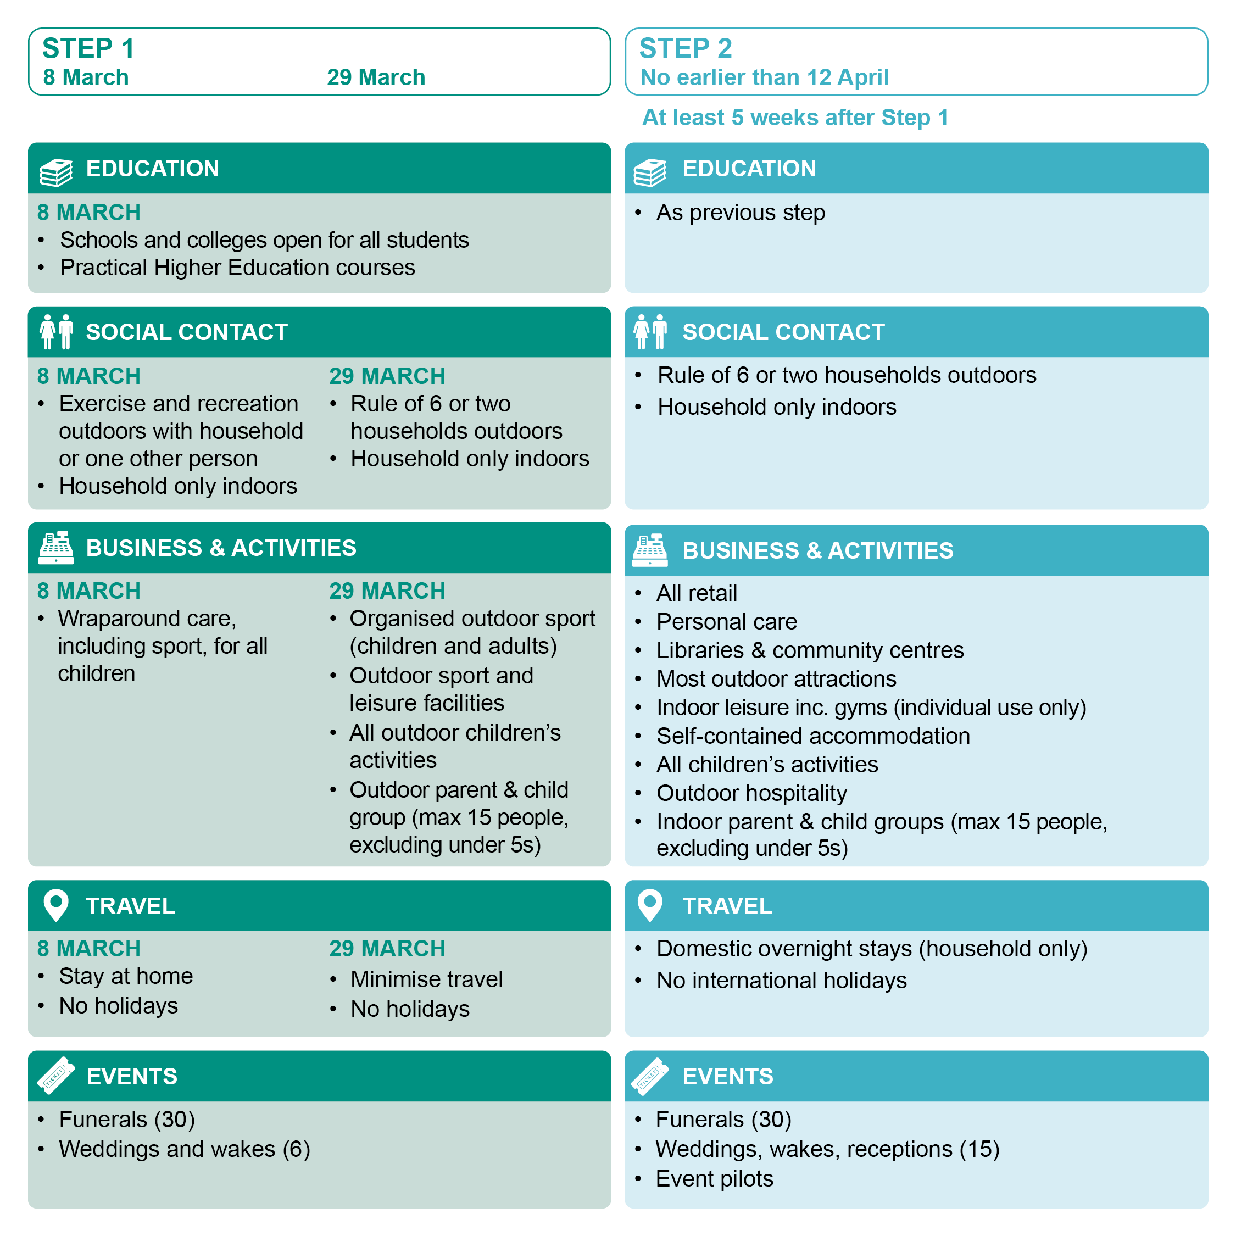
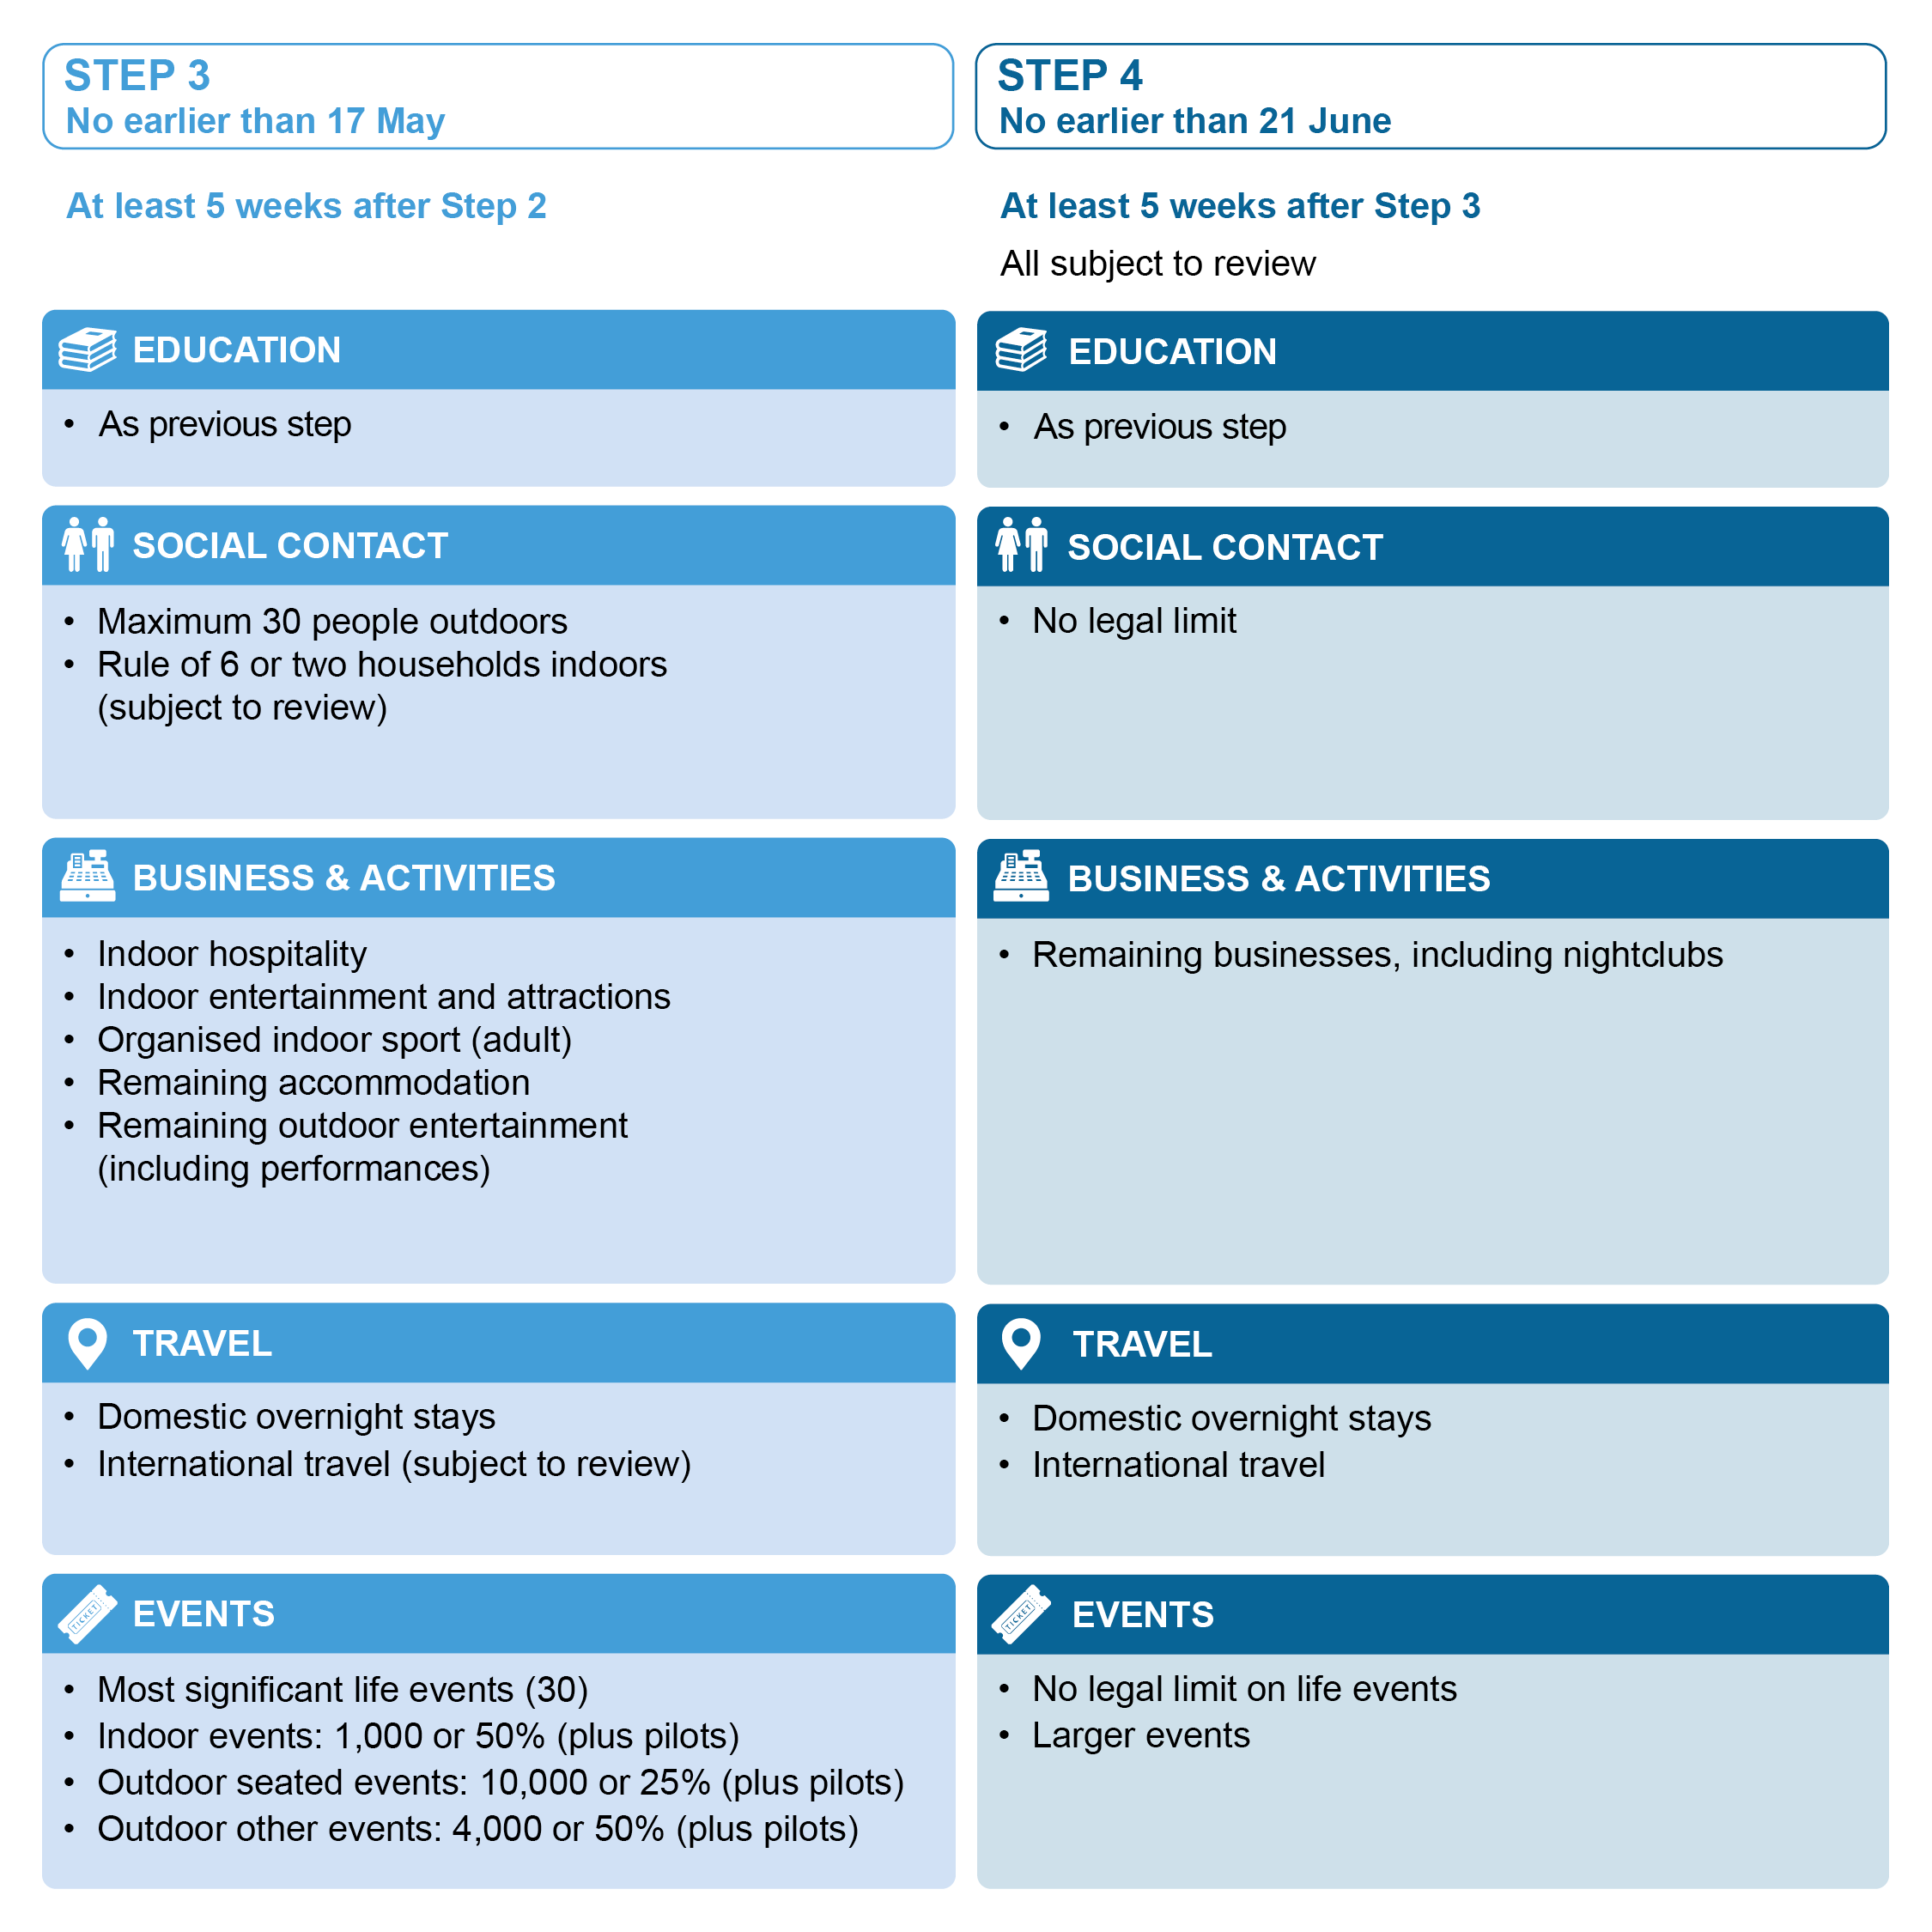

Thanet District Council
Margate Town Deal Announcement
Margate is set to benefit from up to £22.2 million of funding following the Government's Town Deal programme announcement in the Chancellor's Budget on Wednesday 3rd March 2021.

The funding was awarded after Thanet District Council worked with a dedicated Town Deal Board to submit its Town Investment Plan (TIP) to the Ministry of Housing, Communities and Local Government in December 2020.

The Plan outlined a string of internlinked investments around four key themes:
- Scaling Margate’s Creative Production and Skills sector
- Investments in Coastal Wellbeing
- Investment in Public Realm and Connections
- Investment in Supporting and Diversifying Heritage Assets

Read the full press release online.
VisitBritain/VisitEngland
‘We’re Good To Go’ participants get global ‘Safe Travels’ stamp
VisitBritain has announced that tourism businesses in the UK registered to the ‘We’re Good To Go’ industry standard scheme can now be automatically issued with the international ‘Safe Travels’ stamp from the World Travel & Tourism Council (WTTC).

The We’re Good To Go scheme, launched last year by VisitEngland in partnership with the tourism boards of Northern Ireland, Scotland and Wales, has been recognised by the WTTC as meeting its international global standardised health and hygiene protocols and for its role in supporting the recovery of the UK tourism sector.

Any business not already part of We’re Good To Go can apply to the scheme and indicate that they wish to use the additional global WTTC stamp. They will need to demonstrate that they are adhering to the latest Government and public health guidance, that they have carried out a COVID-19 risk assessment and have the required processes in place to aid social distancing and cleanliness.

NCTA Free Coastal Businesses Experience Tourism workshops
The National Coastal Tourism Academy (NCTA) is running two free workshops to help coastal businesses / destinations as visitors are increasingly looking for more genuine ‘authentic experiences’ as part of their holiday.

Presented by the England’s Coast project and Tourism Business Advisor Chris Brant from Unmissable England, the first short workshop will provide an introduction to Experience Tourism, where visitors engage in new activities or pursuits to create lasting memories. Chris is an Experience Maker himself and runs a series of visitor experiences, including baking scones in a thatched cottage and running vineyard tours with wine and gin tasting. You’ll hear first-hand from a panel of coastal businesses, how they tapped into new markets and built growth in the off-peak season. This is a great starter session for any coastal business!

In the second workshop, Chris will delve a little deeper into the key components of experiences and take participants through an interactive workshop on how to create new experiences, get them to market and top tips needed to be successful.

Wednesday 10th March 10-11.30am - Book your free ticket here
Tuesday 23rd March 10-12.30pm - Book your free ticket here

Visit Kent - Art Homes Workshop
Wednesday 10th March 10am-12pm
Do you currently let your property on the Kent Coast to short-stay visitors? Are you looking at ways to rebuild your business once travel restrictions have eased?

The Art Homes Pilot project can help your property to stand out from the crowd and connect you to the local creative industry, as well as providing you with support for ensuring your property is Covid secure. Click here to find out more

Join Visit Kent to find out how you can get involved. At this webinar you’ll hear the latest guidance and advice on how to operate a home-stay property in a pandemic from the experts, Quality in Tourism.

To register your interest in attending, please click here

Learning Producer, Community Rail Partnership Job Opportunity
Turner Contemporary are looking for someone with great project management skills who is passionate about working with the local community to be a Learning Producer for the newly formed Creative Isle Community Rail Partnership (CRP). CRPs encourage greater use of rail services through increased participation of local communities in their rail line and through a range of activities at and surrounding their stations.

To read more about the job opportunity and to allow please, click here

The deadline for applications is 9am on Wednesday 10th March 2021

Heritage Open Days 2021 Registration Open
Have you ever thought about taking part in Heritage Open Days national festival? Well, becoming part couldn’t be easier. Whether there is a local figure you would like to celebrate, a historic area you would like to see recognised, or simply want to tell the story of your home, office or place of work, we’d love you to take part.

To find out more about the scheme and to register your interest, please visit the Heritage Open Days website

Heritage Open Days is back between Friday 10th - Sunday 19th September

Become a Golf Volunteer
Are you a fan of golf? Would you like to be part of one of the biggest Golf events? Do you like helping people? If the answer is yes to any of these, now is the chance to apply to become a Volunteer at the The 149th Open at Royal St. George's in Sandwich.

Event Makers Kent are working with The R&A in providing Event Makers to welcome visitors to the area, providing useful information and assistance.

If you would like to sign up and find out more about this opportunity, click here

Your News
Margate NOW are looking for a Kent-based designer to work with them on revamping their brand for this year’s festival! They are after an engaging, accessible visual identity for Margate NOW 2021 that will be used across our website, social media, printed marketing, and wayfinding.

To find out more about the project and to apply by Monday 15th March visit the festival website

