January’s Tourism Matters: A short update with positive news

Dear Tourism Industry Colleague

We have a short update for you this week, which includes positive news on COVID-19 testing in Thanet, business grants and a free opportunity through the National Coastal Tourism Academy to help you promote your business.

If you know somebody who would like to read our e-news, please forward it on, or let them know they can register to receive it themselves on www.visitthanet.co.uk/tourismmatters

Thanet District Council
Access to COVID-19 testing
A positive move in the fight against COVID-19 is the recent opening of two asymptomatic testing sites for people who live and work in Thanet. One is at Ramsgate Port, the other at The Centre, Birchington. These are in addition to sites in Margate and at Manston for people experiencing symptoms. Booking details here: thanet.gov.uk/testing/

Cases in Thanet remain high and above the national average so it's vital that we all play our part, follow the rules and encourage others to do the same.

Business Grants
You’ll have seen the latest Government announcement about a new package of support for businesses forced to close during the national restrictions. These grants will once again be disseminated via Local Authorities.

Our TDC colleagues are working through applications as quickly as they can and have paid well over 1.5m to over 1,000 businesses. The wet-led pubs grant for pubs forced to close has also had 370 applications since it opened and we have paid out around 70 so far. Applications are open until Sunday 31st January. Link here

The form for December Tier 3 and Tier 4 grants is now available for applications. Link here. You DO NOT need to complete if you applied for either of the November national lockdown grants.

In positive news, extensive work has taken place to streamline the application process and improve the software that the team is using. The result is that there is now a single application portal which means that businesses do not need to reapply every fortnight or any time there is a change of tiers in the future. This will speed up the payment process to local businesses significantly.

Please continue to check the dedicated Thanet Business Support Facebook group which is providing regular updates to businesses.

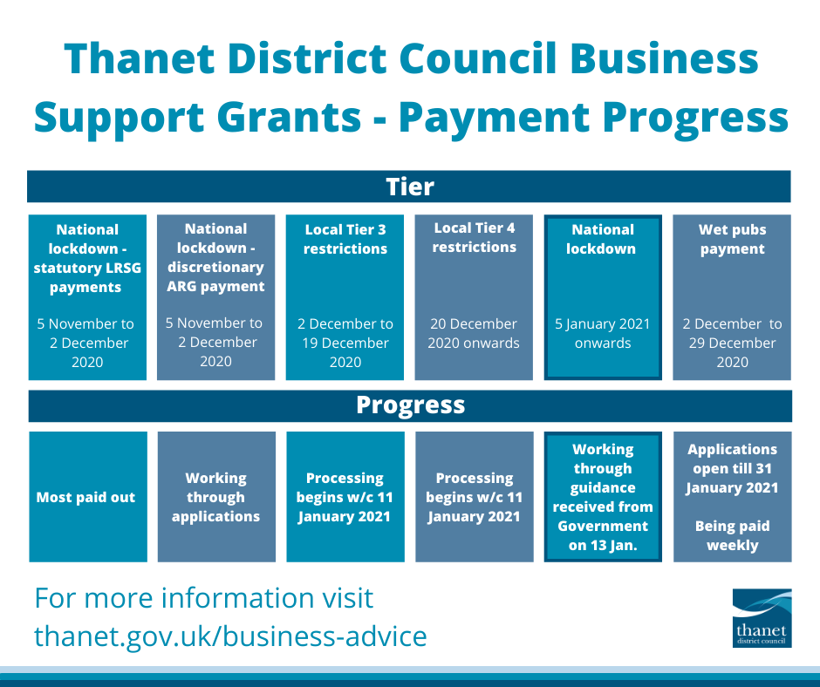

Tourism and Visitor Services News

FREE - National Coastal Tourism Academy Opportunities (NCTA)
Market your business to domestic and international visitors for free
Through our partnership marketing and PR activity with NCTA, there is an opportunity for you to market your business to domestic and international visitors for free!

England’s Coast, the consumer facing side of NCTA, is a one-stop shop for visitors looking to explore our coastline. It’s funded by VisitEngland and Listing your business on the website couldn’t be simpler - it’s free and can be updated at any time.

England’s Coast has just launched a major promotional and PR campaign to attract UK visitors to the coast so it will be gaining extra attention over the next few months. Previous campaigns generated more than £22m of media coverage – so make sure your business is listed today!

If you want added sparkle, you can upgrade your business to a Promoted Listing for just £200 + VAT. Enhanced listings appear higher in the search results, include additional images, the opportunity to add a special offer, and will be valid until March 2022. To make your listing click here

Free online product knowledge training - Become an England’s Coast Ambassador for your area!
In preparation for when we are able to travel again, learn top tips and facts on your local area by completing England’s Coast Ambassador, a free online training course with modules for every region of our coastline.

Each section is packed with information on local attractions, the surrounding area and how to get around, ending with a short quiz. On completion applicants gain a downloadable England’s Coast Ambassador personalised certificate.

So put your local knowledge to the test and get your certificates now! Click here to start

Visitor Information Service Update
Following the announcement of the National Lockdown the Visitor Information Centre at Droit House will remain closed until further notice. The team are available Wednesday - Sunday 10am to 5pm to answer enquiries by email, telephone or social media

Visit Kent
October Business Barometer
Due to the unprecedented situation with COVID-19 and with many attractions being closed, Visit Kent put their monthly Business Barometer on hold. With businesses starting to reopen between July and October they decided to relaunch their monthly survey during this time, to gather the latest visitor footfall and insights, and to be able to report on county level data in a timely manner. The October report is now available here

COVID-19 and EU Transition Impact Survey Results
In December, Visit Kent invited all visitor economy businesses from across Kent to complete a short survey, looking at what impact the second lockdown and the Tier 3 and 4 restrictions had on their business. The survey contained a few questions about the impact businesses anticipate the EU transition would have on their business. Here are the top line findings from the survey:
- Tier 3 and Tier 4 restrictions through December were more detrimental to the sector than the full lockdown in November due to lost business during this key trading period with a similar percentage of footfall lost in each month but 69% more bookings lost during December.
- If the county had been placed in Tier 2, the majority of businesses surveyed could have operated most elements of the business at reduced capacity within social distancing guidelines enabling 88% of those that had furloughed staff to bring back the majority of their workforce.
- Top three financial support measures requested are sector specific cash grants, further business rates relief in 21/22 and extended VAT reduction for 21/22.
- Prior to the closure of the French border, 43% of respondents indicated they are not confident at all in Kent’s transport planning post-BREXIT and 53% of respondents felt that Operation Brock would have a negative impact on their business.
- Top 5 concerns relating to BREXIT are UK economic climate, traffic disruptions, negative perceptions around the Kent brand, an increase in VAT, higher UK retail prices and strength of the pound/ exchange rate.

Visit Kent would like to thank all those who participated in this survey. This feedback will be fed into various Government committees allowing them to lobby for much-needed support for the industry, in addition to informing their recovery strategy going forwards.

