September’s Tourism Matters: Margate Town Deal and Grant Opportunities

Welcome to September’s Tourism Matters

We are getting back into the swing of Tourism Matters being monthly and we still have lots to update you on.

This month there is an opportunity to get involved in Margate’s Town Deal, plus information on the South East Business COVID-19 Recovery Grants and the ERDF (European Regional Development Fund) funding support for SME’s looking at ‘green‘ projects.

Thanet District Council
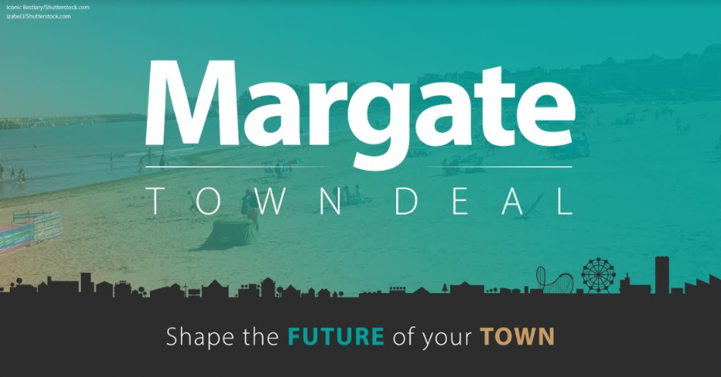

Following on from the information about the Margate Town Deal in the last issue of Tourism Matters, we thought it would be useful to provide some background on why Margate was chosen. The Government scored and ranked 541 eligible towns across England using a formula to select 101 towns for the Town Fund.

Please see below for information on how you can find out more about the Town Deal and the opportunities to input. There are a number of ways to get involved including:

- Completing an online questionnaire by Sunday 20th September. We have different versions so please select from the relevant link below.
  - Local person
  - Aged between 16 and 24
  - A local business
  - A representative of a third sector organisation or charity
If you would prefer a hard copy please text, call 07951 384263 or pick up from Margate Visitor Information Centre (Wednesday - Sunday 10am-5pm).

- Coming to one of our community drop in events:
  - Saturday 12th and Sunday 13th September at the Dreamland Ballroom, Margate between 10am-5pm
  - Monday 14th September at Cliftonville Community Centre Hall, Cliftonville between 3pm-7pm
Please be aware that these will be socially distanced events so you may need to queue. Please wear protective masks and bring hand sanitiser.

- Join a digital business breakfast on Thursday 17 September at 8am. Anyone who is interested can request details either by emailing research@pleydellsmithyman.co.uk or calling/texting 07951 384263.

- Taking part in a digital coffee morning – if you’d like to join the conversation please email research@pleydellsmithyman.co.uk to be sent further information.

- Encouraging other people to complete a questionnaire and come to a drop-in session by sending them the link and/or promoting it through your website, social media and/or other channels.

We are also working to develop a Margate Town Deal People’s Panel. This group will be representative of the community and come together on a regular basis to deliberate issues affecting Margate, make recommendations and support the Town Board. We would appreciate your help in promoting the Panel and encouraging members of the public to apply. Find out more about the panel

South East Business COVID-19 Recovery Grants
In July the Government announced £10million of additional funding to help support tourism businesses. The programme will be launched mid to late September and will be open to small businesses in the Visitor Economy to apply for 100% cash grants to a maximum value of £3,000 (£5,000 in exceptional circumstances). This funding has been made available to support businesses who seek advice to help them adapt their business as a direct consequence of COVID-19.

Applications will be invited from eligible businesses who will be prioritised based on the strength of their case and will be processed in order of receipt.

These grants will be for costs of £1,000 – £3,000 to pay for services that relate directly to the business recovery response to the pandemic, such as: IT, HR, Accountancy Consultancy and to purchase minor equipment.

There are only 75 Grants available across the SELEP area assigned for the Visitor Economy, so applying is recommended as soon as possible.

- Applicants on the Expression of Interest List will be invited (mid September) to complete a pre application form
- Pre-Applications received will be reviewed by a team of Grants Officers and where successful, will be invited to complete a full application by phone appointment
- Application will be formally processed with funding approval notification
- Applicant engages with supplier of services and receives the advice/purchases goods
- Applicant claims the grant funding

Due to the huge demand, it will be necessary to implement a priority filter to ensure the funding is awarded to the most appropriate businesses.

Priority Filters
- Eligible as a small business (less than 250 staff)
- Businesses in the Tourism and Hospitality sector
- Able to demonstrate a need for funding for specialist advice/minor equipment as a direct consequence of COVID-19 i.e. strength of the business case
- Businesses who have not received Government Grant funding from the Hospitality, Leisure and Retail Grant scheme

To register your interest to apply for the grant, please click here

Low Carbon Across the South East Grants
Locase are offering support for SMEs in Kent who are looking at ‘green’ projects or LCEGS (Low Carbon Environmental Goods and Services) firms seeking grant funding for business development purposes, especially pertinent post COVID-19. Maximum 40% ERDF grant contributions will remain at a limit of £10,000, with the minimum grant of £1,000 for qualifying revenue projects. Eligible businesses can apply for this funding with application closing at the end of September 2020. Click here for more information

New Back and Fill Festival
Back and Fill is a one-off festival for October school holiday. The aim is to extend the summer season and invite people to visit seaside towns in the October half term (23rd October – 1st November)

Devised by Margate based Marine Studios, ten towns around the UK have joined so far including both Margate and Ramsgate. Each town is planning its own independent community programme.

More information and an open source toolkit is available here

All plans are subject to COVID-19 regulations. If you want to get involved with either the Margate or Ramsgate events, please contact the local organiser. All help greatly appreciated. This is a collaborative community project so bring your good ideas and enthusiasm.

Here are some ideas of what could take place: walks, talks, book clubs, meet-ups, board games in cafes, open gardens, car boot sales, poetry slams, craft walks, skateboarding lessons and town wide games.

We can dream but we need help to make it happen – what will you organise?

Visit Kent
Visit Kent has just published their Business Barometer for July, which shows the latest visitor footfall and insights for the county. The July survey also incorporated some COVID-19 related questions such as business concerns, priorities and support needed. Click here to read the full report.

Visit Kent is actively working to increase the number of businesses that contribute to the barometer. If you would like to contribute, you can do so here. Your details will be added to the Visit Kent database and you will be contacted monthly by the Visit Kent Research Team to submit your figures on a confidential basis.

Tourism Service News
Press Visit - Accommodation Required
We have received a press visit enquiry from Brussels based journalist Martin Banks who would like to visit Thanet for a review for Brussels in View/EU Reporter.

Martin would like to visit with his family (wife and two children ages 13 and 15) for one or two nights between Tuesday 29th December and Saturday 2nd January and is open to either serviced or self-catering accommodation.

Examples of the type of coverage Martin produces is below.
- https://eutoday.net/news/culture/2020/a-super-spot-for-a-spring-break
- www.brusselsinview.eu/2019/03/15/salisbury-a-city-to-return-to/
- www.brusselsinview.eu/2019/07/18/arts-arrive-in-manchester-international-festival/

If you have availability and would be willing to host Martin and his family on a complimentary basis, please respond to julie.edwards@thanet.gov.uk with date/s. Thank you.

Visitor Information Service Update
Please note that the Thanet Visitor Information Service at Droit House is now operating its winter opening hours of Wednesday to Sunday 10am - 5pm.

New web page for Thanet food and drink offers
Following the success of the Government’s ‘Eat Out to Help Out’ scheme in August, a number of Thanet businesses have decided to continue with their own offers during September and even October. To promote this we have created a page on our website www.visitthanet.co.uk/eathelp If you have an offer, please let us know so that we can add you to the list tourism@thanet.gov.uk

Visitors’ Maps
Please let us know if you would like copies of the Visitors’ Maps 2020. Contact us on visitorinformation@thanet.gov.uk or 01843 577577.

Read our blog www.visitthanet.co.uk/blog

Your News
Margate Caves throughout September will be open Thursday - Sunday 10am-5pm, with last admission at 4.30pm. Booking in advance is asked to avoid disappointment

From Monday 14th September The Shell Grotto, open Wednesday - Sunday 10am- 5pm over the 16th - 20th and 23rd - 27th. During October they will open Fridays - Sundays 2nd -4th, 9th - 11th, 16th - 18th and 23rd - 25th Booking in advance is asked

Events
- 18th and 19th September: Heritage Open Days at Palace Cinema, Broadstairs
- 25th September - 11th October: Margate NOW
- 27th September: OhSoRetroShow, Palm Bay
- Until 30th September: Ramsgate: The Town and its Seaside Heritage

