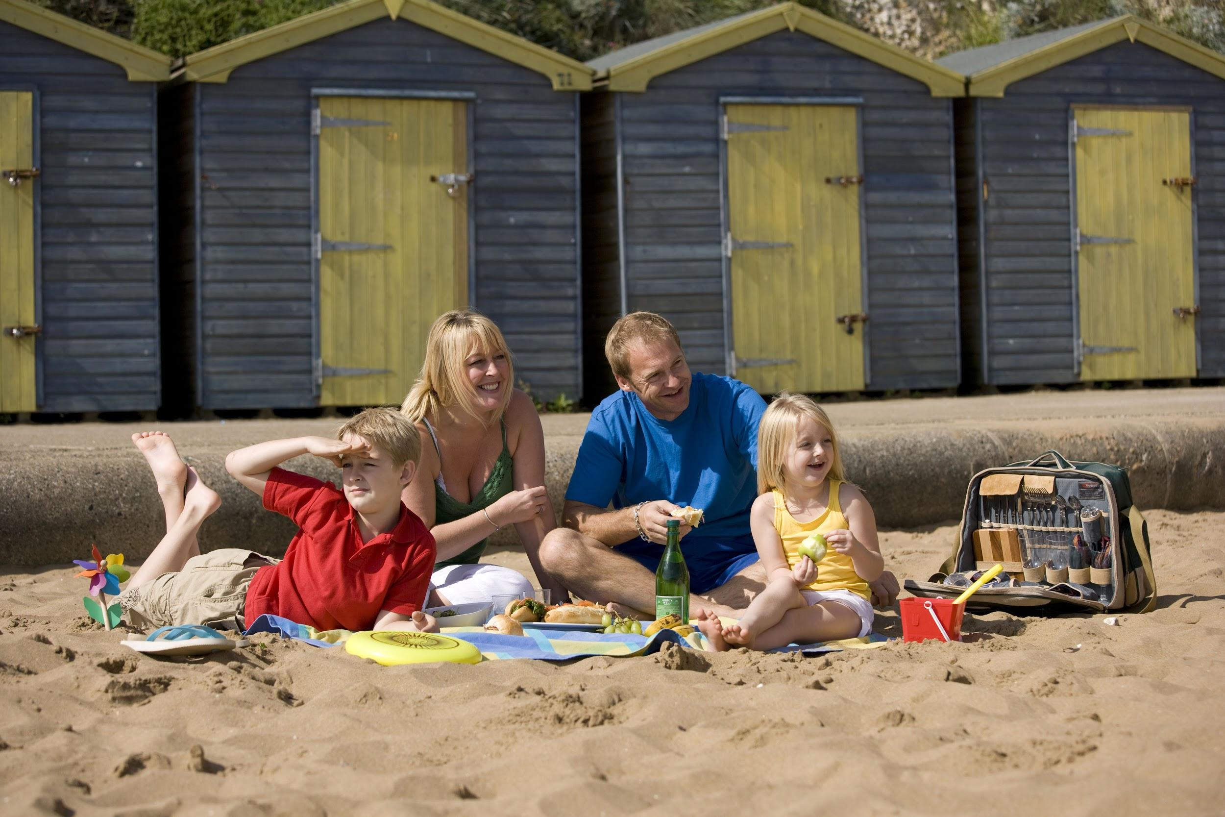
How to connect with visitors to Broadstairs?
• Older visitors, family groups and specialist / interest groups
• High proportion of retired visitors and from ABC1 socio-economic groups
• Travel by car but dissatisfied with availability and cost of parking
• Self catering accommodation booked directly with providers
• High levels of expenditure on accommodation and shopping
• Likely to visit Ramsgate but less likely to visit Margate as part of their trip

WHO
• Broadstairs is popular with family groups (including intergenerational and extended families. It attracts the highest proportion of children (18% under 15 years old) and was the only destination reporting visits from specialist and interest groups. As a result, it attracts the largest visiting groups (2.71 people).
• Visitors to Broadstairs aged 55+ account for 42% and 25% are over 65+, meaning that there is a high proportion of retired visitors (35%). Almost three quarters (71%) were classed as ABC1, the highest of the three towns. Broadstairs attracts a higher proportion of repeat visitors (80% compared to 78% for Thanet as a whole).

HOW
• Most arrive by car but visitors to Broadstairs will also travel by train (16% compared to 19% for Thanet). There is potential to encourage higher usage of railways, especially as parking in town is rated below average for availability (3.9 compared to 4.2 for Thanet) and for the cost of parking (2.3 compared to 2.7 for Thanet). Many respondents also name congestion and the high volume of traffic.
• High numbers of visitors to Broadstairs are likely to also visit Ramsgate during their trip. Overnight visitors are more likely to stay in self catering accommodation establishments and they are likely to book direct with accommodation providers.

How to connect with visitors to Broadstairs?

HOW MUCH
• This choice of accommodation results in the longest length of stay (5.2 nights per trip) and the highest spend per trip (£225.05, compared to £193.46 for Thanet). This higher spend is also triggered by a spike in shopping. Not surprisingly, shopping achieves the highest satisfaction scores (3.91) compared to Thanet as a whole (3.52).

WHAT
The beach and history & heritage are the two biggest influencers when deciding to visit Broadstairs. Things to do for families with children will attract visitors as well as information about places to eat or to have an ice cream.

Visitors to Broadstairs use destination websites to a smaller degree. Once in Broadstairs, they will rely on visitor maps and printed materials. Therefore, ensuring a good distribution of this type of promotional materials is essential.

CONNECT:
• Promote rail links, especially as many are dissatisfied with parking and levels of congestion
• Encourage accommodation providers to offer online bookability options
• Consider joint promotion of Broadstairs and Ramsgate as many will visit both locations during their trip
• Promote the beach, places to eat (including ice cream) and activities for kids
• Ensure a good supply and availability of maps and printed materials for visitors
• Support additional accommodation
• Use a tone of voice according to the visitor profile

